

Friday September 12,2025 9:30AM-10:30AM


Midland Fundraiser is being held from September 1st to September 22nd

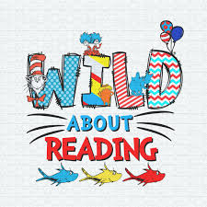
Signup Genius link:

https://www.signupgenius.com/go/10C0845AEAE22A1FBC34-57938438-friday

Friday Parent Reading
September 5th
Kimberly Ford -9:00-9:30
Sean Quarls: 9:00-9:30
Sabrina Hunsaker: 9:00-9:30

September 12th
Kitty Jordan- 9:00-9:30
Mikayla Brown-9:00-9:30
Stephanie Quarls: 9:00-9:30

September 19th
Kitty Jordan: 9:00-9:30

September 26th
Jessica McCann: 9:00-9:30


Samir Johnson 9/5
Liam Garcia 9/16
Cooper Brown 9/25
Alessandra Lopez 9/30
Staff:
Mrs. Kim 9/30

Lighthouse Connections
"You can teach a student a lesson for a day, but if you teach him to learn by creating curiosity, he will continue the learning process as long as he lives." - Clay P. Bedford

Important Dates
September 2025

The Woodlands • 5585 Creekside Forest Dr • Spring, Texas • 832.698.2735 • ChildrensLightouse.com/woodlands



The Woodlands • 5585 Creekside Forest Dr • Spring, Texas • 832.698.2735 • ChildrensLightouse.com/woodlands

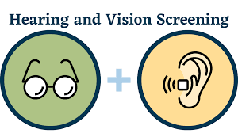

Curriculum Corner
Infants 1,2&3
Theme: Wonderful Me
Color: Red
Shape: Circle
Spanish: Red rojo, Circle círculo
Sign Language: Diaper el panal
Character Value: Cooperation

Toddlers
Theme: All About Me
Color: Red
Shape: Circle
Spanish: Red rojo, Circle círcul
Baby bebe Diaper el panal
Bib el babero
Sign Language: Diaper el panal
Character Value: Cooperation

Cares: 5-9
Theme: Apples,Pets
All About Me/Home
Wild Animals
Letters of the Month
A, C, M, T
Spanish: Hello: Hola
Book of the Month:
Chicka Chicka Boom Boom
Alphabet Book: ABC, I Like Me

Parents, please submit your child’s vision and hearing screen if they have recently turned 4 years old.

September 25th & 26th

Friday September 29th 6:30PM-10:30PM

