September | The Sailor Report
2017 | 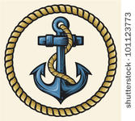
Sunday | Monday | Tuesday | Wednesday | Thursday | Friday | Saturday
 |  |  |  |  | 1 | 2
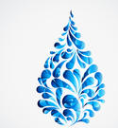
Red White & Blue Day!
3 | 4 | 5 | 6 | 7 | 8 | 9
 | 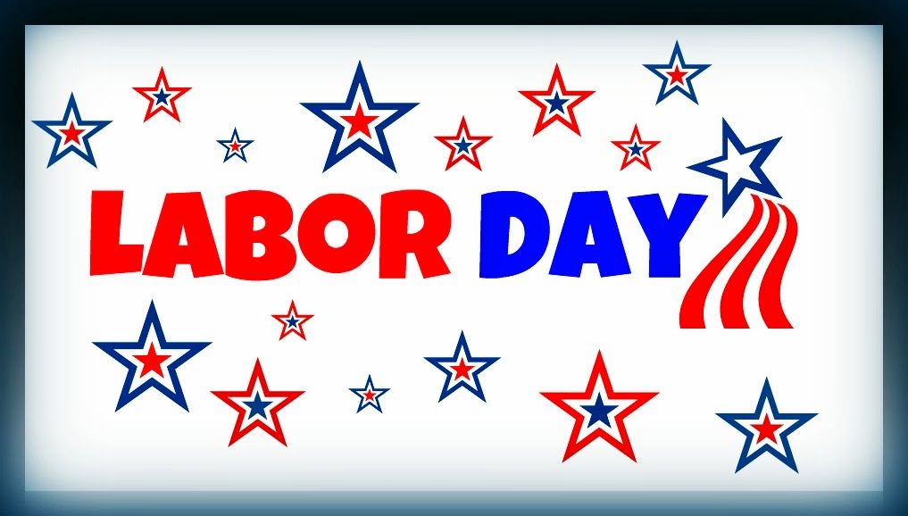  School is out! |  | Read a Book Day! Bring a book
10 | 11 | 12 | 13 | 14 | 15 | 16
 | 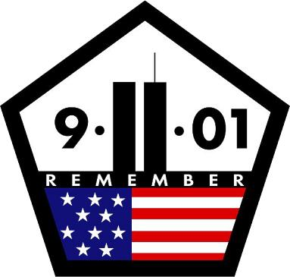 |  |  | Enroll for Soccer Shots | Make a hat day!  Wear a hat today!
17 | 18 | 19 | 20 | 21 | 22 | 23
 | 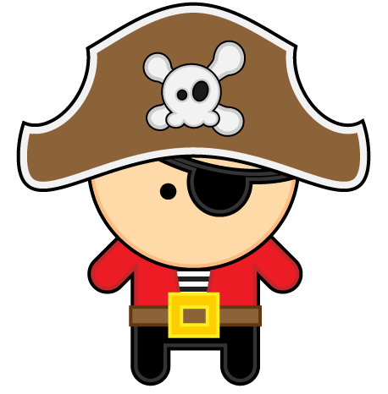 | Talk like a Pirate day! |  | Mini Golf Day!
24 | 25 | 26 | 27 | 28 | 29 | 30
 | Comic book day! | 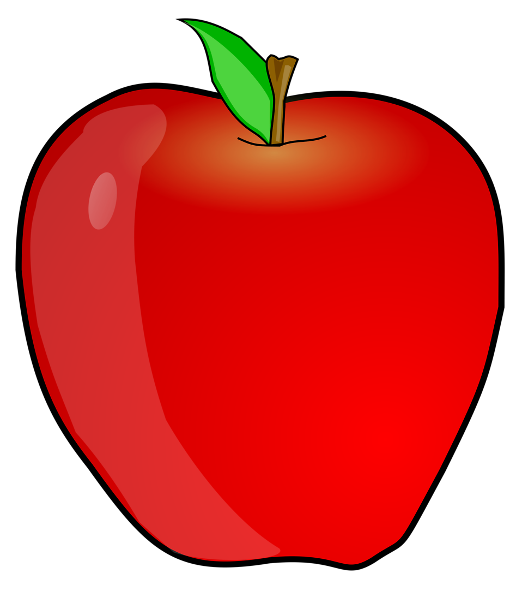  Johnny Appleseed day!

The Children’s Lighthouse Learning Center of Woodforest will be closed on September 4th for Labor Day! | In remembrance of 9/11 please wear red, white and blue! | Wear your favorite hat on September 15th! | Dress like a Pirate on September 19th | Bring an apple to school on September 26th | Soccer Shots Fall season will begin September 14th!  A water drop indicates splash day!

