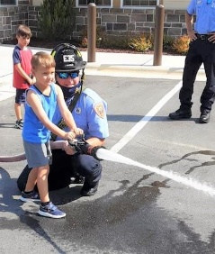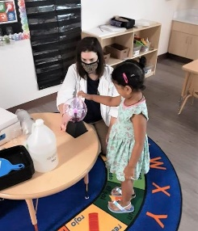

**September Newsletter**

**9/20 Samarth is four!!**

**9/20 Henry is four!!**

**9/22 Wyatt is three!!**

**9/24 Fred is three!!**

Happy Birthday!

Hola! We has such a fun summer, but now we are so excited to start our 2021-2022 school year.

This month our letters will be A, C, M, and T. We will be learning the Spanish and sign for hello, help, please, and thank you. Our themes for the month of September are Apples, Pets, All About Me, and Wild Animals!

Some special dates to remember for September:

We will be closed on the 6th for Labor day.

September 10th all our grandparents are invited to enjoy a snack at 2:30 to celebrate Grandparents Day.

On September 22nd it will be officially fall, so dress in your favorite fall colors!

We are on facebook! Give us a like and check out some of our fun posts and pictures.

**Dear Parents,**

2021

Children’s Lighthouse of Apex • 2001 Apex Peakway • Apex, NC • 919-924-0401 • ChildrensLightouse.com

**Enter Text**