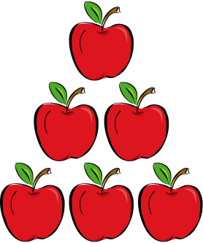 September 2021

Themes | Monday | Tuesday | Wednesday | Thursday | Friday
Around the World | 30 | 31  Passports around the world | 1 | 2 | 3
Apples | 6  SCHOOL CLOSED  Labor Day | 7  Apple Volcano Science Experiment  Apple Life Cycle Hat | 8  Tasting of Different Apples  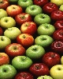 | 9  Who Is Johnny Apple Seed?  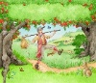 | 10  Grandparents for Snack to celebrate Grandparents Day!
Pets | 13  Bring a picture of  Your pet | 14 | 15 | 16  Virtual Field Trip Tour the Humane Society  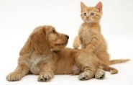 | 17
Our Home & All about me | 20  Create a Self Portrait | 21  Bring in family photos | 22  Create All about me book | 23 | 24  Create Family Trees  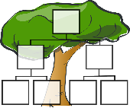
Wild Animals | 27 | 28 | 29  Create a Jungle Book | 30 | 1  Safari Hunt

