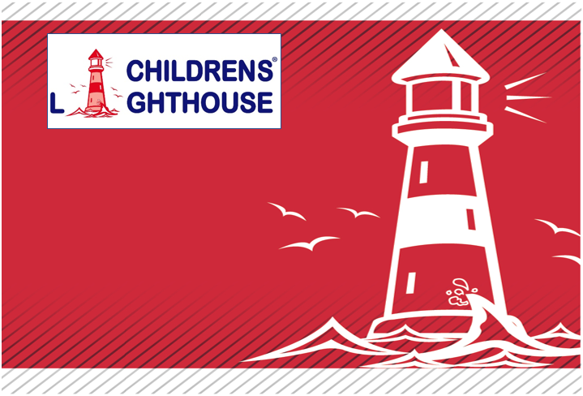

Parent Handbook
for
Childrens Lighthouse Learning Center
of Seabrook
Effective April 1, 2022

Foreward
This Parent Handbook (“Handbook”) has been created by PG Legacies, Inc (“we,” “us,” or “our) and is being provided to the parents or guardians of the children in our care.
Thank you in advance for reviewing this Handbook carefully.

Table of Contents
Introduction 6
Mission Statement 6
Policy Statement 6
Operational Information 7
Daily Operation and Services Offered 7
Severe Weather Procedures 7
Public School Closures 7
Outdoor Temperatures 7
Absences, Sick Days, and Vacations 7
Daily Arrival and Departure 8
Late Arrivals 8
Identity Codes 8
Visitors 8
Release of Child to Authorized Persons 9
Release of Child to Unauthorized Persons 9
Custodial Information 9
Late Pick Up 9
What to Bring on Your Child’s First Day 10
Our Program 11
Curriculum 11
Infants and Toddlers 11
Preschool: Two Years through Five Years 11
School-Age Children 12
Technology Use Guidelines 12
Physical Activity and Outdoor Play 12
Character Development 12
Show and Tell and Personal Belongings 13
Accreditation 13
Ratios and Group Sizes 13
Program Options 14
Enrollment Policies and Required Forms 14
Non-Discrimination Enrollment Policy 14
Confidentiality and Children’s Records 14
Children with Special Needs 14
Required Enrollment Information 15
Registration, Tuition, and Fees 16
Photo Use and Internet Video Monitoring 16
Notification of Withdrawal 166
Re-Enrollment 17
Suspension and Termination of Services 17
Protecting Our Children 18
Positive Discipline Strategies 18
Prohibited Strategies 19
An Individualized Approach 19
Discipline Guidelines to Remember 19
Intervention Support 20
Child Abuse Awareness 20
Education and Training 20
Mandated Reporting Requirements 20
Child Advocacy Information 21
Medical Policies 22
Communicable Diseases 22
Coronavirus Disease 2019 (COVID-19) Information 22
Illness: Signs, Symptoms, and Exclusion/Readmission Criteria 22
Immunizations 23
Influenza Information 23
Handwashing 23
Health Check 23
Medical Emergencies and Accidents 23
Medications 24
Provisional Medical Care 24
Topical Medications 25
Health and Safety Policies 26
Animal Friends 26
Appropriate Attire 26
Biting 26
Breastfeeding 26
Cleaning Procedures 26
Consumer Product Recalls 26
Diapering Procedures 27
Emergency Preparedness Plans 27
Employee Restrictions 27
Gang-Free Zone 27
No Cash Policy 27
Nutrition 27
Quiet Time 28
Safe Sleep Policy 29
Smoking 30
Toilet Training 30
Transportation: General 30
Transportation: Field Trips 30
Transportation: School-Age Children 30
Water Activities 30
Weapons 31
Family Involvement 32
School Information Board 32
Classroom Information Boards 32
Daily Communication 32
School Websites 32
Parent Observations 32
Parent Conferences 33
Parent Surveys 33
Opportunities for Family Involvement 34
Celebrations and Birthdays 34
Special Events 34
Classroom Visitors 34
Collections 34
Parent Concerns 34
General Information 35
Local, State, and National Inspections 35
Volunteers 35
Insurance 35
Appendix 1: Contact Information for your Childrens Lighthouse School 366
Appendix 2: The Flu: A Guide for Parents 37
Appendix 3: Parent/Guardian Acknowledgment of Receipt 38

Introduction

Mission Statement
Childrens Lighthouse Franchise Company is an accredited private preschool system that licenses to others the right to use its name and system. The Childrens Lighthouse system is designed to help the owners of each Childrens Lighthouse School deliver exceptional educational childcare.
At our School, we partner with parents in developing children with character values and physical wellness in an enriched learning environment designed to develop brains, bodies, and best behaviors.

Policy Statement
The policies and procedures in this Handbook are effective as of the date on the cover of this Handbook. Should any of these policies and/or procedures be updated, revised, or otherwise changed, parents will be notified.
Each Childrens Lighthouse school is independently owned and operated.
Operational Information

Daily Operation and Services Offered
Childrens Lighthouse Schools are designed to serve children ages 6 weeks – School-Age, in accordance with state licensing regulations. We are open year-round, Monday through Friday, with a few exceptions, such as Thanksgiving, Christmas, other holidays, and staff development events. You will receive notice of any closures due to holidays or staff development days. Tuition fees remain the same, regardless of School closures. A specific list of this School’s operating hours and scheduled closing dates is available from the School Director.
Extra-curricular activities may be offered at each Childrens Lighthouse School. Please ask our School Director for a list of specific activities and prices (if applicable).

Severe Weather Procedures
If severe weather necessitates closing, early dismissal, or late arrival, we will communicate with you through both our website and the local news station (if available). Tuition will not be exempt or prorated because of severe weather closing or if a state of emergency has been declared.

Public School Closures
If your child attends public school and that school closes for a holiday break, snow day, or any other reason, you will be required to pay an additional fee for your child to stay with us for the entire week or day. Please refer to your Tuition Agreement or contact our School Director for additional information.

Outdoor Temperatures
Outdoor time is a special time of the day to release energy and enjoy the physical rewards of active play.
Winter – As temperatures approach 35°F wind chill, our management team will assess the latest weather conditions. If temperatures fall below 35°F wind chill, staff will keep children indoors. During the winter months, we typically wait until later in the day to take children outside when temperatures are warmer. Please make sure your child is dressed appropriately for winter play – mittens, hats, warm coats, etc.
Summer – As temperatures/heat index approaches 100° F, our management team will assess the latest weather conditions. Children often participate in water play activities outside in shady areas on the playground. During the summer months, we schedule our outdoor times earlier in the day to take advantage of the cooler temperatures.

Absences, Sick Days, and Vacations
If your child is enrolled on a full-time basis, you will receive a number of “absentee credits” for each calendar year. Please see our School Director for additional information about absentee credits.

Daily Arrival and Departure
For your child’s safety, please escort him or her, preferably holding hands, while in the parking areas and hallways; and deliver them to the classroom door each day. The same routine should be followed when picking up your child. Make sure that the classroom teacher is aware of your child’s arrival/departure. In addition, parents are required to sign in and out of the school at the front desk. Throughout the day, our teachers track each child’s movement when they participate in activities that take them outside of the classroom, for example when the class goes outside, or if they participate in an extra-curricular activity.
During arrival, it is very important to set up a routine that your family can follow every day. This provides your child with a sense of security. Please keep teachers informed about your child’s health, mood, eating habits, family situation, or anything you think might affect your child’s behavior at school. We recommend that you help put away items in their cubby, walk with them to greet their teacher and friends, and assist your child in selecting a toy or joining an activity.
When it is time for the person dropping off the child to go, tell the child you are leaving, and say, “Good-bye.” If our child is having difficulty separating, signal a teacher for assistance. Feel free to call us later if your child is upset when you leave, and we will let you know how he or she is doing.

Late Arrivals
Occasionally, children participate in field trips or other activities that take them away from their classroom. Should your child arrive, and their classroom is not on campus, arrangements will be made for your child to participate in another classroom’s activities until they can rejoin their original class.

Identity Codes
As an added safeguard, each school is locked at all times. Upon enrollment, parents/guardians will be assigned an identity code to use when entering our School. DO NOT give this code to any other person. Persons other than parents, guardians, and staff may enter by ringing the doorbell. For anyone who violates this policy, we reserve the right to disenroll your child.

Visitors
Visitors are required to show identification and sign in on the visitor log kept at the front office. Visitors are escorted while on campus.

Release of Child to Authorized Persons
Children will not be released to any person that is not specifically designated on your child’s enrollment form. Each authorized person will be required to show photo identification, such as a driver’s license. This information will be copied by our office personnel. Once the person’s identity has been confirmed, an authorization sticker will be given to the authorized person, who must give it to the child’s classroom teacher. Teachers will place the sticker on your child’s daily sign in/out sheet to record the authorized pickup.

Release of Child to Unauthorized Persons
If there is an emergency which requires an unauthorized person to pick up your child, you must provide the School Director your permission for the pick-up, in writing, before the unauthorized person arrives.

Custodial Information
Persons identified as parents on a child’s enrollment form will be allowed to pick up the child whose name is on the form. If a court has issued an order limiting or restricting access of a parent to a child, a court stamped copy of such an order must be submitted to the School Director. This Childrens Lighthouse School may not be used as a visitation site, nor will we be responsible for determining compliance with parent visitation schedules.

Late Pick Up
Please make every effort to pick your child up on time – he or she is eager to see you! If something prevents you from being on time, you should 1) arrange for one of your authorized persons to pick up your child or 2) notify the school immediately if your emergency contacts are not available.
If your child is not picked up by the school’s closing time, and you have not notified the school, the following steps will be taken:
- We will attempt to contact you and/or your authorized persons.
- If we are unable to reach you or any of your authorized persons within 30 minutes after the School’s closing time, the School Director (or designated person in charge) will decide whether and when this state’s child protective services (or other appropriate authority) will be contacted. This decision will be based on our state’s childcare licensing regulations.
- If authorities are contacted, they will be given the emergency contact information listed on your child’s enrollment form.
Under no circumstances will the School Director or any employee of this Childrens Lighthouse School take your child home or transport your child to another location. Additionally, the late fee listed on your Tuition Agreement will be charged.

What to Bring on Your Child’s First Day
You have probably visited us on one or more occasions, and our intent is for you to have a smooth and informative enrollment and orientation process. We want you and your child to feel comfortable and welcomed on your first day at our Childrens Lighthouse School, and we understand no matter how well prepared and excited a family may be, the newness can also be a little scary for everybody. We do not consider any questions or concerns you may have to be unimportant or silly.
To help you prepare, here is a list of suggested items to bring on your child’s first day, sorted by age:
Infant | Diapers, wipes, premade bottles labeled with your child’s first name and last initial, diaper cream/ointment, sleepsack, baby food (if applicable), at least 3 extra changes of clothes, and pacifier (if your child uses one)
Toddler | Diapers, wipes, diaper cream/ointment, sunscreen, a lightweight blanket, at least 2 extra changes of clothes including a pair of shoes
Preschool (Twos and Older) | A lightweight blanket, at least 2 changes of clothes including closed-toed shoes (consider more if your child is toilet training), training diapers (such as Pull-Ups®) if your child is potty training, diapers if child is not potty training, sunscreen, bug spray
School-Age | Sunscreen, bug spray

Your child’s teacher will communicate when items need to be replenished.
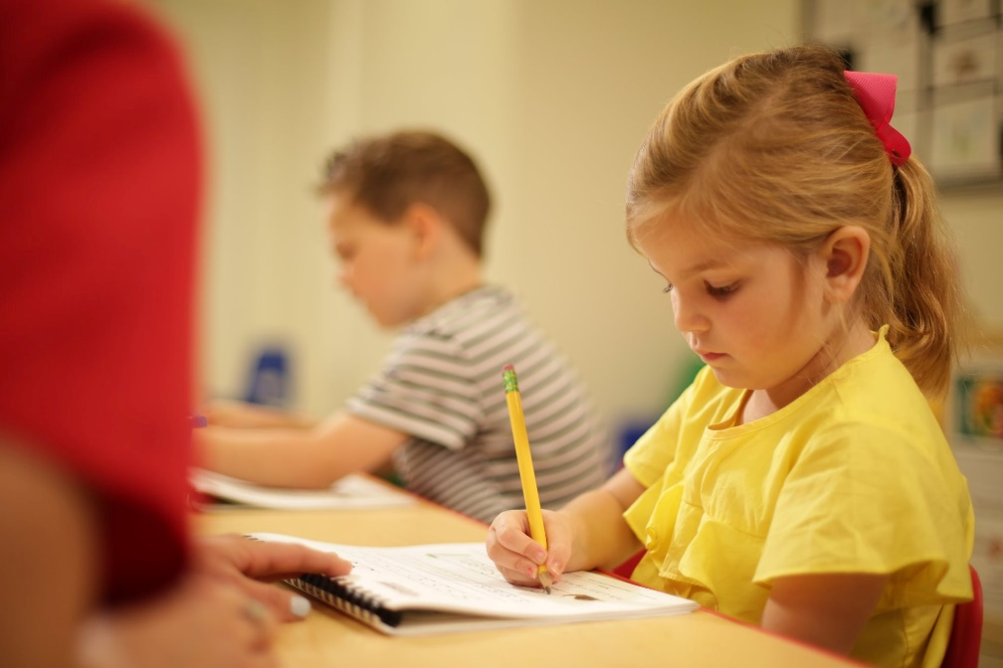

Our Program
The teachers in our School are advocates for children who love and encourage each child to develop academically and socially. As they listen and learn with each child, they assess and guide the learning process and empower children to make sense of their world. It is our goal that our teachers implement teaching strategies that promote positive behavior, cultivate positive relationships, and work together to create a respectful learning environment.
Children are provided with appropriate materials in our beautiful classrooms. The classroom environments are carefully thought-out and reflect a child-centered view. Materials are displayed in a functional yet inviting manner, which nurtures the child’s inner creativity. Tools and props are rotated frequently to reflect the needs and interests of the group. Each classroom has a daily schedule that is posted on the Parent Board outside each classroom.

Curriculum

Infants and Toddlers
Innovations, The Comprehensive Infant Curriculum is a complete program for infants from birth to 18 months of age. This curriculum, together with teacher and parent support, provides everything needed to address the needs of the “whole child,” and gives your infant a strong foundation across all elements of early development.
For toddlers aged 18 to 24 months, Innovations, The Comprehensive Toddler Curriculum builds on this early learning by emphasizing the interrelationship among the teacher’s expertise, the child’s interests, fundamental principles of child development, the child’s unique family context and culture, and social interactions with other children and adults.

Preschool: Two Years through Five Years
Our preschool program uses our proprietary Lighthouse C.A.R.E.S.SM curriculum, which is based on the following five foundations:
Character Values Education: Our comprehensive curriculum focuses not only on intellectual development, but also on healthy social and emotional growth through systematic character values education.
Active Engagement: Activities are designed to promote active learning through a “hands on” approach that allows children to explore the world in which they live.
Research-Centered Practice: Learning activities are grounded both in time-honored practice, such as learning through play, as well as in current research findings in the field of neuro-education. “Brain-based” learning strategies, for example, reveal that memory and creativity are enhanced by music, movement, and artistic expression.
Embedded Content: Our full-integrated curriculum is characterized by thematic units which combine the key skills of reading and mathematics with learning in the content areas of science and social studies.
Standards-Based Objectives: Every learning activity is carefully planned to meet or exceed both national and state standards.
Lighthouse C.A.R.E.S.SM incorporates three primary times of focused learning: The Learning Wall, Lesson Plan instruction, and classroom Discovery Centers (both “free choice” and assigned rotations). Each classroom is equipped with the following Discovery Centers: Literacy, Skills and Games, Math and Manipulatives, Science, Library, Art, Technology, Blocks and Building, and Dramatic Play.

School-Age Children
The purpose of the School-Age program is to provide an environment for children who also attend elementary school that is filled with both fun and enrichment. Every School-Age classroom is complete with displays, decorations, and fully equipped Discovery Centers. Discovery Centers at this age include Science, Technology, Reading, Engineering, Art, and Math and Games, as well as Homework and Snack stations.

Technology Use Guidelines
The use of technology tools – whether devices, programs, or processes – is a valuable means of supporting and enhancing learning. Interactive technology devices used at our Childrens Lighthouse School may include computers, laptops, tablets, interactive learning tables, interactive books and games, Smart Boards, and digital cameras. However, based on recommendations from recent research and licensing regulations, we limit the amount of screen time children experience and focus more on active learning. Screen time, of any kind, is prohibited for children under two years of age.

Physical Activity and Outdoor Play
Our School takes a proactive approach to helping children stay physically active. In each classroom, there are activity areas set up to encourage physical activity. Physical activity occurs in each classroom during structured and unstructured time. We also promote large motor development outdoors. We spend time outside each morning and each afternoon, as weather permits. While outdoors, children have opportunities to run, climb, jump, pedal, push and pull, etc. They are encouraged to participate in group games that are physically active and that help develop their gross motor development and social skills.
Our playground environment sparks the children’s imagination and serves as an integral part of physical development. Physical activity and exercise are encouraged to teach a healthy lifestyle. The equipment on the playground is safe and is inspected regularly by our teachers and School Director to help ensure they remain that way. Our separate play areas keep similarly aged children together, which helps ensure each child’s safety. At the end of the day, when fewer children are at the School, children may be grouped together with low child/teacher ratios and appropriate supervision. We take all of these steps because your child’s safety is our greatest concern.

Character Development
Our exclusive program of character development is an essential part of each of our programs. By planning targeted activities and modeling desired traits, our children are consistently exposed to positive values such as cooperation, helpfulness, patience, respect for diversity, kindness, and gratitude. Not only does this instruction aid in establishing good habits for the future, it also reduces incidents of misbehavior in the classroom.

Show and Tell and Personal Belongings
Show and Tell times, typically held on Friday mornings, are a valuable part of our curriculum and a special venue for encouraging language development. Classrooms generally rotate Show and Tell among a few children designated each week, so each child has a chance to have his or her special time to share. Occasionally, your child’s class will have an “All Class Show and Tell,” such as “Bring a Bear Day” or “Bring Something Red Day.” These special times are noted on your child’s “Calendar Connections.”
The School is not responsible for lost personal items or clothing. It is your responsibility to make sure everything your child brings or wears to school has his/her name clearly written on it in permanent marker. Please do not send personal possessions with your child unless specifically requested.
Toy guns or weapons of any kind are prohibited at all times. Small or delicate items, such as jewelry, coins, and ceramics, which could be easily swallowed or broken, are not to be brought to school either. All items brought to school should fit in your child’s backpack or cubby.
Personal electronic devices from home are prohibited in our Infant, Toddler, Preschool, and APK classrooms. School-Age children may bring devices from home, but they must comply with our Code of Conduct.

Accreditation
All Childrens Lighthouse Schools operate under the childcare education system developed by Childrens Lighthouse Franchise Company – which is accredited by Cognia (formerly AdvancED®). Each Childrens Lighthouse School is held to high standards of operational and educational excellence. The Cognia accreditation demonstrates Childrens Lighthouse Franchise Company’s commitment to nurture the development of each child’s full potential intellectually, emotionally, socially, and physically in an atmosphere of safety and trust. Each Childrens Lighthouse School is privately owned and operated and may be individually accredited.

Ratios and Group Sizes
Appropriate ratios and group sizes are kept in accordance with state childcare licensing requirements. The appropriate ratio varies with the age of children in each classroom. State ratios are posted in each classroom on the Teacher Board.

Program Options

Enrollment Policies and Required Forms

Non-Discrimination Enrollment Policy
Childrens Lighthouse Schools offer educational childcare services to all interested families. Our enrollment policies are based on non-discriminatory policies and laws. We do not discriminate on the basis of religion, color, race, gender, sexual orientation, age, national origin, disability, or any other factor prohibited by law. Children are admitted to our program as openings are available, based on the order of their enrollment application and receipt of the designated registration fee.

Confidentiality and Children’s Records
All information contained in your child’s records is privileged and confidential. Parents or guardians may have access to their child’s records at reasonable times upon request. Please contact your School Director if you wish to add or update any information contained in your child’s records. Updates might include such information as: changes of address, telephone, employment, and/or names of persons authorized to pick up your child. Your child’s records will be kept for the minimum time specified by our state’s licensing regulations. Should you require a copy of your child’s file, an administrative fee may be charged.

Children with Special Needs
We make reasonable accommodations for children with special needs, based on their Individualized Education Program (“IEP”) or similar assessment and as indicated on your child’s Enrollment Form. Please note that “reasonable accommodations” do not include adjustments to the classroom’s child/teacher ratio.
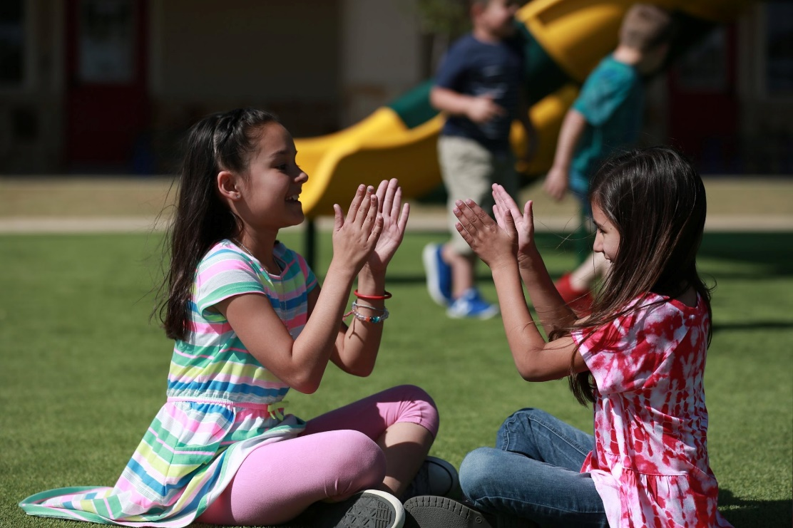
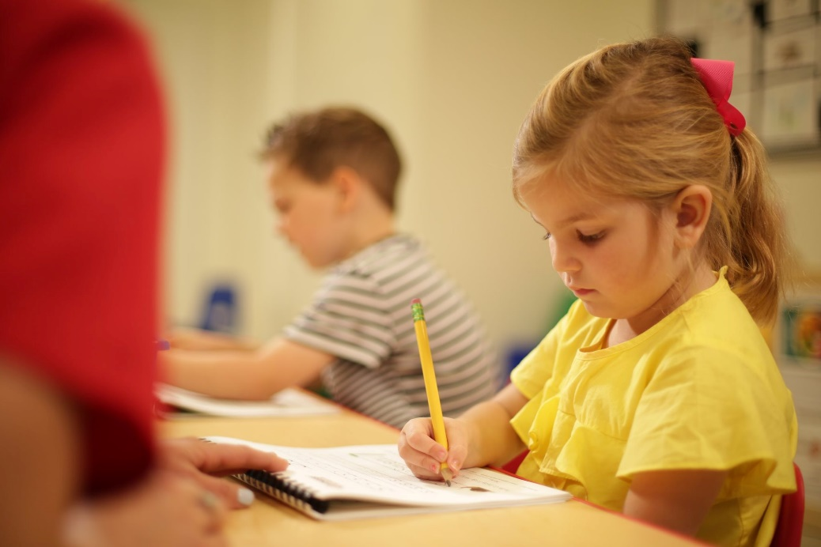

Required Enrollment Information
All forms provided to you upon acceptance of enrollment MUST be completed before your child attends. To enroll (or re-enroll) your child, you must complete and sign the Enrollment Form and other School-specific forms we require, as well as any other local and/or state-specific forms required by licensing regulations. Forms/information include, but are not limited to, the following:
- Our required Enrollment Form, which includes basic information about you and your child, and which will be given to you upon payment of the registration fee. All families must maintain current information by emailing or giving updated information in person to the School Director (the school email address can be found both on the website and School Specific Information form).
- Authorized Release Information, included in your Enrollment Form, includes the names, addresses, and telephone number(s) of all persons you authorize to pick up your child from our Childrens Lighthouse School. We will only release your child to an authorized person, specifically designated by you, in writing. For the safety of your child, we will require that a photo ID be presented EACH TIME the authorized person picks up your child.
- Tuition Agreement, which must be completed and signed. PLEASE NOTE: We reserve the right to change or modify fees and/or policies with a two-week notice. Information regarding payments, charges, and separation procedures can be found in the Tuition Agreement.
- State-required applicable health forms must be completed prior to admittance. These forms may include, but are not limited to, the following:
  - A copy of your child’s current immunizations or a signed affidavit stating the reasons immunizations have not be given. NOTE: Most states require vision and hearing screening at the age of four. The School Director will furnish you with specific requirements for our state.
  - The Ongoing Medication Authorization Form, for children who require daily medication.
  - The Allergy Alert and Action Plan for children with allergies, regardless of the type of allergy.
  - The Physician’s Recommendation and Health Statement, which is often combined with the immunization forms. PLEASE NOTE: The Physician’s Statement stating that your child is physically able to participate in a group care setting (such as the one our School provides) must be signed. We accept children in compliance with the ADA. If your child has special needs, please furnish a copy of his or her IEP, or similar document, for inclusion so we may provide the very best care for your child.
- Video Monitoring and Photo Release Form, which may be included as a part of your Enrollment Form. (Please see “Photo Use and Internet Video Monitoring” below for additional information.).
- Infant Feeding Schedules, if applicable, must be completed and updated as needed or every 30 days—whichever comes first. (Please see “Nutrition” in the Health and Safety section for additional information on infant feeding.).
- Transportation Agreement, for children participating in our School-Age before and after school program.
- If there are court orders affecting the custody of your child, you must furnish us a certified copy of the court order, signed by the presiding judge. While we will ensure that we are in compliance with the court order on file for your child, it is our policy to remain neutral in all custody matters. Our Childrens Lighthouse School may not be used as a visitation site, nor will we be responsible for determining compliance with parent visitation schedules.
- Sunscreen Permission Form may be a part of your enrollment packet or may be distributed at a later date.
- Parent Handbook Acknowledgement Form, which is included at the end of this handbook.
- School Specific Information Sheet, which provides information specific to this Childrens Lighthouse School, and
- Any additional forms required by us or the state.

Registration, Tuition, and Fees
A non-refundable registration fee is due when your child’s enrollment application is submitted. Tuition is billed in advance of each week on Monday morning. Late payment fees, as defined on your Tuition Contract, will be charged if payment is not received by close of business on Tuesday of each week. We will refund tuition and fees if paid ahead and not utilized, excluding non-notification of withdrawal and registration fees. Refunds can take up to 30 days to process.
We reserve the right to refuse service for families who have an outstanding account balance at the end of the week.

Photo Use and Internet Video Monitoring
Our staff often take photos of the children in our care while in the classrooms and/or on the playground. While most of these photos are used solely for classroom projects, some may be used on our website, the Childrens Lighthouse Franchise Company website, in marketing materials such as brochures or flyers, in school publications such as the parent handbook, and/or for staff development/training purposes. If you prefer that your child not be included in these latter categories, please check the appropriate box on your Enrollment Form.
Many Childrens Lighthouse Schools offer internet video monitoring for parents. These “real-time” videos not only offer parents the comfort of knowing their child is in good hands, but also provide a unique glimpse into their child’s daily work and play. Naturally, the security of the children and the school are a primary concern; therefore, any use of these videos—including reproduction, printing, or image duplication—is prohibited without prior written consent by the School Director. Parents and/or visitors in our schools may not photograph or video children other than their own. We reserve the right to disenroll the child of any parent who violates this photo use and internet video monitoring policy.

Notification of Withdrawal
If you must withdraw your child from our School, for any reason, you are required to provide a two-week notice by completing the Notification of Withdrawal form, available from the School Director. If proper notification is not given, you will be responsible for the payment of a fee equal to two weeks of tuition. Withdrawing your child to avoid payment of tuition during scheduled closures or times like spring break or summer vacation will result in a temporary suspension of all services and a re-enrollment form will only be reviewed after 30 days. If absentee credit has been accrued, it should be used instead. No staff members have the authority to overturn this and any requests for exceptions shall ONLY be reviewed by the Owners. If reenrollment is approved then any current waiting list will still apply and your child will be placed in the que.

Re-Enrollment
Should you wish to re-enroll your child, new enrollment information must be submitted, along with the applicable registration fee, provided an opening is available.

Suspension and Termination of Services
We will take all measures to avoid suspension and or expulsion. Our program uses a proprietary curriculum which is based on intellectual development and healthy social emotional growth through character values. Our teachers provide written documentation throughout the year to communicate with parents about their child’s growth and development. Individual behavioral incidents will be documented and communicated with parents on an on-going basis. Parents are notified in writing and, if needed, a conference will be scheduled to discuss their child’s behavior. In certain situations, parents may be encouraged to seek professional support and services. Ask your School Director for recommendations.
At times, parents may be asked to pick up their child and keep him/her home the following day to work on behavior issues. If behavior is not corrected, as a last resort, a one-week notice of termination of services will be given, unless the child is an immediate health or safety risk to property or other persons. We reserve the right to terminate services if we cannot meet the social, emotional, and safety needs of the child and/or due to aggressive and or unsafe behavior exhibited by the child.

Protecting Our Children

Positive Discipline Strategies
At Childrens Lighthouse, “discipline” is defined as training by instruction or example. Our policy prohibits the use of any form of negative discipline including “behavior charts” or any similar reward/punishment technique. Ten positive discipline strategies, which are of benefit to both teachers are parents, are:
Develop a plan. Be familiar with the personalities and needs of your individual children, as well as overall developmental guidelines for your child’s age group.
Ignore the misbehavior, if possible. Remember, you are ignoring the behavior, not the child.
Structure the environment. Children who are engaged in creative and meaningful learning activities have few behavior problems.
Choose your battles. Ask yourself, in the grand scheme of the day, how important is this?
Involve the child through choices and consequences. Provide children with as many choices as possible according to their development levels. Teach children that their actions have consequences; and that they choose whether or not to follow the classroom/family rules.
Provide privileges in relation to responsibilities. Subtly (but consistently) reinforce the connection between “the more responsible we are” and “the more things we get to do.”
Learn to ACT instead of REACT. Action is both self-driven and positive; reaction, on the other hand, is negative and implies that someone or something else is in charge of actions.
Increase consistency. Children want to be able to depend on us – even when they are testing their boundaries (and you!).
Notice positive behavior. The most impactful discipline strategy for young children is to “catch them being good.” Children want our attention, and they will settle for negative attention if they cannot get positive attention. Encouraging words, combined with engaging and developmentally appropriate activities, are the most important tools a teacher (or parent) has in his or her toolbox.
Excuse the child for some “self-time.” This strategy should be used sparingly and only as a last resort. If a child’s behavior has become disruptive or physically aggressive, the child should be “excused” from the group. The purpose of “self-time” is not to punish the child, but to give him/her a chance to re-gain control.

Prohibited Strategies
Childrens Lighthouse maintains a zero-tolerance policy regarding any forms of discipline or guidance which involve harsh, cruel, or unusual treatment of any child. The following types of discipline methods are strictly prohibited at all Childrens Lighthouse Schools:
- Corporal (physical) punishment, including grabbing, squeezing, pinching, shaking, or biting a child;
- Threats of corporal punishment;
- Any punishment associated with food, naps, blankets/toys, or toileting;
- Picking up, lifting, and/or dragging a child by hands or arms;
- Hitting or tapping a child with a hand or instrument;
- Putting anything in or on a child’s mouth;
- Humiliating, ridiculing, rejecting, or yelling at a child;
- Subjecting a child to harsh, abusive, or profane language;
- Placing a child in a locked or dark room, bathroom, or closet, with or without the door closed;
- Requiring a child to remain silent or inactive for inappropriately long periods of time for the child’s age; and
- Inappropriate restraint of a child.
Our staff members are specifically trained in the use of positive guidance methods and may only use discipline strategies which encourage the development of self-esteem, self-control, and self-direction.

An Individualized Approach
Discipline strategies are individualized and consistent for each child, appropriate to the child’s level of understanding, and directed toward the goal of “self-discipline.” In addition, we believe in establishing open, honest communication concerning every aspect of your child’s development and in working as a team to achieve the desired results. If necessary, we will meet with you to complete a Behavior Modification Plan if the child’s inappropriate behavior is deemed by us to be a safety concern or to be a disruption to the classroom environment. As a last resort, we reserve the right to deny services due to aggressive and/or unsafe behaviors exhibited by the child or parent.

Discipline Guidelines to Remember
- The goal of discipline is self-discipline.
- Discipline is not something you do TO the child. It is something you do FOR the child.
- Love, in the absence of instruction, will not produce a child with self-discipline, self-control, or respect for his fellow man.
- The proper attitude for a child’s misbehavior is, “I care too much about you to let you act like this.”
- Every child is important and deserves to be valued.

Intervention Support
We believe in working as a team to identify the specific social and emotional needs of each child. Our staff are trained in methods that enable them to understand children’s behavior and develop positive behavior support plans for each child. This reduces challenging behaviors and may prevent suspensions and expulsions.
When a situation occurs that make a child’s needs difficult for staff and parents to adequately address, the family will be given information on how to access an early childhood mental health specialist to support their child in all environments. You may consult the School Director for additional resources.

Child Abuse Awareness

Education and Training
According to the Administration for Children and Families (ACF), child abuse and neglect affect about 6 million children in the United States each year. We train our employees on the prevention, recognition, and reporting of child abuse situations. The training must be completed within 90 days of employment and yearly thereafter. The training includes opportunities for feedback, as well as a written questionnaire, to ensure that all staff understand the information presented.
Childrens Lighthouse is also committed to increasing awareness of this very important issue through a combination of education and support for the families we serve. We inform both parents and staff by sharing information concerning child abuse and neglect prevention methods, as well as warning signs of abuse, through a combination of memos, monthly newsletters, and electronic communications through our website, Facebook®, and Twitter®. Parent information concerning child advocacy organizations and the detection and prevention of abuse are included in the “Parent Resource” section at the end of this Handbook.

Mandated Reporting Requirements
State law mandates that teachers and childcare employees report suspicions of child abuse and/or neglect. Failure to do so can result in legal liability. A report is not an accusation, but a request for investigation and possible help for the family involved. We comply with all state and federal laws for reporting child abuse and/or neglect. We want all of our children to be safe and well-cared-for—not just while in our care, but always. If you would like more information on the mandatory reporting requirements for our state, please contact the School Director.

Child Advocacy Information
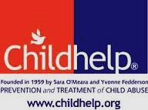
Our local or state Child Abuse Hotline is listed on your Tuition Contract and/or Enrollment Form. Parents of children who are/have been victims of abuse or neglect may contact local child advocacy websites, state child protective services, or local law enforcement to obtain assistance and/or intervention. A list of community child advocacy websites and other information concerning child abuse may also be obtained from your School Director.
National Child Abuse Hotline
1-800-4-A-Child (1-800-422-4453)
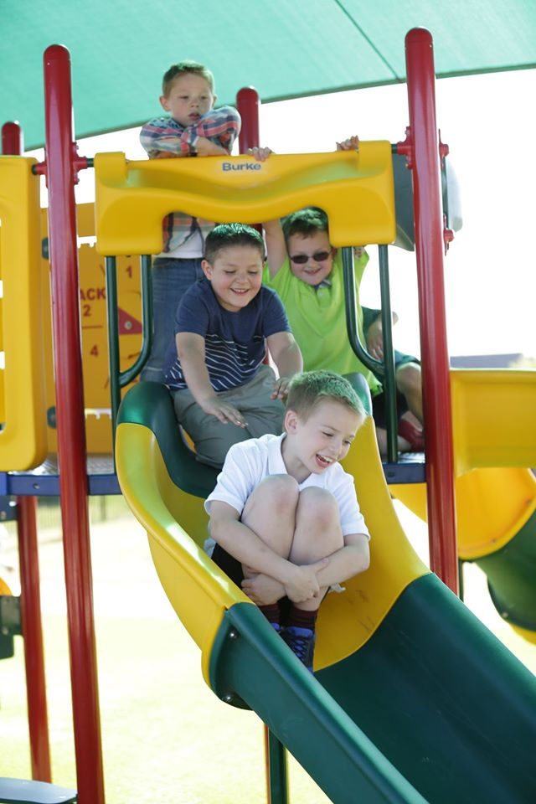

Medical Policies
We are committed to providing a safe environment for children, parents, and employees. All persons on our property must adhere to acceptable safety practices and standards.

Communicable Diseases
We value your child’s health and recognize the importance of preventing infectious diseases, particularly in a childcare setting. If any child in our care is diagnosed with a reportable disease, as specified by our state’s licensing agency or other government agency, parents/guardians of the other children will be notified. If you would like additional information about reportable diseases, please contact the School Director.

Coronavirus Disease 2019 (COVID-19) Information
Coronavirus (COVID-19) is an illness caused by a virus that can spread from person to person. The virus that causes COVID-19 is a new coronavirus that has spread throughout the world. COVID-19 symptoms can range from mild (or no symptoms) to severe illness. As of July 2020, there is currently no vaccine to protect against COVID-19.
To help mitigate the chance of children and staff contracting the coronavirus while attending our School, we adhere to all local, state, and federal sanitation, social distancing, and communications guidelines. Guideline examples may include teachers wearing face shields, minimizing families and visitors in the school, temperature screenings, lowering classroom group sizes, and social distancing, where appropriate. We will keep you apprised of any changes in mandatory or voluntary guidelines.

Illness: Signs, Symptoms, and Exclusion/Readmission Criteria
Please do not bring your child to School if he or she exhibits any of the following conditions and/or symptoms:
- Any reportable condition that a government agency or your child’s physician has determined to be contagious. In this instance, your child may return upon receipt of a physician’s release note;
- Any fever higher than the temperature allowed by our state’s licensing agency;
- Colored discharge from the nose;
- Constant, deep, or hacking cough;
- Sore throat with swollen tonsils or glands, white spots in throat, or throat that hurts when swallowing;
- Undetermined rash;
- Stomachache accompanied by vomiting, abdominal cramping, and/or diarrhea;
- Signs of conjunctivitis, such as redness or discharge from one or both eyes;
- Complaints of ear pain, followed by fever; and/or
- Head lice and/or eggs.

If any of these signs or symptoms appear while your child is at school, he or she will be kept separate from the group; and you will be contacted to arrange immediate pickup. In many cases, children will not be allowed to return until 24 hours have passed without symptoms. In specific regards to Hand, Foot, and Mouth Disease; if there are any current cases in our school and a child or staff member exhibits symptoms of the disease this will result in the child or staff member being required to be separated from others and will have leave the facility as soon as possible. They may not return until they have not had a fever for 24 hours AND all sores and blisters have healed. For more information on Hand, Foot, and Mouth Disease please visit www.cdc.gov/hand-foot-mouth/index.html.
To attend school, your child needs to be well enough to participate in group care, which means he/she must be able to follow his/her class’s daily schedule and activities without the need for one-on-one attention from the teachers.

Immunizations
A copy of your child’s current immunizations or a signed affidavit stating the reasons immunizations have not been given must be on file before your child may attend. NOTE: Most states require vision and hearing screening at the age of four; the School Director will furnish you with specific requirements for our state. Similarly, a TB test may be required, as well as other immunizations, depending on the location of our School and then-current requirements of government agencies.

Influenza Information
Influenza, commonly called “the flu,” is caused by a virus which affects the nose, throat, and lungs. According to the U. S. Center for Disease Control (CDC), influenza, unlike the common cold, can cause severe illness and life-threatening complications. Severe flu complications are most common in children under 2 years of age; however, children under the age of 5 commonly need medical care. “Flu Season” can begin as early as October and last as late as May. For additional information, please read the CDC publication, “The Flu: A Guide for Parents,” included in this handbook and/or contact the School Director for specific state guidelines regarding the influenza virus.

Handwashing
Handwashing is like a "do-it-yourself" vaccine. It involves five simple and effective steps – Wet, Lather, Scrub, Rinse, Dry – you can take to reduce the spread of diarrheal and respiratory illness so you can stay healthy. Regular hand washing, particularly before and after certain activities, is one of the best ways to remove germs, avoid getting sick, and prevent the spread of germs to others. www.cdc.gov/handwashing
We emphasize stringent hand washing and sanitation procedures (such as “covering” a cough), both as a part of our daily routine and as a specific part of our curriculum, beginning at age two.

Health Check
When appropriate, our staff may conduct periodic health checks prior the child’s admittance to the building, the classroom, and/or throughout the day. A health check is a visual and/or non-invasive physical assessment taken in order to identify potential concerns – such as signs or symptoms of illness or injury – about a child’s health. (Please refer to the previous section, “Illness: Signs, Symptoms, and Exclusion/Readmission Criteria” for a basic “health check” list.)

Medical Emergencies and Accidents
In case of an accident, care for the injured child is our first priority. If the emergency requires immediate attention, we will call 911. (Your emergency medical permission and preferred treatment facility is listed on your Enrollment Form.) If the injury requires treatment, but is not serious, you will be called to pick up your child and take him or her to your physician. Minor incidents or accidents, such as a splinter or skinned knee, will be treated, documented, and reported to you on the day of occurrence.

Medications
We recommend that you dispense medication to your child before or after the school day. (Most physicians can provide a prescription for 12-hour dosages of medication.) If medication must be dispensed at the School it MUST be a Life Saving Medication. NO over the counter medications will be giving. We will use the following guidelines:

LIFE SAVING Prescription medications must be in their original packaging or container and be clearly labeled with dispensing/dosage instructions and your child’s first and last name.

Nonprescription, or “over the counter” (OTC) medications will not be administed.

If your child has an adverse reaction to medication, we will document his or her symptoms and call you for immediate pick up.

All medication must be taken home every Friday or on the child’s last day of attendance. We will not store medications over the weekend, except in the case of emergency medications.

Provisional Medical Care
Our employees are required to meet the vaccination requirements of our local health department. All required vaccinations are kept in the employee’s file. Our employees receive CPR and first aid training as required by our state. Our employees are neither licensed nor trained to provide medical care. Our employees do not have authority to provide invasive medical treatments, determine medication dosages, or administer injections (except for a prescribed “EpiPen” or similar injection for the treatment of severe allergic reaction). Please ask the School Director if you have any additional questions about medical care.

Topical Medications
If our state’s licensing or other government agency requires physician approval for us to use topical medications/lotions such as sunscreen, insect repellent, diaper ointments, or teething gels on your child, the School Director will provide you with the appropriate forms. If sunscreen or insect repellent needs to be applied, directions must be provided in writing on the Sunscreen/Insect Repellent Permission form with the specific name of the product and times of applications. We are not able to share products among children. Our staff will assist in the application of the products and will keep the products in a safe and secure location, out of the reach of children.
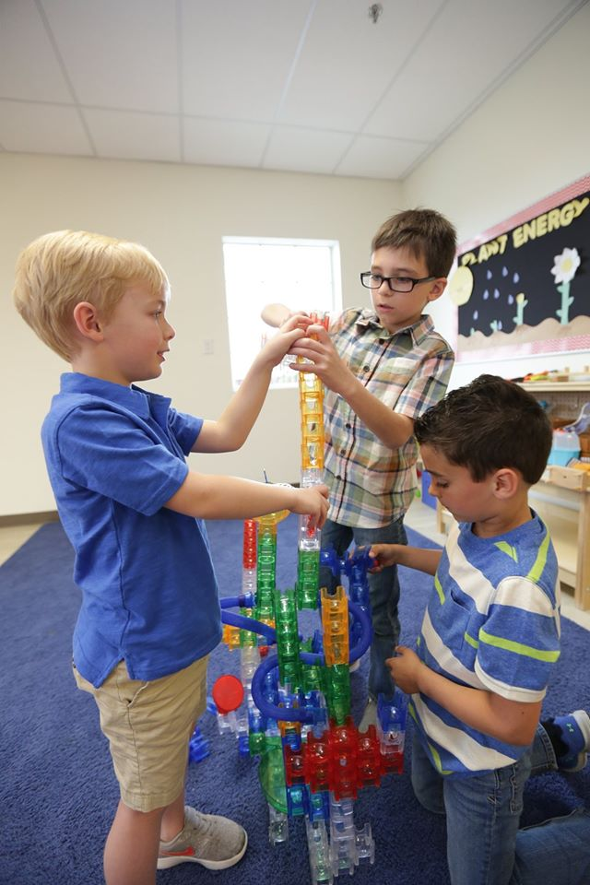

Health and Safety Policies

Animal Friends
Learning to care for an animal can be a positive influence on the development of such character traits as responsibility, helpfulness, and compassion. Our classrooms may include class pets, such as fish, hermit crabs, or hamsters; and veterinarian statements, when applicable, will be available for review. With prior notice, pets are welcome to visit the classroom for “Show and Tell;” however, unauthorized animals are not allowed in the building.

Appropriate Attire
To keep your child safe on the playground, make sure that he or she wears shoes that are rubber-soled and closed-toe, with either a closed heel or heel strap. Also, we are very active – both inside and outside – as we explore our environment. Please send your child in washable, durable play clothes. In addition, please send an extra set of clothing, clearly labeled with first and last name, to be kept in your child’s cubby – just in case. We are not responsible for lost clothing.

Biting
As you are well aware, biting is not an uncommon occurrence among young children. Biting may be used by the young child to compensate for his or her lack of language skills, in order to make his or her needs known, or as a simple expression of curiosity—I wonder what she tastes like. We take every precaution to minimize biting. Should you have any concerns regarding a biting incident, please contact the School Director. PLEASE NOTE: We adhere to strict confidentiality rules concerning the children in our care. We do not release the names of children or families who may be working through this developmental stage.

Breastfeeding
As a company committed to excellence in all areas, we will provide mothers who wish to breastfeed their new baby a comfortable, private area to do so in our facility.

Cleaning Procedures
We make every effort to ensure the safety of children from environmental hazards and pollution through the use of environmentally friendly supplies. Spraying for insects is done when children are not present and is done in a timely manner so that students will not be in the area immediately after treatment. All chemicals or cleaning agents are stored out of the reach of children.

Consumer Product Recalls
Parents may access recall information, which is typically posted on a weekly basis, at www.cpsc.gov. Recall notices will include pictures of the items, as well as procedures and contact information. In addition, you may sign up to receive email notifications from the CPSC at www.cpsc.gov/cpsclist.aspx. We encourage all parents to make sure there are no recalled products in the home.

Diapering Procedures
Teachers in our infant and toddler rooms are fully trained in safe diapering procedures, including proper sanitation of the changing area and hand washing for both teacher and child. In addition, teachers are required to wear gloves when changing diapers. Every diaper change is recorded on your child’s Daily Communication Log (described in “Parent Communication and Notifications” section). PLEASE NOTE: To ensure your child’s comfort, parents must provide diapers, baby wipes, and any needed diaper creams or ointments.

Emergency Preparedness Plans
Our School has plans for emergency evacuations in accordance with local and state requirements. All classes routinely practice fire and severe weather drills. Documentation of emergency plans and drills may be viewed in the front office. If you have questions regarding specific requirements, please ask the School Director.

Employee Restrictions
Our employees are selected solely on the basis of their performance in teaching within a CONTROLLED and FULLY SUPERVISED environment. Although our employees are discouraged from providing any type of “after hours” childcare services to our families, we are unable to prohibit such activities. PLEASE NOTE: If you engage any of our employees for services outside the employee’s work schedule at our Childrens Lighthouse School, we will not be responsible for any incident that may occur. In addition, we offer no assurances of fitness/qualifications of our employees in any situation other than our professionally supervised environment; and none should be implied or inferred under any circumstance.

Gang-Free Zone
A gang-free zone, which includes such locations as schools, playgrounds, and video arcade facilities, is an area in which a gang-related activity is subject to an increased penalty under individual state laws. These laws typically prohibit any type of gang-related criminal activity within 1000 feet of a school or childcare facility.

No Cash Policy
To ensure the safety of the children in our care as well as our employees, we do not accept cash payments, nor do we keep cash “on hand.”

Nutrition
Except as described below for infants and toddlers, we are proud to offer nutritious and delicious meals and snacks. Menus are available at the front desk. Documentation from a healthcare professional will be required to provide a replacement snack or meal for your child and you will be responsible for meeting his or her nutritional needs. We provide lunch, as well as morning and afternoon snacks.
Infants and toddlers are fed according to your instructions. We do not provide food for the infants in our care. Please complete the Infant Feeding Schedule and update it as needed or every 30 days, whichever comes first. Please let us know, as your child begins to eat “table food,” if you would like her or him to participate in our snack/meal program.

Quiet Time
Specific age groups have a scheduled time to relax and recharge. You may provide a small blanket for use during this time if your child needs a special “lovey.” Children who do not nap will be offered books to look through or other quiet activities. Ask your School Director if you have other questions regarding quiet time.
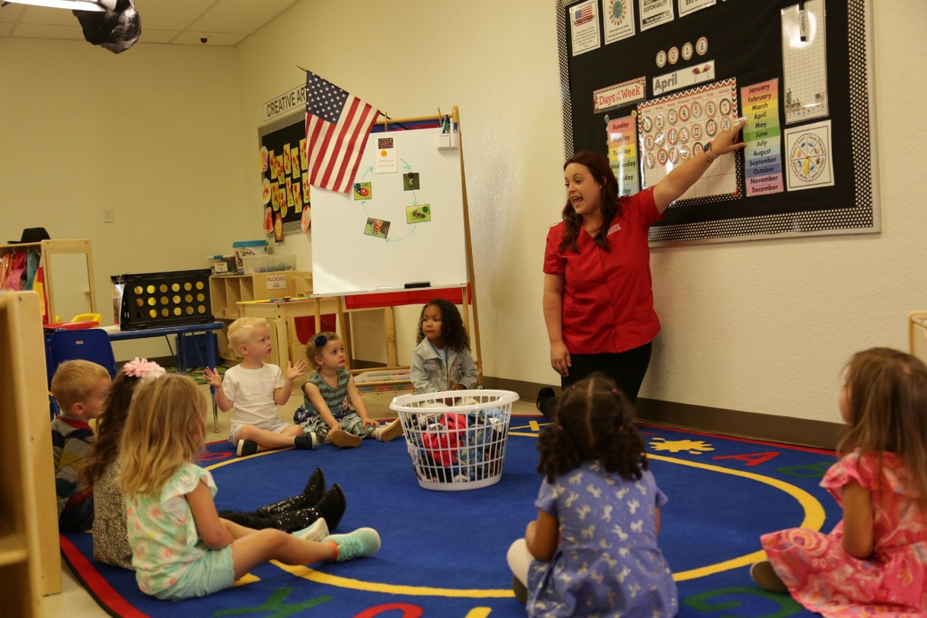

Safe Sleep Policy
Parents can review information on safe sleep and reducing the risk of Sudden Infant Death Syndrome or Sudden Unexpected Infant Death Syndrome (“SIDS” or “SUIDS”) at: http://www.healthychildren.org/English/ages-stages/baby/sleep/Pages/A-Parents-Guide-to-Safe-Sleep.aspx
All staff, substitute staff, and volunteers at our School will follow these safe sleep recommendations of the American Academy of Pediatrics (“AAP”) and the Consumer Product Safety Commission (“CPSC”) for infants to reduce the risk of SIDS or SUID):
- Always put infants to sleep on their backs, unless you provide an Infant Sleep Exception letter signed by the infant's health care professional.
- Place infants on a firm mattress, with a tight-fitting sheet, in a crib that meets the CPSC federal requirements for full size cribs and for non-full-size cribs.
- For infants who are younger than 12 months of age, cribs should be bare except for a tight-fitting sheet and a mattress cover or protector. Items that should not be placed in a crib include soft or loose bedding, such as blankets, quilts, or comforters; pillows; stuffed toys/animals; soft objects; bumper pads; liners; or sleep positioning devices. Also, infants must not have their heads, faces, or cribs covered at any time by items such as blankets, linens, or clothing.
- Do not use sleep positioning devices, such as wedges or infant positioners. The AAP has found no evidence that these devices are safe. Their use may increase the risk of suffocation.
- Ensure that sleeping areas are ventilated and at a temperature that is comfortable for a lightly clothed adult.
- If an infant needs extra warmth, use sleep clothing. Sleep sacks, sleepers or footed pajamas are required as an alternative to blankets.
- Place only one infant in a crib to sleep.
- Infants may use a pacifier during sleep. But the pacifier must not be attached to a stuffed animal or the infants clothing by a string, cord, ribbon, or other devise.
- If the infant falls asleep in a restrictive device other than a crib (such as a bouncy chair or swing, or arrives to care asleep in a car seat), move the infant to a crib immediately, unless you provide an Infant Sleep Exception letter signed by the infant's health care professional.
- Additional recommendations for SIDS reduction include the avoidance of exposure to spoke. Our childcare program is smoke-free. Smoking is not allowed in Childrens Lighthouse childcare operations (this also includes e-cigarettes and any type of vaporizers).
- Actively observe sleeping infants by sight and sound.
- If an infant can roll back and forth from front to back, place the infant on the infant's back for sleep and allow the infant to assume a preferred sleep position.
- Awake infants will have supervised “tummy time” several times daily. This will help them strengthen his/ her muscles and develop normally.
- Do not swaddle an infant for sleep or rest unless you provide an Infant Sleep Exception letter signed by the infants’ health care professional.

Smoking
Smoking, electronic smoking devices, and using smokeless tobacco are not permitted in school buildings, vehicles, or on or near the School property.

Toilet Training
When you are ready to begin toilet training your child, we are on your team! We have scheduled (and unscheduled) potty times for our toddlers and twos who are just learning to use the toilet. We will document your child’s progress on your Daily Communication Log.

Transportation: General
All employees who are responsible for transporting children are required to complete annual training. Our training addresses expectations for children, escorts, and drivers while participating in transportation activities and includes safe loading/unloading procedures, attendance procedures, safety and emergency preparedness, and state minimum standard requirements.
Children who will be transported in our School vehicles must also abide by rules to ensure their safety.
- Children must be on their best behavior and follow instructions before, during, and after any transportation to/from school or on a field trip.
- Hands must be kept inside the vehicle and to oneself. Children must allow the driver to open or close the vehicle door(s).
- Children must remain seated, facing forward with seat belts fastened while in the vehicle.
- Any child who does not follow these rules or any rules determined by the vehicle driver puts themselves in danger and may be denied transportation privileges. All behavioral incidents will be written and communicated by the School Director.

Transportation: Field Trips
Only children 5 years and older will be transported, on a fully licensed, inspected, and insured School van or bus, for field trips. Neither parent nor staff vehicles may be used to transport children. You will receive prior notification of scheduled field trips and will be required to complete written consent/permission forms for your child to be able to participate in any field trip.

Transportation: School-Age Children
We provide transportation to and from designated public and private schools in fully licensed, inspected, and insured buses or vans. School-Aged children who ride our vans/buses are expected to report to the bus immediately following school dismissal.

Water Activities
During the hot summer months, if we offer outdoor “splash play” water activities, parents will be sent a permission form to sign for any water activities that involve swimming and/or a lifeguard.

Weapons
We do not allow any type of firearm or other weapon to be carried on our property and/or any event sponsored by the School. An exception may be made for sworn law officers, if required by law. Please see the School Director if you need additional information.

Family Involvement

School Information Board
A statement of where to locate the school license, state and local inspections, and additional parent access information is located on the School Information Board in the front hallway. This board will also include the name of the person in charge of the School, a current list of employees, visitor information, and weekly menu.

Classroom Information Boards
Parent Boards, posted outside each classroom door, include, but are not limited to, the following types of information: teacher biographies and photos, “key learning” and scope and sequence posters (one each for fall, winter, and spring), daily schedule, and weekly lesson plans (if applicable).
The classroom Teacher Board, posted inside the classroom, includes the following types of information: state licensing ratio chart, student allergy list with photos, opening and closing procedures, cot assignment and numbering list, lesson plans, and daily schedules.

Daily Communication
The Daily Communications Log, which may be distributed as a “hard copy” or electronically, contains information for families of infants and toddlers concerning daily activities such as toileting, meals and snacks, naps, overall mood of the child, and classroom activities.

Parents/Guardians are responsible for ensuring that contact information (email address, phone number, address etc. is up to date.

School Websites
The Childrens Lighthouse website, http://www.childrenslighthouse.com, provides links to each individual school location. Childrens Lighthouse information and photos may also be accessed through this School’s Facebook page.

Parent Observations
We always maintain an open-door policy. We welcome parent visits and invite you to observe your child through the classroom hallway windows at any time; however, we do ask that you spend no more than five minutes in the classroom during “drop off” and “pick up” times to minimize disruption for the other children.

Parent Conferences
Conferences will be held periodically to discuss your child's progress and development. These conferences will be offered to parents to exchange information a minimum of 2 times per year. Please feel free to discuss any questions/concerns you have at any time with your child’s teacher. Your child’s teacher will be able to speak with you briefly, or you may make an appointment so that we can have someone cover his/her class for a more in-depth conference at any time. Information from teacher observations and written assessments is shared during these meetings.

Parent Surveys
Parent surveys are conducted at selected times throughout the year. Please take a moment to complete the parent survey so we may better serve your needs. Your opinion is important to us.
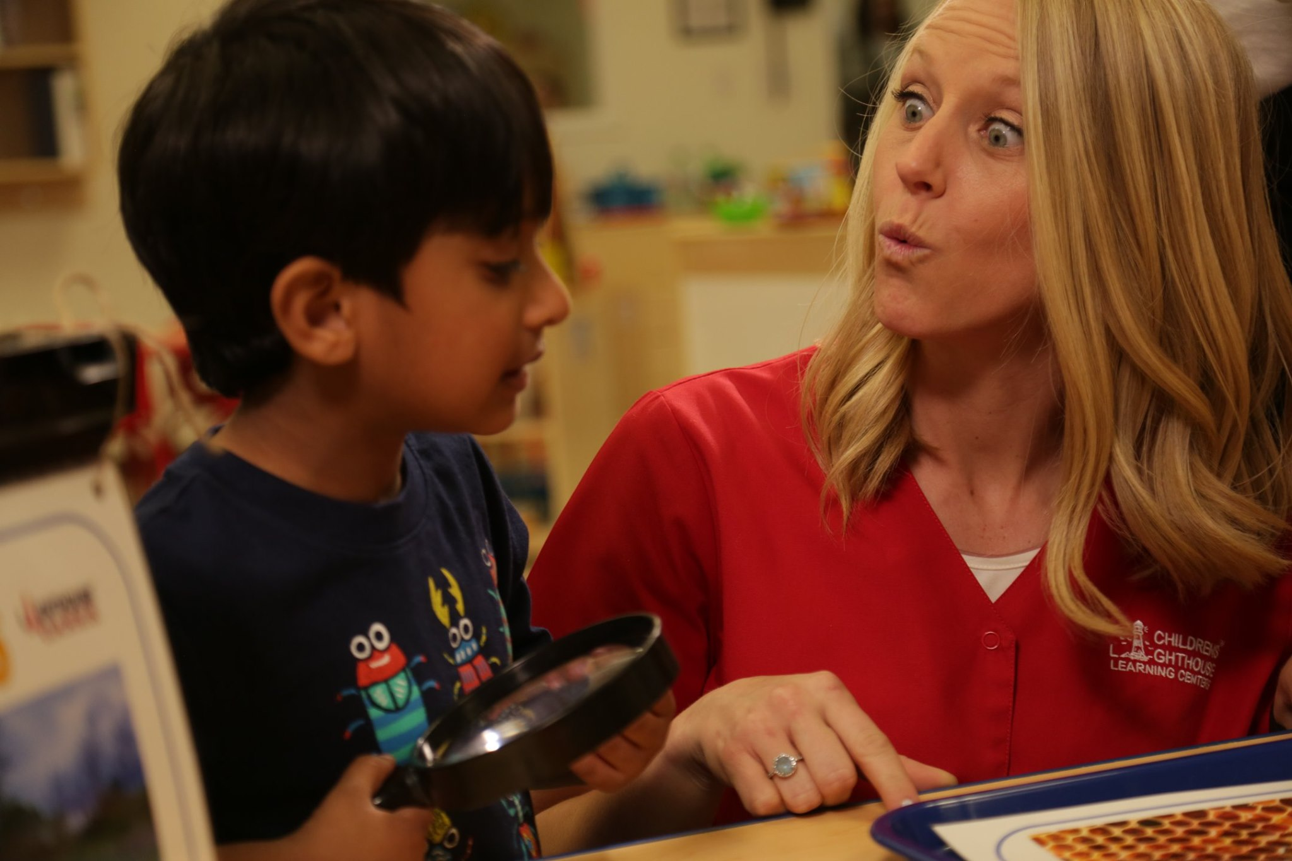

Opportunities for Family Involvement

Celebrations and Birthdays
Seasonal holidays, cultural celebrations, and birthdays are special days for our children and their families. In order to broaden our children’s cultural experiences, we encourage you to talk to the School Director about sharing your family’s unique traditions. If you would like to provide food for a special day, please make sure that your food is commercially packed, with all ingredients clearly listed, so we may safely accommodate our children with food allergies or dietary restrictions.

Special Events
We sponsor a variety of events for children and family participation, including annual book fairs, “Fall Fest,” Spring Fling,” and others. These events will be noted on the School’s annual and monthly calendars.

Classroom Visitors
Do you (or a family member) have a special skill, hobby, or talent that you would like to share? For example, we have been visited by a mother who played a musical instrument, a grandfather who was a beekeeper, and a father who raised chickens! Whatever your special gift, we would love to have you share it with your child’s class. Please contact the School Director for more information.

Collections
Because we value authentic, hands-on learning experiences, we are always on the lookout for interesting “stuff” to enhance our learning materials and “Prop Boxes.” For example, if your Monopoly® game is missing its cards, save the houses. We will use them for counters in our Math and Manipulatives Discovery Center.

Parent Concerns
If you have any concerns regarding your child or School policies and procedures, or if you would like to schedule a conference with your child’s teacher, please do not hesitate to contact the School Director.

General Information

Local, State, and National Inspections
Each Childrens Lighthouse School is licensed by the state in which it operates. Every school is visited/inspected and monitored by state and local licensing agents, along with additional fire and health inspectors, if applicable, per local and state regulations. These inspections typically focus on staff qualifications, facility and playground maintenance, health and safety guidelines, nutrition, record-keeping, and specified child to staff ratios. Parents may review these standards, as well as inspection reports, at any time with their School Director. In addition, School Directors will provide parents with essential local licensing contact information, such as telephone numbers and applicable websites.
State | Website | Phone Number
ALABAMA | http://dhr.alabama.gov/services/Child_Care_Services/Licensing_Overview.aspx | 334-242-1425 or  866-528-1694
CALIFORNIA | http://www.cdss.ca.gov/inforesources/Child-Care-Licensing | 800-952-5253
COLORADO | http://coloradoofficeofearlychildhood.force.com/oec?lang=en | 800-799-5876  Complaints: 303-866-5948
FLORIDA | https://www.myflfamilies.com/service-programs/child-care/child-care-licensure.shtml | Orange County: 407-552-0492 or 407-552-0493  Hillsborough County: 813-264-3925
ILLINOIS | https://sunshine.dcfs.illinois.gov/Content/Licensing/Welcome.aspx | 217-785-2509 or  312-814-6800
KANSAS | http://www.kdheks.gov/bcclr/ | 785-296-1270
NORTH CAROLINA | http://ncchildcare.dhhs.state.nc.us/general/home.asp | 919-527-6335 or  800-859-0829 (in-state only)
TEXAS | https://hhs.texas.gov/doing-business-hhs/provider-portals/protective-services-providers/child-care-licensing | Austin 512-834-3426  Houston 713-287-3238  Fort Worth 800-582-8286  Plano 469-229-6900 x6901

Volunteers
All volunteers, including parent/guardian volunteers, are subject to a criminal background check prior to volunteering with the School.

Insurance
A copy of this school’s Certificate of Liability Insurance is available for review. Please ask the School Director for more information.

Appendix 1: Contact Information

Childrens Lighthouse of Seabrook

2551 Humble Drive
Seabrook, TX 77586
281-909-4008

Appendix 2: The Flu: A Guide for Parents
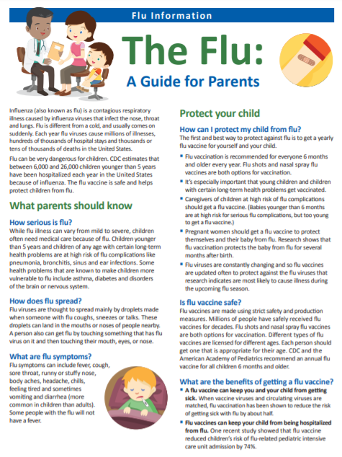
1Appendix 3: Parent/Guardian Acknowledgment of Receipt

I have read and fully understand the policies and procedures set forth in the Childrens Lighthouse Parent Handbook. In addition, I have received a printed or electronic copy of the Handbook for my personal reference.

Printed Name of Parent or Guardian

Signature of Parent or Guardian

Date

Please note that these are the standard procedures at our School. However, these procedures are subject to change as required by state licensing or other governmental authorities due to public health or other concerns.
Please note that these are the standard procedures at our School. However, these procedures are subject to change as required by state licensing or other governmental authorities due to public health or other concerns.

