[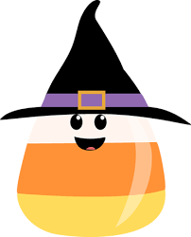](https://www.google.com/imgres?imgurl=https%3A%2F%2Fcontent.mycutegraphics.com%2Fgraphics%2Fhalloween%2Fcandy-corn-wearing-witches-hat.png&imgrefurl=https%3A%2F%2Fwww.mycutegraphics.com%2Fgraphics%2Fhalloween-graphics.html&docid=XsFO0TF7CMQorM&tbnid=mgg6L-blRucBJM%3A&vet=10ahUKEwiZ4L-cqbDlAhWiT98KHSDPAloQMwjLASg-MD4..i&w=363&h=450&bih=787&biw=1440&q=HALLOWEEN%20CLIPART&ved=0ahUKEwiZ4L-cqbDlAhWiT98KHSDPAloQMwjLASg-MD4&iact=mrc&uact=8)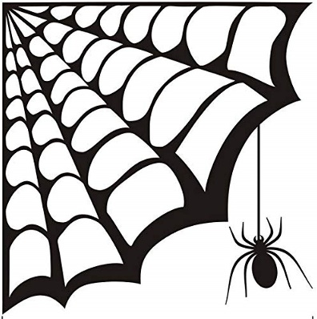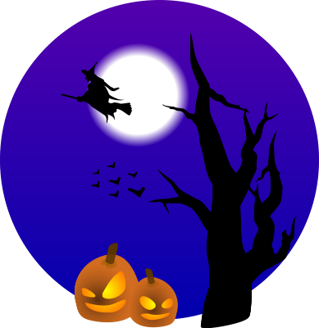



**SPIRIT WEEK**

**MONDAY, OCTOBER 25TH**

**PAJAMA DAY**

**TUESDAY, OCTOBER 26TH**

**Superhero Day**

**WEDNESDAY, OCTOBER 27TH**

**Disney Day**

**THURSDAY, OCTOBER 28TH**

**Orange and Black**

**FRIDAY, OCTOBER 29th**

**Wear your Halloween Costume**

**( Inside trick or treat)**

**(Classroom Parties)**