October | The Sailor’s Report
2017 | 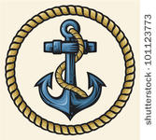
Sunday | Monday | Tuesday | Wednesday | Thursday | Friday | Saturday
1 | 2 | 3 | 4 | 5 | 6 | 7
 | Child Health Day! |  | 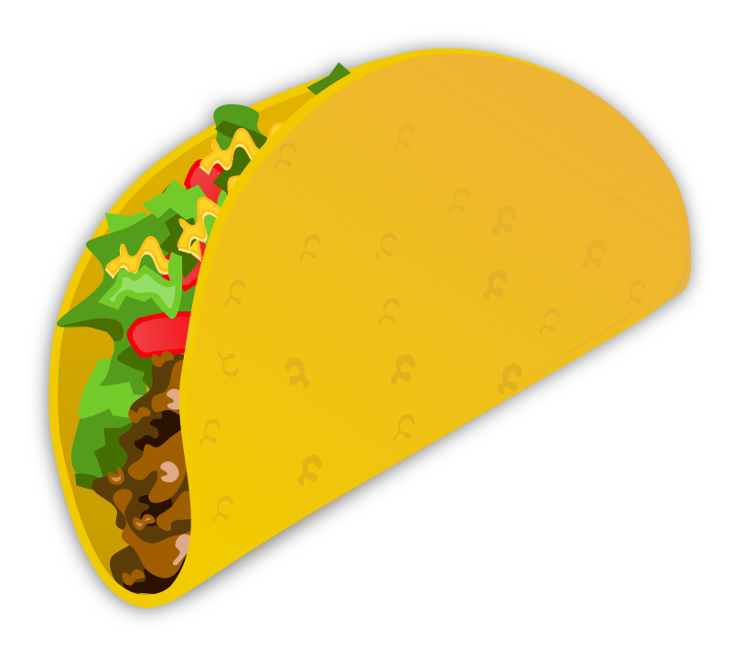  National Taco day! |  | National Mad Hatter Day!
8 | 9 | 10 | 11 | 12 | 13 | 14
 | Columbus Day! |  |  | Farmers Day!  Dress like a farmer. | 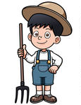
15 | 16 | 17 | 18 | 19 | 20 | 21
 |  | Pasta day!  Pasta art |  |  | Yummy fruit day!
22 | 23 | 24 | 25 | 26 | 27 | 28
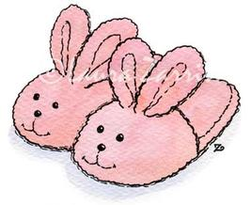 | PJ Day! |  |  | 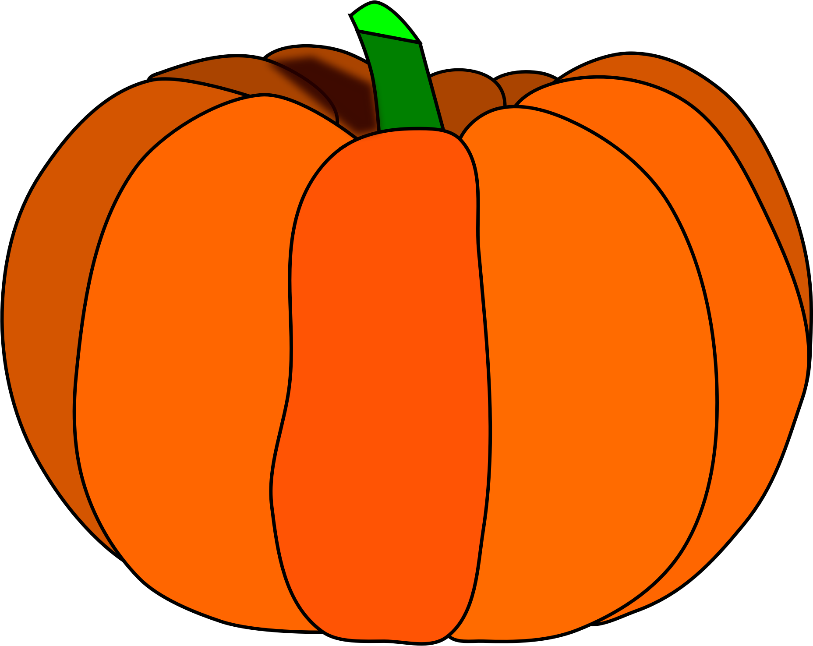  Pumpkin Day! | National Navy Day! | October Fest  10am-2pm
29 | 30 | 31 |  |  |  | 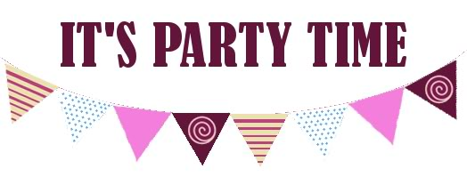
 | 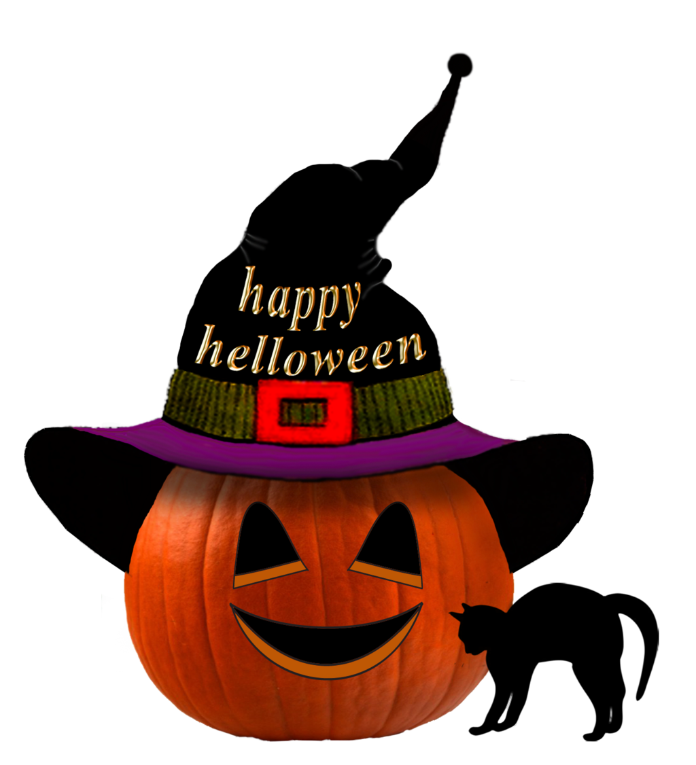 | Happy Halloween!

Make a hat and wear it on October 6th! | Dress like a farmer on October 12th! | October Fest is on October 28th from 10am-2pm for everyone to enjoy! Bring a bag and your costume! | Wear your costume on October 31st! | This month our classes will have a friendly class pumpkin competition! Don’t forget to vote. | Enroll in Soccer Shots today!

