October |  | Children’s Lighthouse of Sienna  281-778-2133
2021 | Fridge Calendar
C.A.R.E.S. Curriculum | Monday | Tuesday | Wednesday | Thursday | Friday | Infant/Toddlers Innovations
Careers | 27 | 28 | 29 | 30 | Show & Tell 1 | Color:
Our preschool classes will be exploring different careers all Month! |  |  |  |  | Rooms 6-8 Bring item from home that starts with the letter Bb. | Black & Orange
 | Make Fire Hats 4 | 5 | Wear Red! 6 | 7 | Show & Tell 8 | Shape:
National Fire Prevention Week |  | Sparky the Fire Dog Video |  | Make Thank You Cards for Firefighters! | Rooms 6-8 Bring something that starts with Rr.  Room 9 draw a Picture of something that begins with Rr. | Infants-Square  Toddlers- Circle
Community Helpers | 11 | 12 | Dentist Visit 13 | 14 | Show & Tell 15 | Sign:  Drink/Thirsty
Any person with our health and overall well-being. |  | The Great Pumpkin Patch | Community Helper Dress Up  (Rm 5-9) |  | Rooms 6-8 Bring something that starts with Ss.  Room 9 draw a Picture of something that begins with Ss. | Theme:  Infants- Trucks & Trains
Nocturnal Animals | 18 | 19 | 20 | 21 | Show & Tell 22 | Toddlers- Wheels
Animals who are active mostly at night. | Wheel painting  (Rm 3-4) | Candy corn counting  (Rm 6-9) | Spider web art  (Rm 6-9) |  | Rooms 6-8 Bring something that starts with Oo.  Room 9 draw a Picture of something that begins with Oo. | Toddler Spanish- Orange/Naranja
 | 25 | 26 | 27 | 28 | 29
Don’t forget to check take home folders every week! | Pumpkin art | Fall Sensory Bags (Rm 1-4)  Parent/Teacher Conference Rm 7 | Parent/Teacher Conference Rm 8 | Parent/Teacher Conference Rm 9 | Parade of Costumes  All Classes | 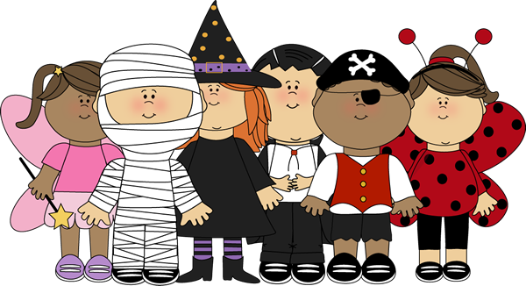

Character Value  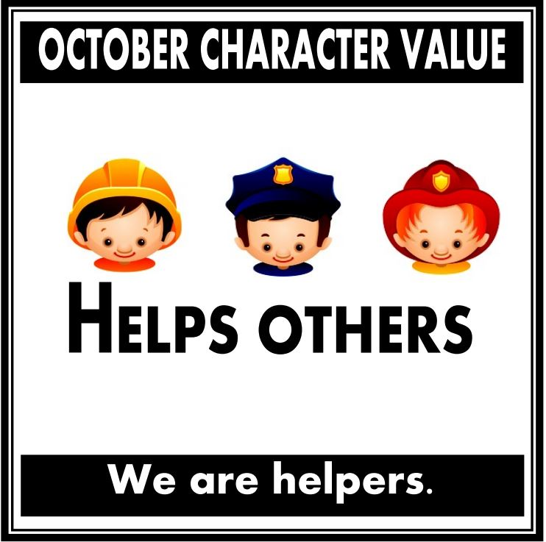 | C.A.R.E.S.  Letters of the Month  Bb, Rr, Ss, Oo | C.A.R.E.S.  Book of the Month | C.A.R.E.S.  Spanish Vocabulary  Dentist- Dentista  Spider- Arańa  Fireman- Bombero  Night – La Noche | 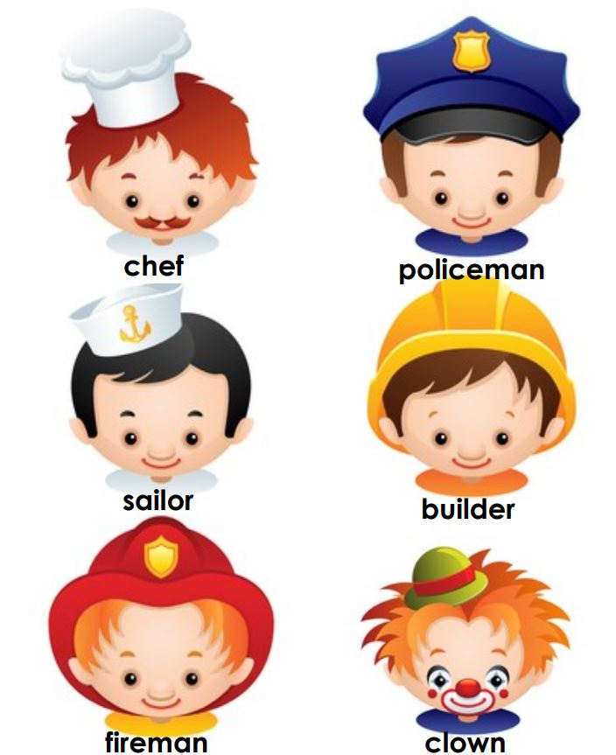  Community Helpers | Nocturnal Animals  Owls  Foxes  Bats  Racoons  Lemurs  Wolves

