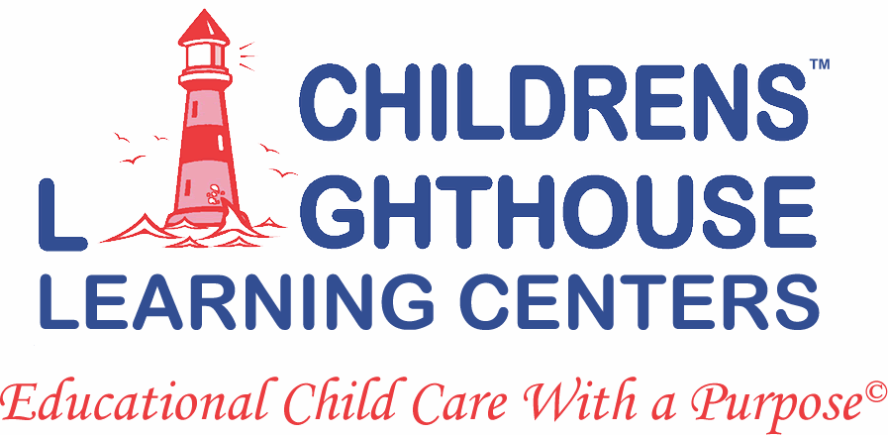

**Fun Days in October**

**10/11 Take your teddy bear to work day**

**10/13 Friday the 13th**

**10/16 Bosses day**

**10/21 National Pumpkin cheesecake day**

**10/30 Candy corn day**

**10/31 HALLOWEEN**

Class Halloween parties will be October 27th, 2017. Parties will start at 3:30PM. Look for your child’s classroom sign up on their classroom door.

**All items must be store bought with a list of ingredients. NO PEANUT PRODUCTS.**

**Congratulations to the Hawkins family for being our family of the month. Thank you for sharing and entrusting us with your sweet, sassy and spunky little girl, Malea. You guys are such a joy to have here at Childrens Lighthouse.**

**We would like to take a moment to thank ALL of our AMAZING teachers for all of their hard work and dedication. Without our ladies smiles, laughter and willingness to tackle anything, we would not be as strong as a team as we all are. THANK YOU LADIES! We truly appreciate you!**

**HAPPY BIRTHDAY TO YOU!**

**Levi Bett 10/11**

**Pierce Hill 10/27**

**Analeah Rico 10/3**

**Anashelle Thompson 10/12**

**Riley Bain 10/4**

**Jason He 10/16**



We will be having a pumpkin decorating contest! Staff and families! Limit 1 per family. Please drop off pumpkins at the front desk on Monday October 30th. The winner will be ribboned, Wednesday November 1st. Take home pumpkins Friday November 2nd, 2017.

**Pumpkin Decorating Contest**