November Menu
2023
Sunday | Monday | Tuesday | Wednesday | Thursday | Friday | Saturday
 |  |  | 1 | 2 | 3 | 4
Breakfast: 8:15-8:45AM  Lunch: 11:15-12:15AM  AM Snack: 2:15-2:45PM  PM Snack: 5-5:30PM |  |  | Breakfast: Unfrosted Pop tarts  Lunch: Fish sticks W/Mac & Cheese & Diced Pears  Am Snack: Goldfish  Pm Snack: Cheerios | Breakfast: French Toast W/ Syrup  Lunch: Frito Pie W/Green Beans & Fresh Cantaloupe  Am Snack: Graham Crackers  Pm Snack: Cheerios | Breakfast: Berry Kix W/ Chilled Milk  Lunch: Turkey Cheese Roll-ups W/Veggie Straws & Chilled Apple Sauce  Am Snack: Pretzels  Pm Snack: Cheerios
5 | 6 | 7 | 8 | 9 | 10 | 11
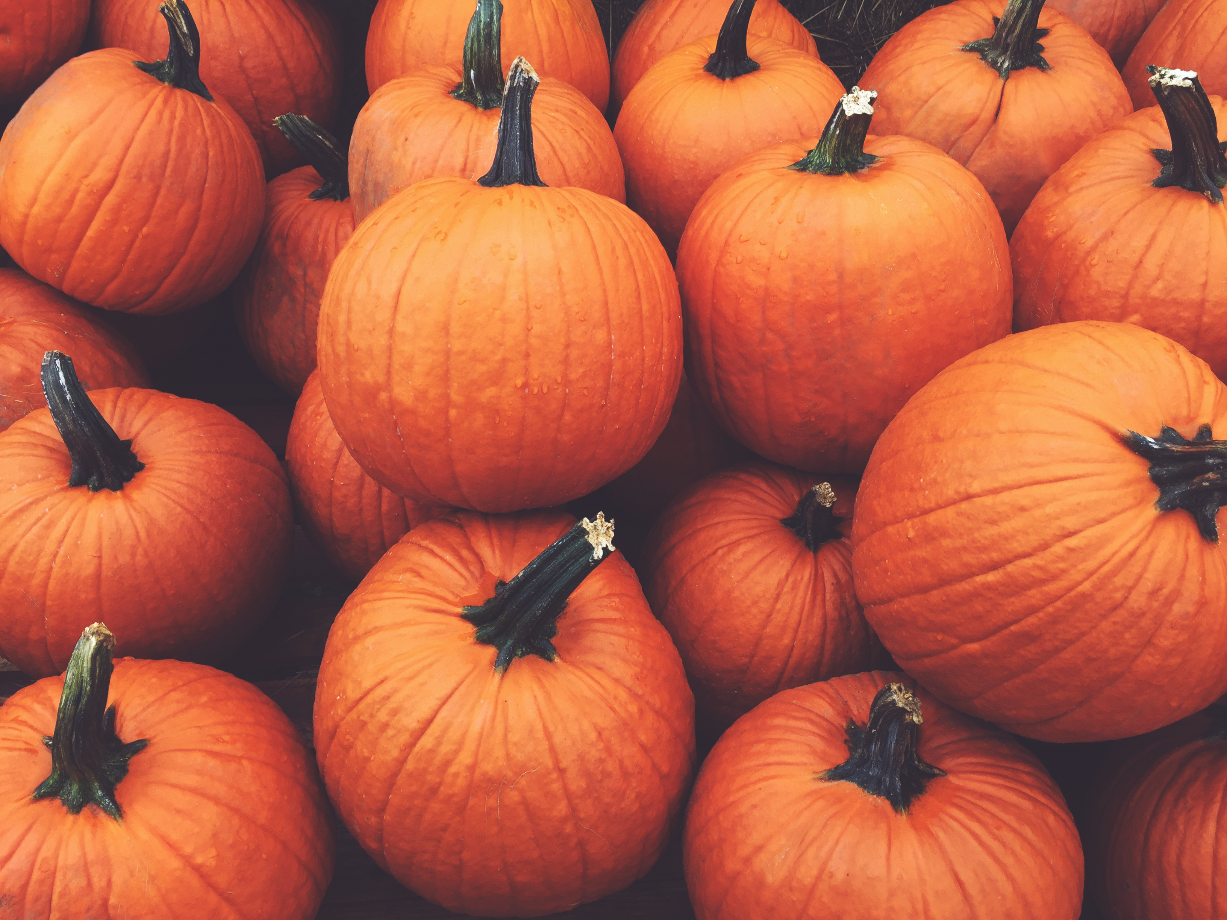 | Breakfast: Sausage W/Biscuits  Lunch: Smothered Chicken W/ Rice, Fresh Peas & Diced Peaches  Am Snack: Animal Crackers  Pm Snack: Cheerios | Breakfast: Strawberry Parfait  Lunch: Spaghetti W/Meatballs, Green Beans, & Fresh Sliced Apples  Am Snack: Cheez- It’s  Pm Snack: Cheerios | Breakfast: Potatoes & Sausage  Lunch: Chicken Nuggets W/Mashed Potatoes, Strawberries  Am Snack: Banana Bread  Pm Snack: Cheerios | Breakfast: Cheese Omelets  Lunch: Bean & Cheese Burritos W/Spanish Rice & Pineapples  Am Snack: Cheese & Crackers  Pm Snack: Cheerios | Breakfast: Berry Kix W/ Chilled Milk  Lunch: Turkey Cheese Wrap-Ups W/Carrot Sticks & Diced Apples  Am Snack: Grill Cheese Rollies  Pm Snack: Cheerios
12 | 13 | 14 | 15 | 16 | 17 | 18
 | Breakfast: Yogurt W/Grahams  Lunch: Baked Chicken W/Roasted Mixed Veggies & Mandarin Oranges  Am Snack: Jello Cups (Cheez It’s For Special)  Pm Snack: Berry Kix | Breakfast: Butter Biscuits W/Grape Jelly  Lunch: Beans & Rice W/Cheese Quesadillas & Blueberries  Am Snack: Chilled Apple Sauce  Pm Snack: Berry Kix | Breakfast: Cinnamon Maple Oatmeal  Lunch: Beef Taquitos W/Tots & Sliced Bananas  Am Snack: Various Muffins  Pm Snack: Berry Kix | Breakfast: Bagels W/ Cream Cheese  Lunch: Broccoli & Rice W/Beef Crumble & Sliced Apples  Am Snack: Cucumbers W/ Ranch  Pm Snack: Berry Kix | Breakfast: Cheerios W/ Chilled Milk  Lunch: Turkey Cheese Triangles W/Veggie Straws & Fruit Cocktail  Am Snack: Graham Crackers  Pm Snack: Berry Kix | 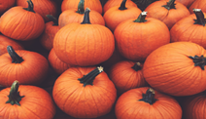
19 | 20 | 21 | 22 | 23 | 24 | 25
 | Breakfast: Toast W/ Hummus  Lunch: Chicken Spaghetti W/French Fries & Diced Peaches  Am Snack: Pretzels  Pm Snack: Life Cereal Squares | Breakfast: Cheesy Hash Browns  Lunch: Grilled Chicken W/ Mashed Potatoes, Corn & Diced Pears  Am Snack: Animal Crackers  Pm Snack: Life Cereal Squares | Breakfast: Turkey Sausage & Toast  Lunch: Thanksgiving Dinner  (Turkey Breast, Green Beans, Mashed Potatoes, Mac & Cheese, Cranberry Sauce, Diced Apples & a Roll)  Am & Pm Snack: Thanksgiving Brownies | 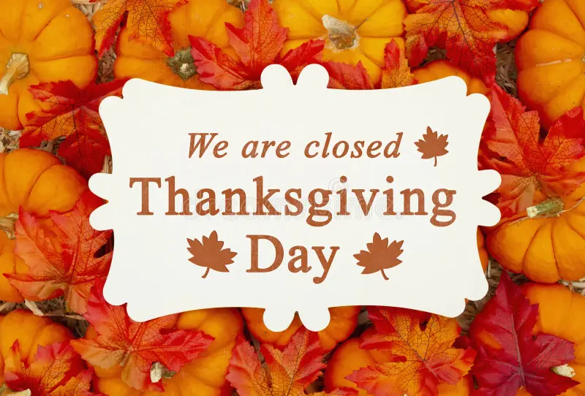
26 | 27 | 28 | 29 | 30
 | Breakfast: Unfrosted Pop tarts  Lunch: Chili Beans W/Rice, Green Beans & Mandarin Oranges  Am Snack: Goldfish  Pm Snack: Cheerios | Breakfast: Nutri-Grain Fruit Bar  Lunch: Fish Sticks W/ Mac & Cheese & Diced Pears  Am Snack: Various Muffins  Pm Snack: Cheerios | Breakfast: Bagels W/Cream Cheese  Lunch: Grilled Cheese Roll Ups, W/ Tomatoes & Cucumbers & Fresh Cantaloupe  Am Snack: Banana Bread  Pm Snack: Cheerios | Breakfast: French Toast W/ Syrup  Lunch: Frito Pie W/Green Beans & Fresh Cantaloupe  Am Snack: Graham Crackers  Pm Snack: Cheerios

