Theme: | Monday | Tuesday | Wednesday  1 | Thursday  2 | Friday  3
 |   7 | 8 | Room 1 Parent Teacher Conferences    Wear Fall Colors | Room 2 Parent Teacher Conferences  9 | Room 3 Parent Teacher Conferences  10
Food Drive:
6
Nov. 1st-17th
Bright Curriculum | Room 4 Parent Teacher Conferences  Disguise a turkey project sent home! | Room 5 Parent Teacher Conferences  14 | Room 5 Parent Teacher Conferences  15  Wear Fall Colors | Room 6 Parent Teacher Conferences  16  17 | Room 6 Parent Teacher Conferences
Food, food, food
13
Yellow
Rectangle

Cares Curriculum | Room 8 Parent Teacher Conferences  20 | Room 8 Parent Teacher Conferences  21  22 | Room 7 Parent Teacher Conferences  Wear Fall Colors | Room 7 Parent  Teacher Conferences  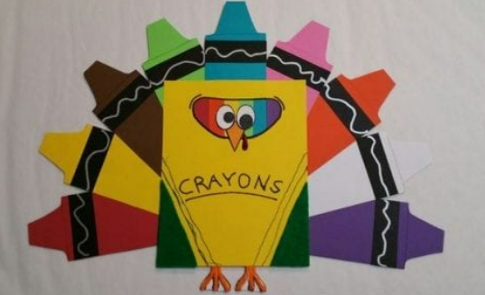  23  Disguise a turkey project due! | Pajama day!  A Charlie Brown Thanksgiving Movie Day    24
Fall, Forest Animals & Giving Thanks
F, I, G

QUEST | Thankful Hands!  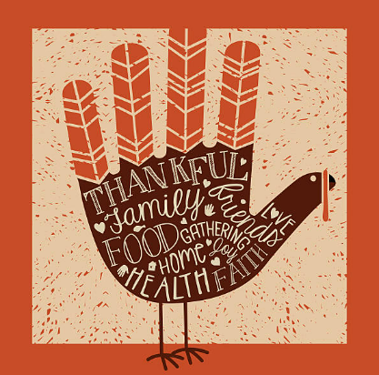  28 | 29 | Classroom 2-10  Thanksgiving Feast  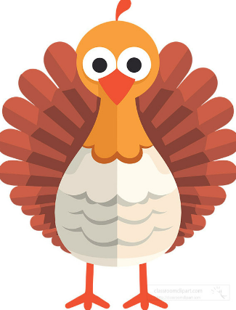 | Closed for Thanksgiving Holiday  30   | Closed for Thanksgiving Holiday
16 monthly S.T.R.E.A.M Challenges

27
Character Value | Room 9 Parent Teacher Conferences | Room 9 Parent Teacher Conferences  **Holiday Toy Drive Begins** | Make-Up Parent Teacher Conferences  Wear Fall Colors
Gratitude
Children’s Lighthouse at Grand Mission
281-232-7733 * gm@childrenslighthouse.com
7307 Grand Mission Blvd. Richmond, TX 77407
Children’s Lighthouse at Grand Mission
November 2023

