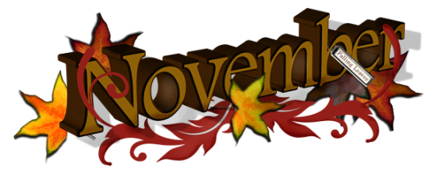
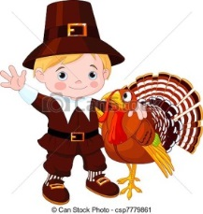
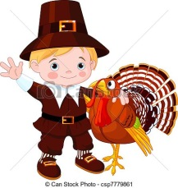

 | Monday | Tuesday | Wednesday | Thursday | Friday
November 1st - 3rd |  |  | B: : Biscuit, Peaches, Milk  L: Grilled Cheese Sandwich, Green Beans, Applesauce, Milk  S: Animal Crackers, Oranges, Water | B: Cheese Toast, Pineapples, Milk  L: Sloppy Joes with Ground Turkey, Peaches, Milk  S: Chex Mix, 100% Apple Juice | B: Mixed Cereal, Tropical Fruit, Milk  L: Pizza, Extra Cheese, Green Salad w/ Dressing, Mixed Fruit, Milk  S:Ritz Crackers, Apples, Water
November 6th- 10th | B: Frosted Mini-Wheat Cereal, Mixed Fruit, Milk  L: Beans and Cheese Burrito, Corn, Tropical Fruit, Milk  S: Saltine Crackers, String Cheese, Water | B:Cheese Toast, Pineapples, Milk  L: Chicken & Rice Casserole, Corn, Tropical Fruit, Milk  S: Nilla Wafers, Melon, Water | B: Blueberry Muffins, Peaches, Milk  L:Cheese Quesadilla, Peas, Tropical Fruit, Milk  S: Club Crackers, String Cheese, Water | B: English Muffins w/Jelly, Milk  L: Baked Ziti w/ Extra Cheese & Broccoli, Peaches, Milk  S: Carrot Chips w/ Ranch and Water | CLOSED  VETERANS DAY  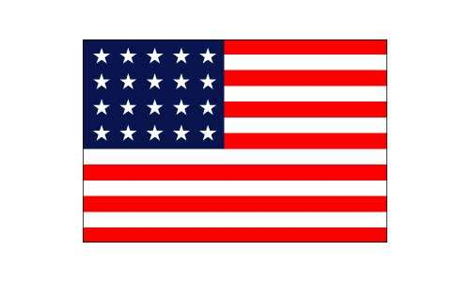
November 13th- 17th | B: Cheese Toast, Mixed Fruit, Milk  L: Chicken Nuggets, Corn, Applesauce, Milk  S: Cheez-Its, Apples, Water | B: Mixed Cereal, Tropical Fruit, Milk  L: Chicken Alfredo, Mashed Potatoes, Peaches, Rolls, Milk  S: Nilla Wafers, 100% Juice | B: Grits, Applesauce, Milk  L: Chicken & Rice Casserole, Corn, Tropical Fruit, Milk  S: Graham Crackers, Banana, Water | B: Oatmeal, Pineapples, Milk  L: Sloppy Joes with Ground Turkey, Peaches, Milk  S: Chex Mix, 100% Apple Juice | B: Blueberry Muffins, Peaches, Milk  L: Pizza, Extra Cheese, Green Salad w/Dressing, Mixed Fruit, Milk  S: Chex Mix, 100% Apple Juice
November 20 – 24 | B: : Frosted Mini-Wheat Cereal, Milk  L: Grilled Cheese Sandwich, Green Beans, Applesauce, Milk  S: Animal Crackers, Oranges, Water | B: Biscuit w/Jelly, Peaches, Milk  L: Spaghetti & Ground Turkey, Peas, Pineapples, Milk  S: Cheez-Its, 100% Apple Juice | B: Mini Croissants w/Jelly, Milk  L:Sliced Turkey, Green Beans, Stuffing w/ Gravy& Roll, Milk  S: Nilla Wafers, Oranges, Water | 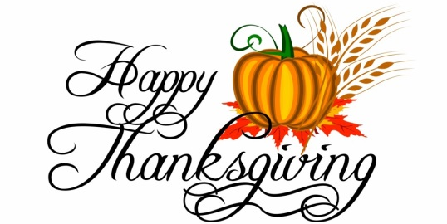  School is | closed
Nov. 27 – Dec. 1st | B: Cheese Toast, Pineapples, Milk  L: Sloppy Joes with Ground Turkey, Peaches, Milk  S: Chex Mix, 100% Apple Juice | B: Biscuits, Peaches, Milk  L: HM Mac-n-Cheese, Peas, Pineapples, Milk  S:Cheese-It, 100% Apple Juice | B: Pancakes w/syrup, Applesauce, Milk  L: Grilled Cheese Sandwich, Green Beans, Applesauce, Milk  S: Animal Crackers, Oranges, Water | B: Blueberry Muffins, Peaches, Milks  L: Chicken & Rice Casserole, Corn, Tropical Fruit, Milk  S: Graham Crackers, Banana, Water | B: Mixed Cereal, Tropical Fruit, Milk  L: Pizza, Extra Cheese, Green Salad w/ Dressing, Mixed Fruit, Milk  S:Ritz Crackers, Apples, Water
B: Breakfast L: Lunch S: Snack

