
November Birthday’s
11/01 – Grayson G.

11/01 – Jackson R.

11/02 – Isaiah T.

11/05 – Stetson G.

11/08 – Ella S.

11/11 – Maddox W.

11/12 – Benjamin T.

11/18 – Harper M.

All Month – November Pantry Clean Out Food Drive

11/01 – Happy 4yr. Anniversary Mrs. Denise

11/02 – Fall Back Daylight Savings Time Ends

11/3 & 4 – Mag & CISD Out

11/3-11/7 – Book Fair

11/11 – Veteran’s Day

11/14 – National PJ Day (Wear you PJ’s)
& PNO 6:30-9:30pm $25 CASH per child

11/18 –Mickey Mouse’s B-Day Wear Disney Attire

11/21 – St. Jude’s Turkey Trot
Pie With Parents@ 4pm

11/24th - 28th – MISD, MOGO & CISD Out

11/26 – CLOSING EARLY @3pm

11/27 & 28 – CLOSED Thanksgiving & Black Friday

Theme: Fall
Letters: Ff, Ii, Gg
Spanish and Sign: Tree / El Arbol
Book: Brown Bear, Brown Bear, What Do You See?
Character Value: Gratitude

November
2025

Theme: Food, Food, Food
Shapes: Rectangle
Color: Yellow
Character Value: Gratitude





Curriculum Monthly Themes

Upcoming Events
Children’s Lighthouse of Woodforest • 2183 Woodforest Pkwy NW • Montgomery, TX • 936-588-8999• ChildrensLightouse.com
Lighthouse Beacon
Children’s Lighthouse of Woodforest

Children’s Lighthouse Anniversaries

Craft Corner

Did you know!: Five Fun Facts About Owls
- Because of the shape and the size of their large eyes, owls cannot move their eyes to look around.
- Female owls tend to be slightly larger than male owls.
- Owls have specialized auditory functions that help provide acoustic information to locate and pursue their prey.

----------------------------------------------------

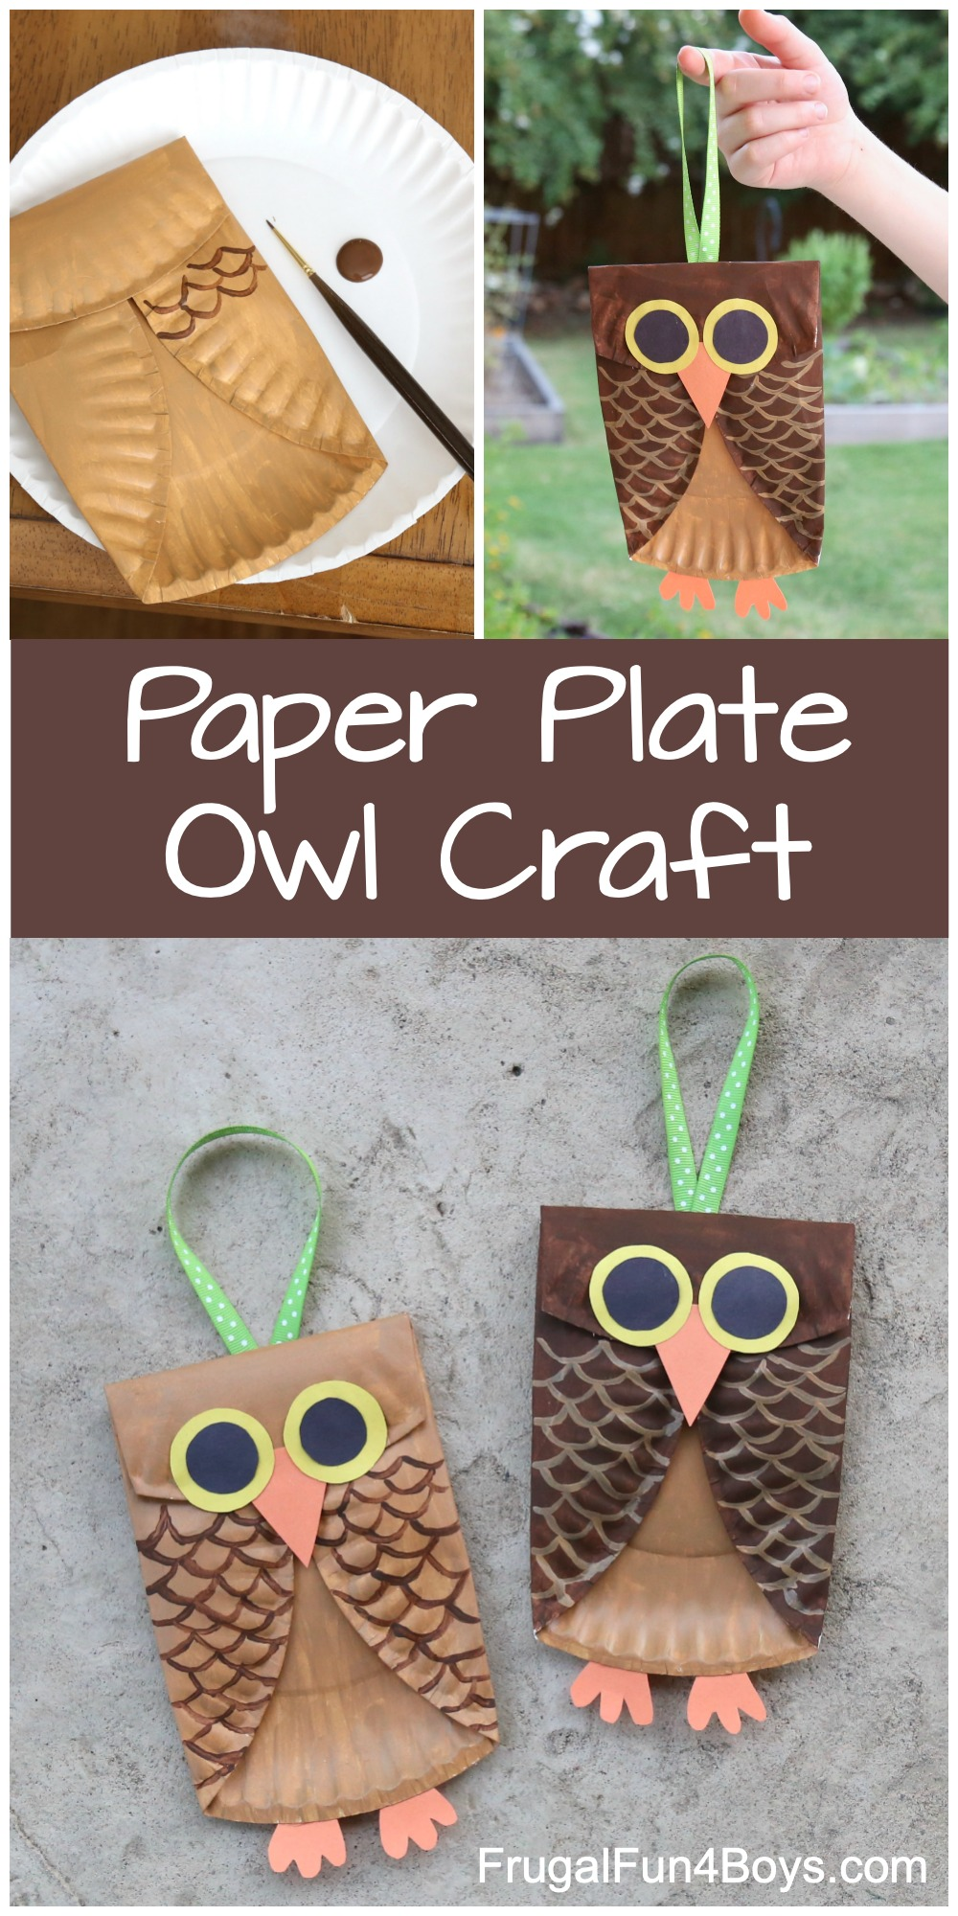
Supplies Needed:
- Paper plates – uncoated basic plates
- Paint – we used acrylic
- Construction paper
- Scissors
- Ribbon for hanging – optional
- Glue – Tacky Glue or hot glue
What to do:
1 – Fold both sides of the plate in toward the center.
2 – Then fold over the top of the plate to make the owl’s head.
3 – Now it’s time to paint. Open up the plate and paint the inside. Let it dry. Then fold the plate again and paint the head and wings
If you don’t have orange food coloring you can combine red and yellow.
4 – Use either hot glue or Tacky Glue to glue the wings and head down. Then paint feathers on the body. For younger kids, the feathers can be larger. There’s no wrong way to do this!
5 – Cut out the eyes, beak, and feet from construction paper.
TIP: Plastic caps are perfect when you need to draw a nice, round circle! I like to save plastic caps in a variety of sizes for crafting.
6 – Glue the eyes, beak, and feet to the owl’s body, and your owl craft is complete!
https://frugalfun4boys.com/paper-plate-owl-craft/



We would like to congratulate our valued employees for all their hard work and dedication. We appreciate all they do.

Denise Lusk 4 Years!

Friend us on Facebook
https://www.facebook.com/Childrens-Lighthouse-1753359808238757

Shout Out to November ’s Teacher of the Month

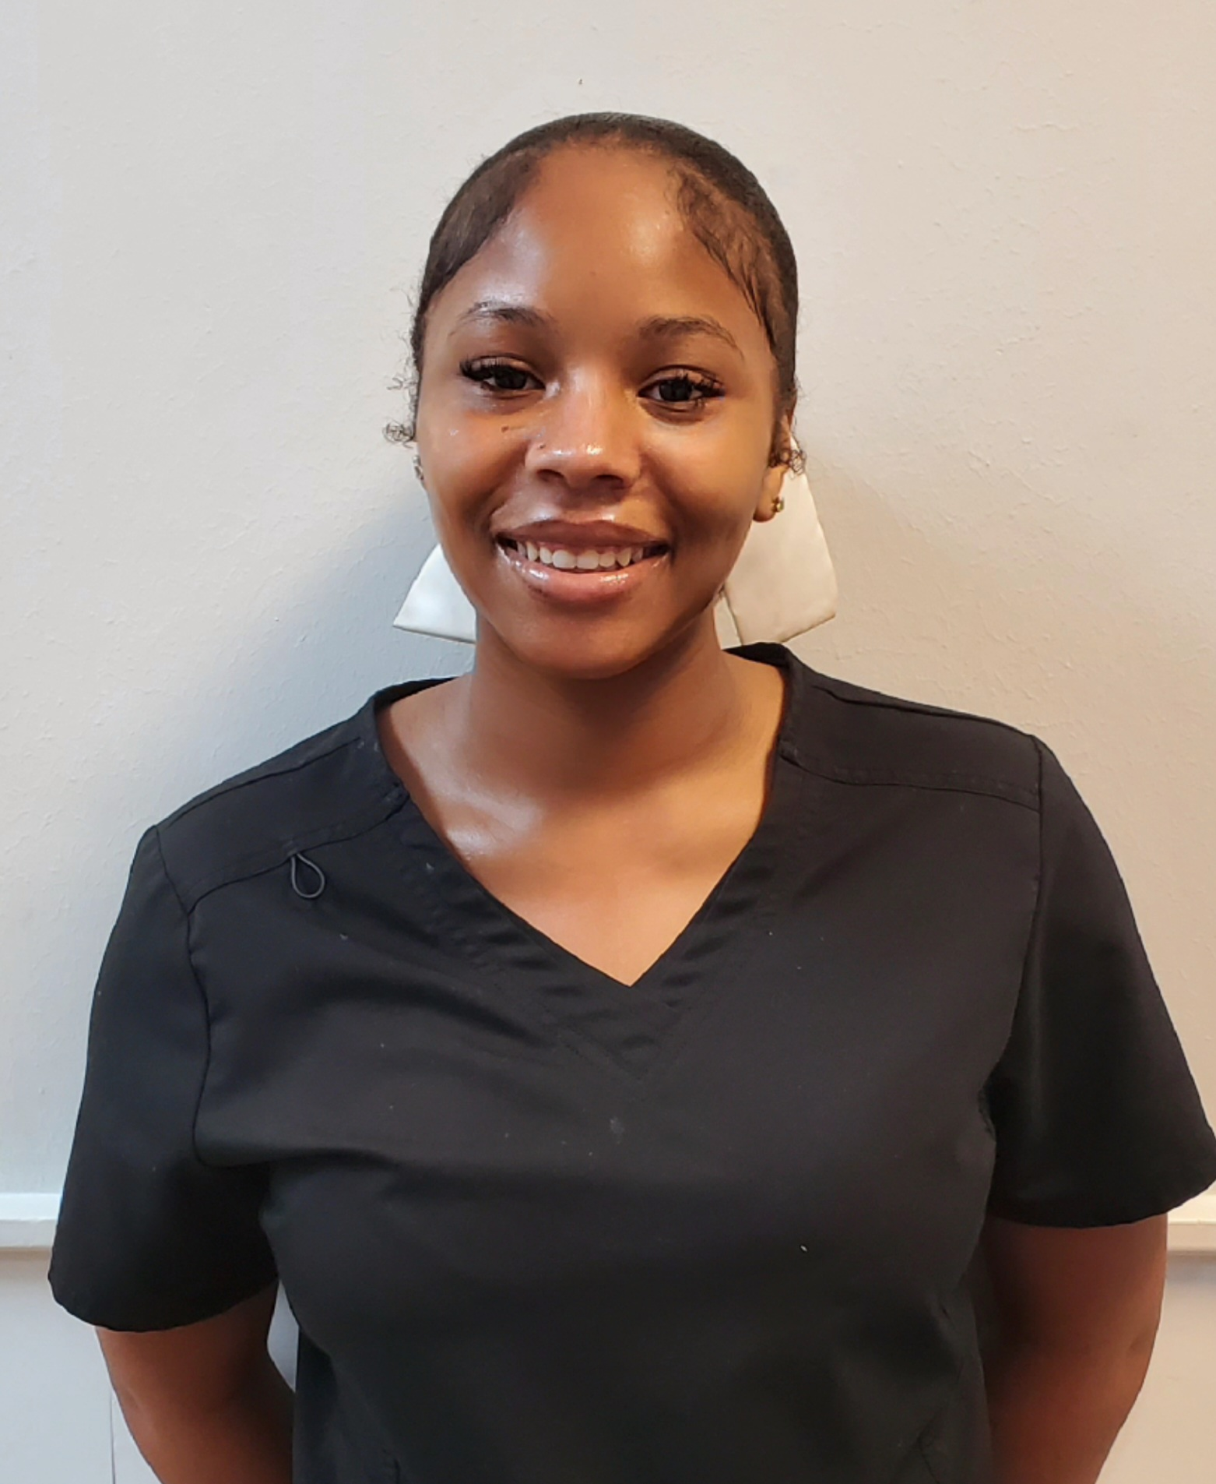

Thank you to Ms. Maia
Rm10

