Events and reminders | Monday | Tuesday | Wednesday | Thursday | Friday | Infants & toddlers Lighthouse Bright
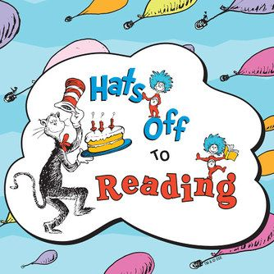 |   2. |  | 4. Pajama Reading Day   | 5.  Bring Your Favorite Book from Home   | 6.  Reading Picnic Day | 
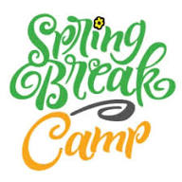 | 9. RM 10  Elevator Drop  Nature Self-Portrait  Wonder Ball | 10. RM 10  Island Ecosystem  Marble Run  Baseball  Rock Paper Scissors | 11. RM 10  Field Trip: Incredible Pizza  11:00am–1:00pm  230 S TX-336 Loop W  Conroe, TX 77304 | 12.  Toxic Waste Spill  Drawings That Float  Cup Stacking Relay | 13.  Petri Dish  Seafloor  Escape Room | 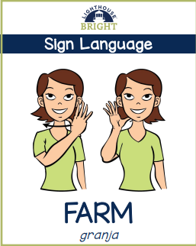
  As we prepare for our upcoming Garden Day, we are kindly asking families to donate potting soil and flower seeds to help us refresh and brighten our garden. Any contribution is greatly appreciated and will help make our planting day a success. Thank you for your support! | 16.  Make a Spring sensory Bin/bag  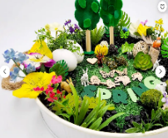 |   17. |   18. | 19.  Dress like a Dr. Seuss Character   | 20.  Plant a Rainbow  Garden Day    10AM/family picnic. | 
 |   23 | 24.   | 25.   |   26. |   27. | 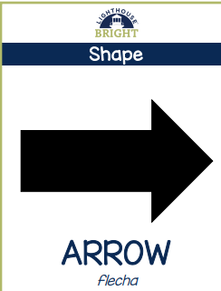
 | 30. | 31. | 1. |   2. | 3. | 


