March | The Sailor Report
2018
Sunday | Monday | Tuesday | Wednesday | Thursday | Friday | Saturday
 |  |  |  | 1 | 2 | 3
 |  |  |  | 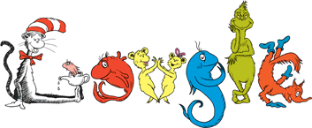 | Dr. Seuss Day!
4 | 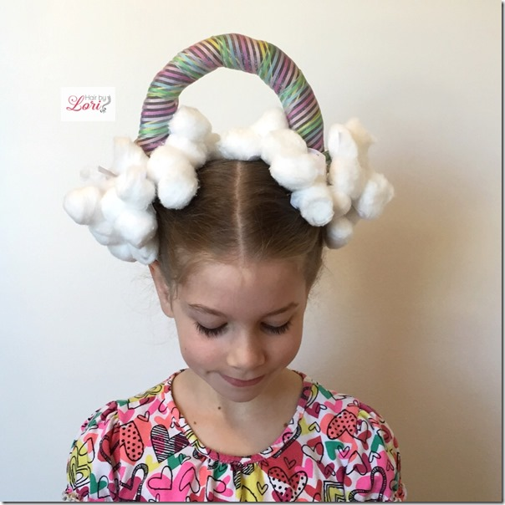  5 | 6 | 7 | 8 | 9 | 10
 |  | Silly Hair Day
11 | 12 | 13 | 14 | 15 | 16 | 17
 | Wear 80’s gear! |  | Schoolers Field Trip to Kangas | 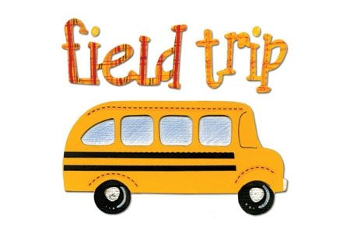
18 | 19 | 20 | 21 | 22 | 23 | 24
 |  | National Day of Happiness |  | World Water Day! | National Puppy Day! | 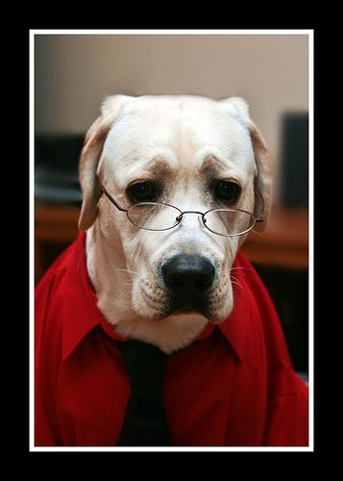
25 | 26 | 27 | 28 | 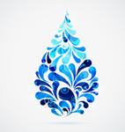  29 | 30 | 31
 | PJ Day |  |  |  | Closed Good Friday

Bring your favorite Dr. Seuss book to read with your class! | Wear 80’s themed clothing on march 12th. | After School children will attend a field trip to Kanga’s on March 14th at 8:00am. | Bring your pets photo to the school to show your class on March 23rd. | Wear PJ’s and be comfy on March 26. | The Children’s Lighthouse Learning Center will be closed Good Friday due to a mandatory corporate training.

