7/3 Mayson Davis 7/21 Ricardo D.

7/9 Gabriel Rodriguez 7/22 Hudson S.

7/10 Zoey Payne 7/24 O’mari R. .

7/10 Eleanor N. 7/27 Jordan M

7/11 Madison 7/30 Rylee S.

7/12 Analegih T. 7/30 Abigail D.

7/19 Ellie B. 7/30 Claire M.

7/21 Alanna I.

**Happy Birthday!**

As summer begins to wind down, we are looking forward to a great school year. Please be on the lookout in the following weeks for important dates pertaining to back-to-school details.

**Summer fun brings new forms and safety measures for our school. Please be sure to pick up a sunscreen / Insect Repellant Form for your child. Parents can choose whatever product they prefer. The Children should wear pool shoes (no crocs) on splash days and bring a towel along with a bag to carry the wet items back home. (Classrooms 1, 2 and 3 will**

**not participate in splash pad activities to ensure their safety.)**



[This Photo](https://helloliteracy.blogspot.com/2015/06/7-hidden-ways-to-keep-your-kids-reading.html) by Unknown Author is licensed under [CC BY-SA-NC](https://creativecommons.org/licenses/by-nc-sa/3.0/)

Assistant Directors:

Dayna Noski and Stephanie Kwiatkowski

School Director: Joanne Webster

Compass Newsletter

**Spring-Harmony**

Summer Fun!

**Director’s Corner**

July 2022

Childrens Lighthouse – Spring Harmony • 2885 Waterbend Cove Drive • Spring, TX • 832-813-8307 •

**JULY CURRICULUM OVERVIEW**

**Infants & Toddlers -Rooms 1,2,3**

This month we will be learning about: “Inside &Outside”

We will focus on the shape Octagonand the colors

red, white &blue.

We will be singing “Hokey Pokey”

The Sign Language focus word for this month is: Hurt

Spanish: Red: rojo, White: blanco, Blue: azul

**Toddlers Curriculum Overview-Room 4**

This month we will be learning about “Water”

We will focus on the shape Octagonand the colors

red, white, blue

We will be singing “Row Row Row your Boat”

The Sign Language focus word for this month is:

Turtle:la Tortuga, Inside: dentro, Outside:fuera, Dog: el perro

**Twos through Four’s Curriculum Overview-Rooms 5-9**

Character Value: Courage

Curriculum Theme: Summer Splash

Literacy Focus: Clifford Takes a Trip

Spanish:Trip “Vacaciones”

**School Age**

**Summer Camp Activities**

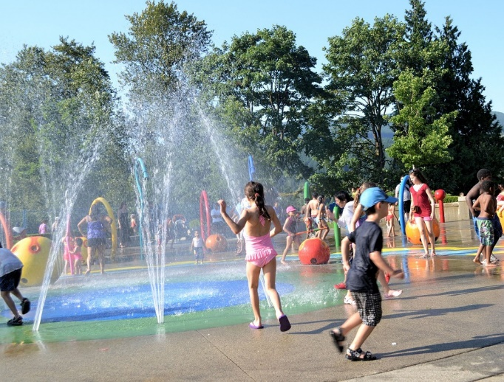

Splash Day Requirements  
  
Every child needs the following items to safely participate in splash day activities:

1. Swimsuit
2. Pool shoes or old tennis shoes (must be closed toe and have a back – no crocs)
3. Towel
4. Sunscreen (applied at home and the school)
5. Swim diaper for children who are not potty trained.
6. A re-useable bag / backpack that is labeled with child’s name for wet clothing/towels. (No grocery bags please).



**Friday July 29th**

**6:30 P.M.-11 P.M.**

**Help us Save Lives!**

**Please Join Our**

**Community Blood Drive**

**Wednesday**

**July 13th,2022 From**

**1:30 P.M.-5:00 P.M.**

**Childrens Lighthouse will be**

**Closed**

**July 4th in**

**Observance of**

**Independence Day**



Childrens Lighthouse – Spring Harmony • 2885 Waterbend Cove Drive • Spring, TX • 832-813-8307 •

**Splash Day!**