July | 2021
Sunday | Monday | Tuesday | Wednesday | Thursday | Friday | Saturday
 |  |  |  | 1 | 2 | 3
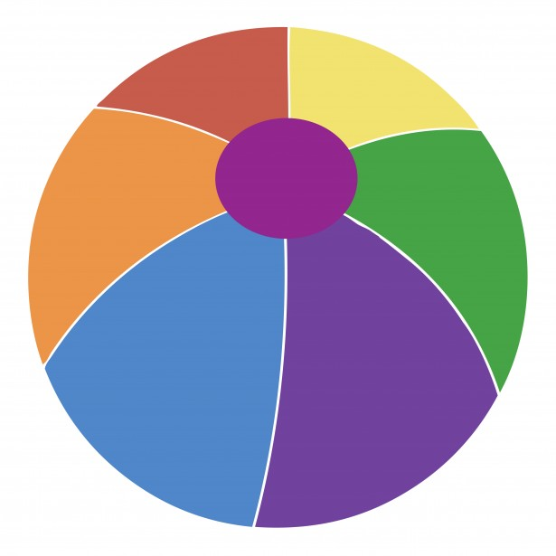
SPLASH PLAY
4 | 5 | 6 | 7 | 8 | 9 | 10
This Photo by Unknown Author is licensed under CC BY-ND | School Closed |  | National Strawberry Sundae Day | Popsicle Day | SPLASH PLAY
11 | 12 | 13 | 14 | 15 | 16 | 17
 |  | National Cow Appreciation Day |  | National Horse Day | SPLASH PLAY
18 | 19 | 20 | 21 | 22 | 23 | 24
 |  | National Moon Day
25 | 26 | 27 | 28 | 29 | 30 | 31
 |  |  |  |  | SPLASH PLAY

