MONDAY | TUESDAY | WEDNESDAY | THURSDAY | FRIDAY | FABULOUS FRIDAY
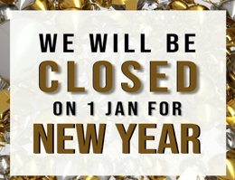  1 | 2 NEW YEARS CELEBRATION  Wear your best GOLD and BLACK ATTIRE | 3 Read the Mitten  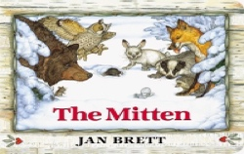 | 4 Raindrops, Raindrops Everywhere | 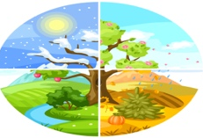  5 Four Seasons | 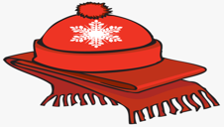  Wear your favorite WINTER HAT&SCARF
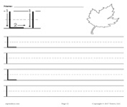  8 Letter of the Week L | 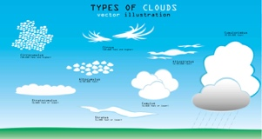  9 Types of Clouds | 10 My Snowflake | 11 "I Wonder Where All the Clouds  Go" | 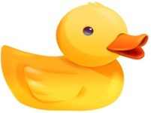  12 Rubber Ducky Day | Rubber Ducky Day  Wear YELLOW or your favorite  RUBBER DUCK shirt
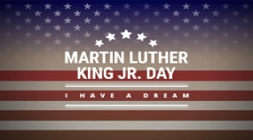  15 We will be OPEN | 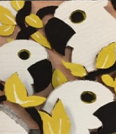  16 Black and White 3D Collage | 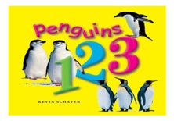  17 Read Penguins 123 | 18 WINNIE THE POOH DAY  Wear: RED for Winnie  PINK for Piglet  PURPLE for Eeyore  ORANGE for Tigger | 19 Penguin Awareness  Day | Dress like a Penguin.  Wear BLACK and WHITE or a PENGUIN shirt
22 It's Raining, It's Pouring | 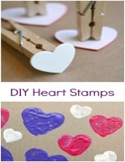  23 Heart  Stamping | 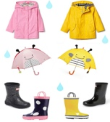  24 Rainy Day  Dress Up | 25 Magnets | 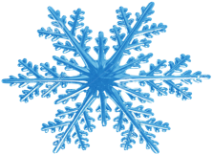  26 Snowflake Drop | 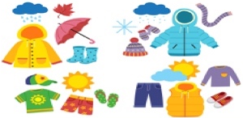  Wear your SEASON shirt/attire
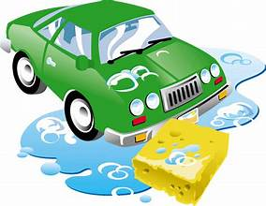  29 Car Wash | 30 Star | 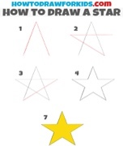  31 I Can  Draw a  Star! | 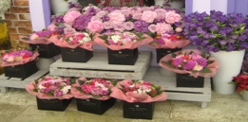  1 Flower Shop | 2 No Place Like Space! | Wear your  best PINK  and RED  attire
Monthly Themes

Infants
Up in the Air and Sky

Toddler
Up in the Air and Sky

CARES
Seasons,
Weather,
Artic Animals
and Magnets

Character Value
Diversity
McKinney

