Families,

Please stop by the front desk to update your child/children’s Enrollment Annual Forms

Monday January 16th

**Ms. Marlen Hernandez**

**Thank you for all you do for our school**

**and our Lighthouse family.**

**You are valued and appreciated.**

**The Little Beacon**

**Newsletter**

Imperial-Sugarland • 15013 Voss Road • Sugarland, TX • 281.207.6845 • childrenslighthouse.com/imperial

**Enter Text**

Imperial-Sugarland • 15013 Voss Road • Sugarland, TX • 281.207.6845 • childrenslighthouse.com/imperial



**Curriculum Corner**

**Infants 1 & 2**

This month’s theme is **Up in the Air and Sky**.We will focus on the shape **Star** and the color **Blue**.   
We will learn the song and rhyme:  
“**Mister Moon” and “I Wonder Where the Clouds Go”.**  
The Sign Language and Spanish word for this month is: **Star-La Estrella, Blue- Azul**

**Infant 3**

This month’s theme is **Up in the Air and Sky**.  
We will focus on the shape **Star** and the color **Blue**.   
We will learn the song and rhyme “**Mister Moon” and “I Wonder Where All the Clouds Go”.**  
The Sign of the month is **Star**:

The Spanish words for this month are:   
**Blue-Azul, Star-La Estrella, Sun-El Sol, Moon-La Luna,Cloud-La Nube**

**Toddlers**

This month’s theme is **“Up in the Air and Sky”**  
We will focus on the shape **Star** and the color **Blue.**We will learn the song and rhyme **“Mister Moon” and “I Wonder Where All the Clouds Go”**The Sign Language and Spanish words for this month are:   
**Blue-Azul, Star-La Estrella, Sun-El Sol,Moon-La Luna, Cloud-La Nube, Snow-La Nieve**

**Preschool & Pre-Kindergarten**

The character Value is **“Diversity”**This month’s themes are **“Seasons”, “Weather” “Arctic Animals”** and **“Magnets”.**  
We will focus on the Reviewing the letters: **Jj, Ll, and Pp.**The Book of the month is **“Alphabet Book: Penguin ABC”**   
The Sign Language and Spanish words for this month are:  
**Weather-El Tiempo, Peace-La Paz, Penguin- El Pinguino, Snow- La Nieve**

**School Age Questers**

Children will focus on completing school work assignments and move on to Quest Challenges.  
Quest Challenges this month include **“Hoop it Up”, “Marble Run”, “Straw Sculpture”,** and more!



**December 18th**

**National Winnie the Pooh Day!**

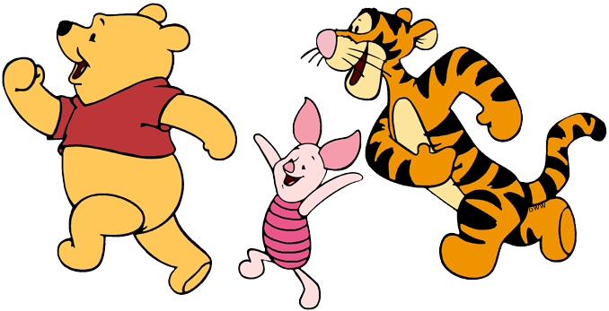

**Maverick P- 2nd**

**Ms. Jocelyn- 6th**

**Myla G.-8th**

**Adam A.-9th**

**Alex T.- 16th**

**Ms. Cherrie-17th**

**Elijah O.-17th**

**Ms. Leen-18th**

**Sir G.-21st**

**Sydney S.-26th**

**Noah F.-30th**

**Piper B.-31st**

**December 19th**

**National Popcorn Day!**

**Enjoy popcorn for snack!**



**Our color of the month is blue, so everyone come dressed in Blue on Thursday, January 5th!**

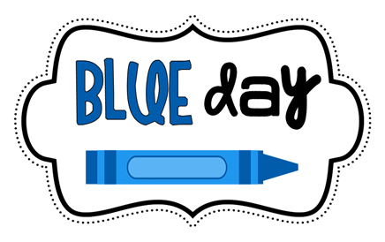



**January 9th is National Law Enforcement Appreciation Day!**

**Scheduled law enforcement visit where police offiers will get to talk to the children about their duties and students will show appreciation with school made banner!**

**Friday January 20th 6:30pm-11:30pm**

**$40 per child $35 for siblings Dinner provided!**

**Leave the kiddos with us and enjoy a date night**

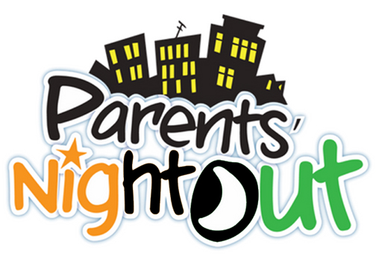

**Friday, December 30th -**

**School Closes @ 3pm**

**Monday, January 2nd - School Closed**

**Upcoming January Events**

January 2nd- Center Closed

January 5th- Wear Blue for Color of the Month

January 9th- National Law Enforcement Day

January 16th- Martin Luther King Jr. Day

January 18th- National Winnie the Pooh Day

January 19th- National Popcorn Day

January 20th- Parents Night Out

**December Recap!!**

