

Theme: Seasons
Letters: J L P
Spanish & Sign: Snow
Book: ABC Book / Jan Brett
Character Value: Diversity

01/01 – Logan W. 01/23 – Brooklyn H.
01/03 – Colby H. 01/24 – Blake M.
01/10 – Emerson K. 01/25 – Curtis S.
01/12 – Joao G. 01/31 – Cece P.
01/13 – Margaux B.
01/13 – Nolan B.
01/14 – Everett W.
01/14 – Ava P.
01/15 – Samuel L.
01/17 – Hank H.
01/19 – Preston W.
Community Challenge: Read all about it
Character Value: Diversity
January’s Birthdays

Theme: Up in the air
Shape: STAR
Color: Blue
Character Value: Diversity

Curriculum Monthly Themes

CONROE ANIMAL SHELTER DONATIONS ALL MONTH
01/01 – New Years Day CLOSED

01/02 – CLOSED

01/05 – Blake Magic Show

01/06 – National Cuddle Up Day (Wear your PJ’s)

01/07 – Happy 4 Year Anniversary Mrs. Karen!

01/09 – Law Enforcement Appreciation Day

01/15 – Happy B-Day Mrs. Stephanie!

01/16– National Hat Day (Wear your best hat)

01/19 – Martin Luther King Day
(ALL ISD’s OUT)

01/20 – Happy B-Day Mrs. Kelly!

01/21 – National Hugging Day (Hug a friend)

01/22 – Polka Dot Day (Wear your DOTS)

01/23 – Happy B-Day Coach Ashton

01/27 – National Chocolate Day

01/30 – National Backward Day (Have fun dressing up)

January
2026
Upcoming Events
Children’s Lighthouse of Woodforest • 2183 Woodforest Pkwy NW • Montgomery, TX • 936-588-8999• ChildrensLightouse.com
Lighthouse Beacon
Children’s Lighthouse of Woodforest

Children’s Lighthouse Anniversaries
Craft Corner

Ring In 2026 With - NEW YEAR’S FIREWORKS RINGS!!!

- Lets try these quick and easy fireworks rings!
- They make adorable jewelry to wear to fireworks displays or parties on New Year’s Eve

----------------------------------------------------

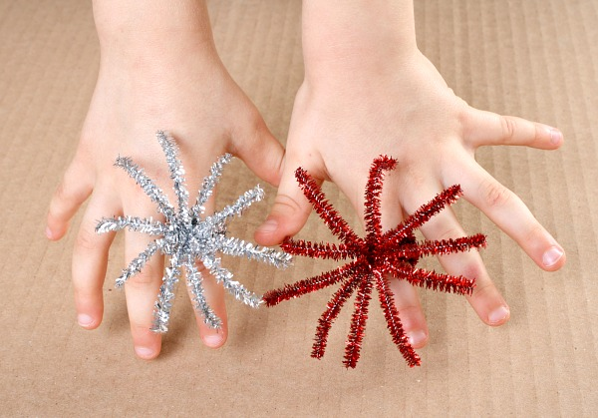
Supplies Needed:
Red tinsel stems
Silver tinsel stems

What to do:
- Cut the tinsel stems in half to make 6 pieces of equal length.
- To make one ring, gather five of the stems and fold them in half.
- Leave enough of a circle to fit the child finger. You may need to shape it into a circle a bit.
- Then wrap the sixth stem around a couple of times to secure the ring. Be sure the ends lay flat so they don’t poke the child’s finger.
- Turn the ring so the loose ends face up and bend them slightly into the shape of a burst of fireworks. Leave the stems raised enough so they aren’t poking into the child’s hand.
- Repeat and make fireworks rings in all of your favorite colors!

https://www.fantasticfunandlearning.com/fireworks-ring-craft.html
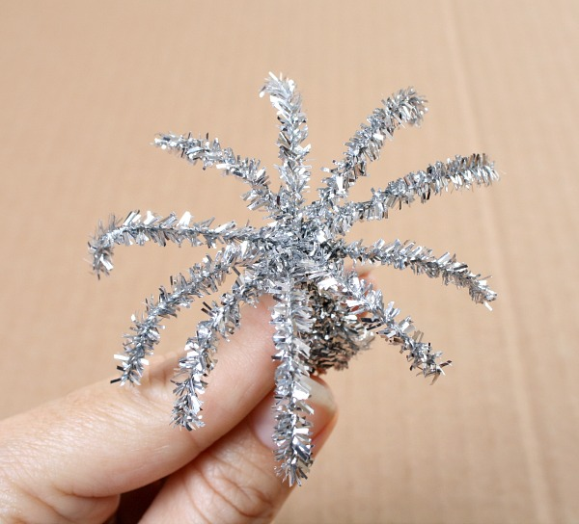

We would like to congratulate our valued employees for all their hard work and dedication. We appreciate all they do.

Ms. Karen R. 4 YEARS!!!!

January’s Family of the Month – The Galloway’s

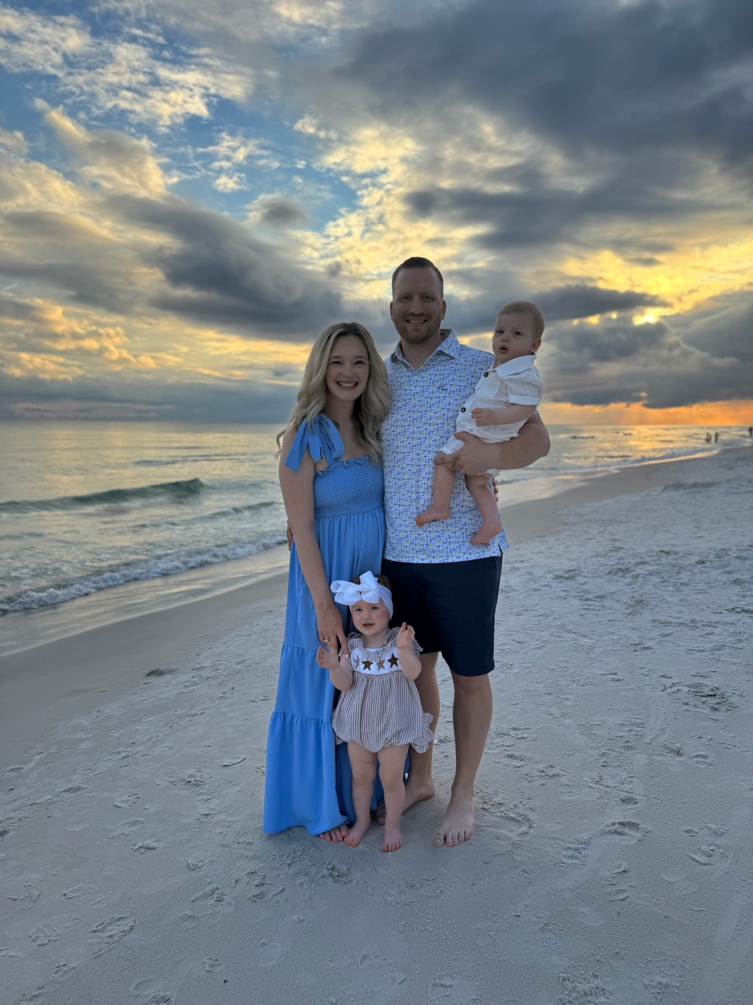

Our family includes Mom, Hayley, who works as a commercial real estate appraiser, and Dad, Andrew, who is in lumber sales. We have two young children, Steele, who is two years old, and Stetson, who is 13 months old, who keep us busy and laughing every day. Our family is completed by our two dogs, Gunner and Steiner. Together, we love going on walks, spending time at the park, and traveling to visit our friends and family.

Shout Out to January’s Employee of the Month



Thank you to Mrs. Emma
Administrative Assistant
Friend us on Facebook
https://www.facebook.com/Childrens-Lighthouse-1753359808238757

