



**January 2022**

Important Dates

**January 1- Happy New Year! Hello 2022**

**January 5- National Bird Day**

**January 17- Martin Luther King Jr. Day (We Are Open)**

**January 19- National Popcorn Day. Popcorn/Puff Corn for Snack**

**January 27- National Chocolate Cake Day**





**January 7- Wacky Hair Day**

**January 14- Sports Day**

**January 21- Superhero Day**

**January 28- Snow Day**

Pay your tuition safely and securely with TUITION EXPRESS and never have to worry about paying a late fee!

Additional information is available at the front office.

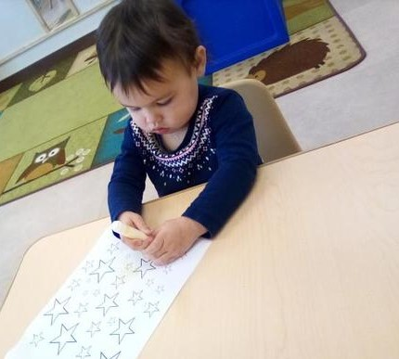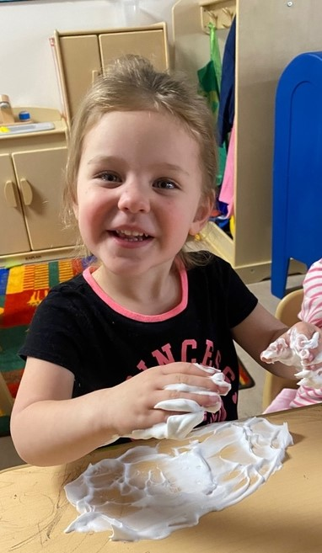

**Children Lighthouse at Corinth**

**1560 Post Oak | Corinth TX. 76210 |** [**corinth@childrenslighthouse.com**](mailto:corinth@childrenslighthouse.com) **| 940.279.1168**



Please feel free to join us VIA Zoom for a FREE Temper Tantrum Training.

Tuesday January 18th, 2022   
Let us know if you would like to join and we can email you the ZOOM link.

**Angie P. 1/15**

Grayson 1/23

**Delaney 1/25**

**Carter 1/28**





**Rooms 1,2, & 3**

**Theme: Competent Me**

**Spanish: Play, Jugar**

**Sign Language: Play**

**Pop Box: Cooking, Cleaning, Construction**

**Character Value: Recognizes and Accepts Differences**

**Music & Movement: Ball Toss, Shaking Rattles**

**Room 4**

**Theme: Space**

**Sign: Stars**

**Shape: Star**

**Song: Mister Man**

**Color: Blue**

**Finger Play: Five Little Rockets**

**Children Lighthouse at Corinth**

**1560 Post Oak | Corinth TX. 76210 |** [**corinth@childrenslighthouse.com**](mailto:corinth@childrenslighthouse.com) **| 940.279.1168**

Curriculum Highlights - December 2021





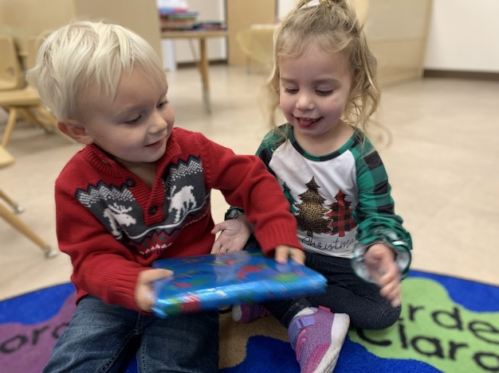





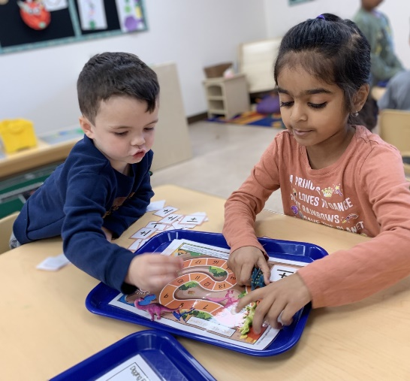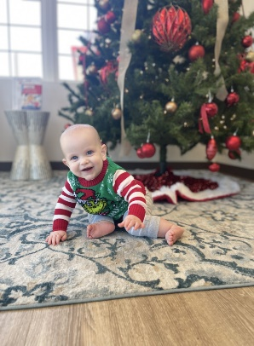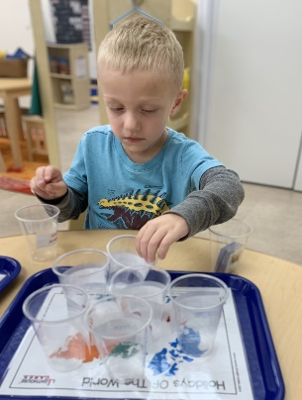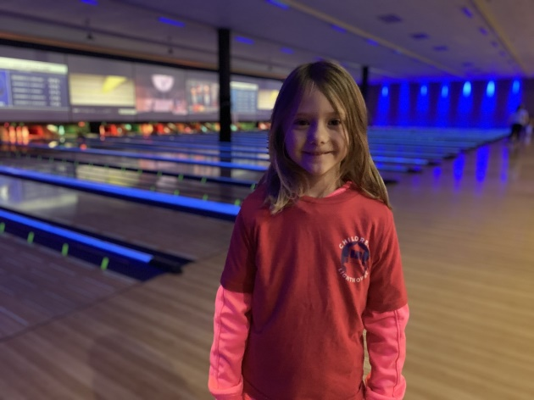

**Rooms 5-9**

**Theme: Seasons, Weather, Arctic Animals, Magnets**

**Letters: Jj, Ll, Pp, Review**

**Book/Author: Jan Brett, Penguin ABC**

**Character Value: Diversity  
Spanish & Sign: Snow, La Nieve**



BLUE









**Room 10**

xSTREAM Quest Challenges:

Ancient Greeks, Bookmark Art, Brain Teaser, Caber Toss, Create a Snowflake