January | Children’s Lighthouse of Sienna  281-778-2133  Fridge Calendar
2020
Reminders | Monday | Tuesday | Wednesday | Thursday | Friday | Infants/Toddlers  Innovations
December 31st |  | 31School closes @ 3 pm | 1 School Closed | 2 | 3 Show and Tell | Theme
School Closes @ 3pm |  | Make Noise Makers | 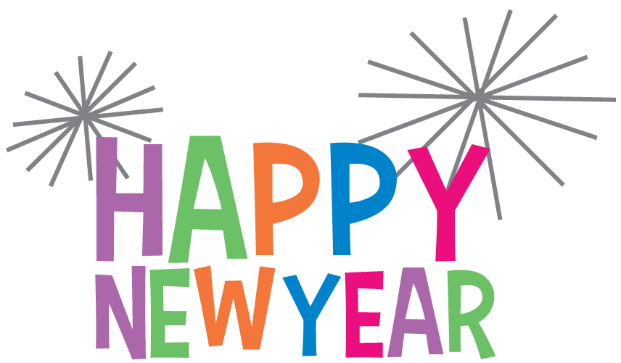 | Winter white & Blizzard Blue Art | Bring something you wear in winter | Competent Me/ Space
January 1st | 6 | 7 FBISD Returns to School | 8 | 9 National Law Enforcement Day | 10 Show and Tell | Shape
School is closed | Circle painting  (Rm1-3) | Shiny Moons Art  (Rm 4) | Thank you cards for law enforcement  (All Classes) |  | Something that starts with letter  Jj, Ll, or Pp | Circle  Stars
January 10th | 13 | 14 | 15 National Hat Day | 16 | 17 | Colors
Breakfast for Parents | Puff painting  (Rm 5-9) | 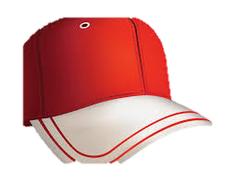 | Wear your best hat! | Star Sensory Bottles  (Rm 4) | Cotton Ball Painting  (Rm 1-3) | Blue
January 23rd | 20 | 21 | 22 | 23 National Pie Day | 24 Show & Tell | Infant Sign
“Polar Bear” Art Showcase | 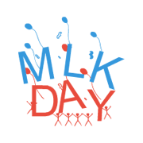 | Make Apple Pie in a Cup  (Rm 5-9) | 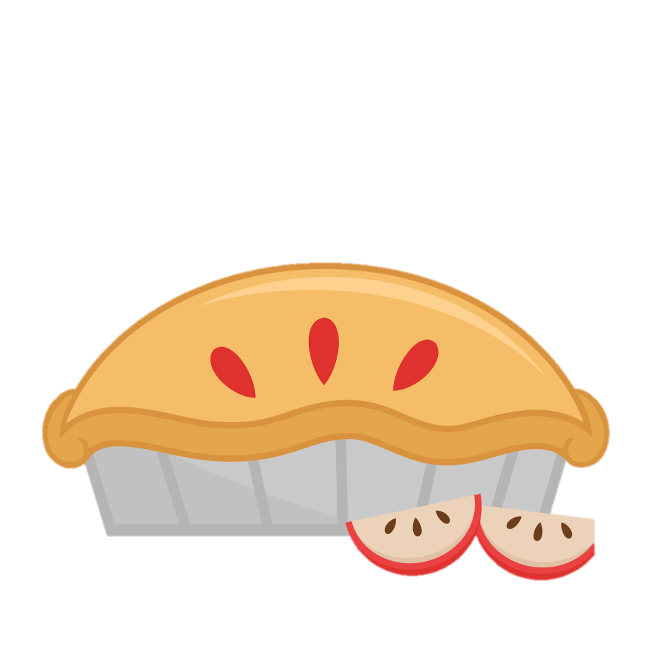 | Make Apple Pie in a Cup  (Rm 5-9) | Bring a puppet  (Rm 5-7) | Play
January 25th | 27 | 28 | 29 National Puzzle Day | 30 Storytime: | 31 National Backwards Day | Toddler Sign
Chinese New Year Event  Details TBA | Rain stick, sensory & sound bottles  (Rm 1-3) |  | Make your  face a puzzle  (Rm 5-9) | 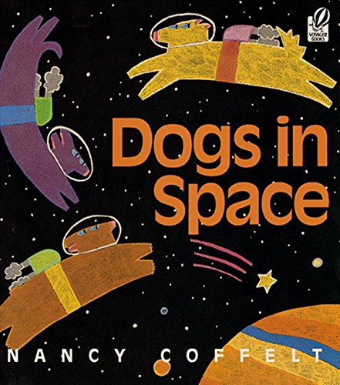 | Wear your shirt backwards! | Stars

Character Value | C.A.R.E.S. Letters of the Month  Jj, Ll, Pp | 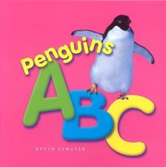  C.A.R.E.S. Book of the Month | C.A.R.E.S. Spanish Vocabulary  Weather – El Tiempo  Snow – La Nieve  Penguin – El Pinguino  Peace- La Paz | Polar Animals  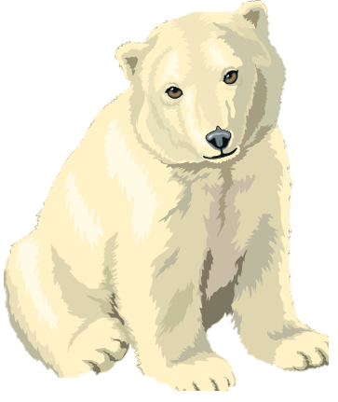 | Seasons  Winter  Spring  Summer  Fall

