**CORINTH**

**January 2025**

**Children Lighthouse at Corinth**

**1560 Post Oak Drive| Corinth, TX 76210 |** [**corinth@childrenslighthouse.com**](mailto:corinth@childrenslighthouse.com) **| 940-279-1168**



January Important Dates

December 31- CLOSE AT 3PM

Wear Your Sparkle

January 1- CENTER IS CLOSED

January 3- Wear Your Bird Watching Gear

National Bird Day- Make Bird Feeder

January 10- Dress Like a Lady Bug in support of Childhood Illnesses

Read Gift of the Lady Bug

January 13- Wear Yellow for Rubber Ducky Day

January 17- National Winnie the Pooh Day- Wear Pooh Gear

January 20- WE WILL BE CLOSED

January 22- National Polka Dot Day- Wear Your Polka Dots

January 28- National Kazoo Day- Stop by front for a surprise

January 31- Backwards Day- Wear Your Clothes Backwards

Inspire Your Heart with Art

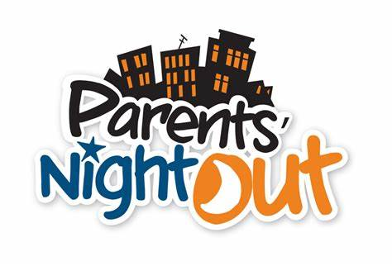

**Tax Statements are available now on myprocare.com**

Curriculum Fees

due

1/13/2024

**Hot Chocolate Bar**

**January 29th**

**7:00 AM-9:30 AM**

**Ages 0-17 Years of Age**

[**https://cliengage.org/clirep/CLI-website/Little-Texans/ITELG-English.pdf**](https://cliengage.org/clirep/CLI-website/Little-Texans/ITELG-English.pdf)

<https://tea.texas.gov/academics/early-childhood-education/2022-texas-pkg-comprehensive-guide.pdf>

**1/2 Stephen R.**

**1/6 Brinda B.**

**1/6 Owen F.**

**1/8 Anthony G.**

**1/9 Isabella H.**

**1/13 Kinsley H.**

**1/14 Lily S.**

**1/14 Christan A.**

**1/14 Lucy S.**

**1/14 Ellie K.**

**1/23 Peri B**

**1/23 Camila N**

**1/24 Kai H.**

**1/25 Gemma M.**

**1/26 Allora B.**

**1/28 Easton & Jennings B.**

**1/28 Jalaiah F.**

**1/29 Alex R.**

**1/29 Petra C.**

**1/29 Emmett S.**



**January 17th**

**6:30 PM- 11:00 PM**

**Sign-up sheets are at the front check in**.

**3rd Friday of the Month**

Please make sure that you are labeling your child’s belongings, especially coats, hats and gloves. As the weather gets colder, we are seeing more duplicates and want to make sure we return them to the correct children!



**Rooms 1-4** –

**Theme: Up In The Air & Sky**

**Spanish: Blue/ Azul , Star / La Estrell**

**Sign Language: Stars / La Estrells**

**36**

**Prop Boxes: Ready For The World**

**Character Value: Diversity  
Color: Blue**

**Shape: Star**

**Music: “Mister Moon”**

**Finger Play/Rhyme: “I Wonder Where All The Clouds Go”**



**Room 5-9**

**Theme: Seasons, Weather, Arctic Animals, and**

**Magnets**

**Letters: J, L, P, and Review**

**Spanish/ Sign Language: Cold/ Frio**

**Book/Author: Jan Brett**

**Character Value: Diversity**



**Ancient Greeks Bookmark Art**

**Brain Teaser Caber Toss**

**Create a Snowflake Far Out Fable**

**Give Me Shelter Hoop It Up**

**Marble Run Snowball War**

**Tapatan The Bead Man**

Curriculum Highlights – December 2024

**Children Lighthouse at Corinth**

**1560 Post Oak Drive| Corinth, TX 76210 |** [**corinth@childrenslighthouse.com**](mailto:corinth@childrenslighthouse.com) **| 940-279-1168**

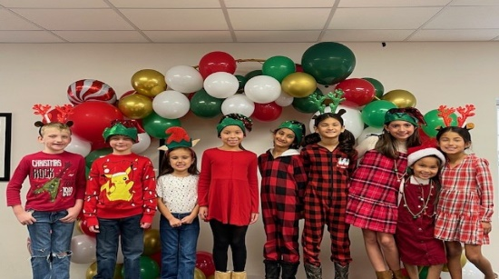

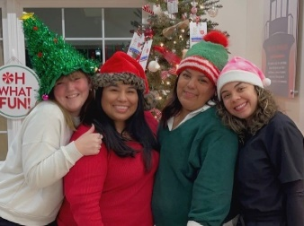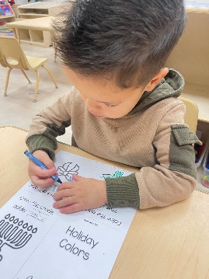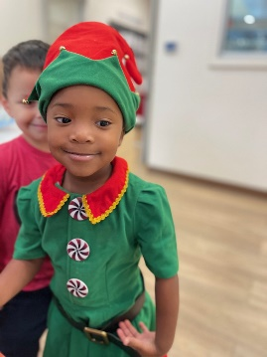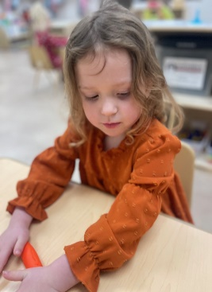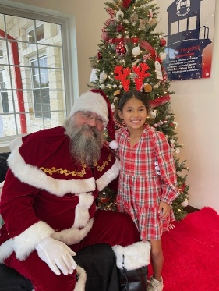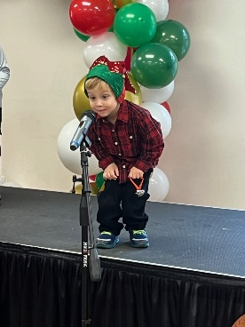

,N

Pay your tuition safely and securely with TUITION EXPRESS and never have to worry about paying a late fee!

Additional information is available at the front office.