January | The Sailor Report
2018
Sunday | Monday | Tuesday | Wednesday | Thursday | Friday | Saturday
 | 1 | 2 | 3 | 4 | 5 | 6
 | Happy New Year!  Closed |  |  |  | Slipper Day!  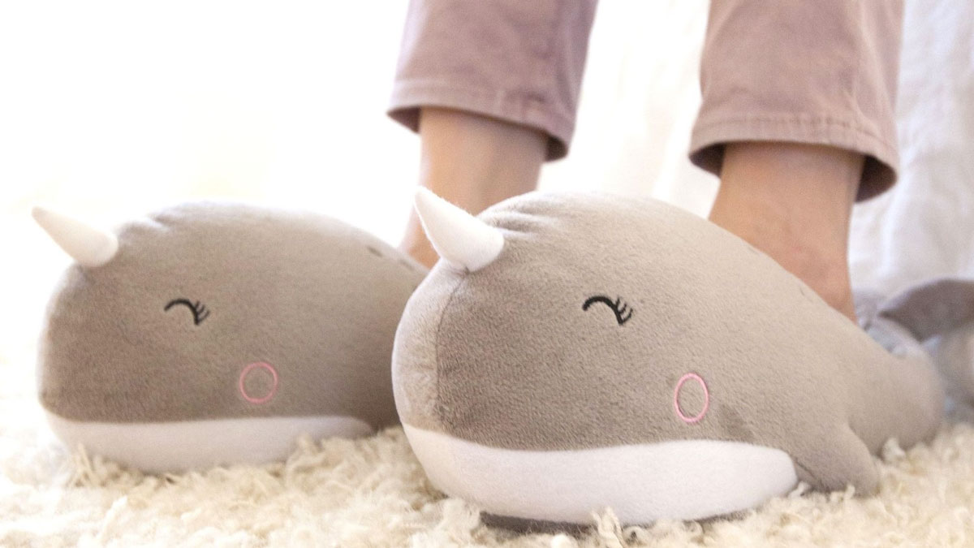
7 | 8 | 9 | 10 | 11 | 12 | 13
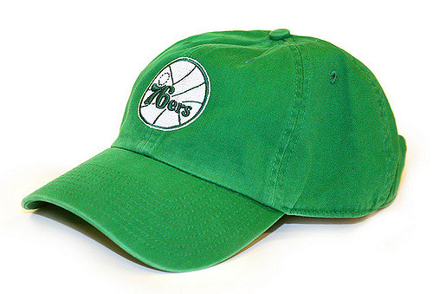
Backwards Hat Day!
14 | 15 | 16 | 17 | 18 | 19 | 20
 | Happy Martin Luther King Jr. Day! |  |  |  | PJ Day!
21 | 22 | 23 | 24 | 25 | 26 | 27
 |  | 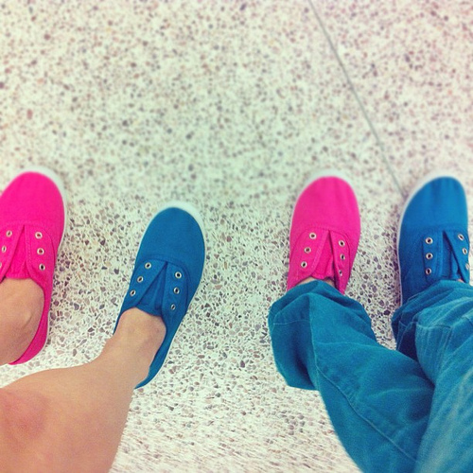  Mismatch Day! |  |  | College T Shirt Day!
28 | 29 | 30 | 31
 |  |  | Tie-Dye Day!

School will be closed on January 1st 2018! Enjoy the New Year! See you on Tuesday. | Wear your favorite slippers on January 5th!  Bring an extra pair of shoes to change into for outside play. | Wear PJS on January 19th with your regular closed toed shoes! | Mismatch Day allows your child to wear different shoes, backwards clothes and anything mis- matching! | January 31st wear tie-dye!

