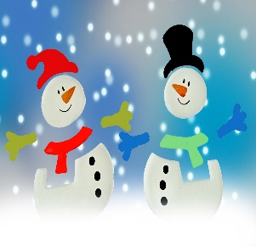 | January 2022
Sunday | Monday | Tuesday | Wednesday | Thursday | Friday | Saturday
1
New Year’s Day!

2 | 3 | 4  National Spaghetti Day! | 5  National Bird Day  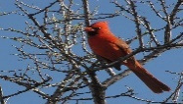 | 6 | 7 | 8  Bubble Bath Day!
9 | 10 | 11 | 12  National Hot Tea Day | 13  National Rubber Duckie Day  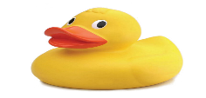 | 14  Happy Birthday Kiera! | 15 National Bagel Day
16 | 17  Teacher Workday! School Closed | 18 | 19  Happy Birthday Ms. Melissa! | 20  Happy Birthday Reya!  Happy Birthday Liam! | 21  Happy Birthday Cameron! | 22
23  National Pie Day | 24  Happy Birthday Jiheon! | 25  Opposite Day! | 26 | 27  Chocolate Cake Day | 28 | 29
30 | 31  Backwards Day

