JANUARY
Sunday | Monday | Tuesday | Wednesday | Thursday | Friday | Saturday
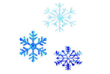 | Donations for Conroe Animal Shelter |  |  | 1  CLOSED  Happy New Year!  2026 | 2  CLOSED   | 3
4 |   5  Blake Magic Show | 6  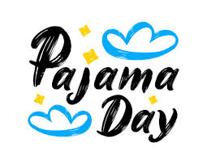  National Cuddle Day | 7  Happy 4 Yr. Anniversary Mrs. Karen!!!!   | 8 |   9  Law Enforcement Appreciation Day! | 10
11 | 12 | 13 | 14 | 15  Happy B-Day Mrs. Stephanie!   | 16  National Hat Day  Wear your best HAT!   | 17  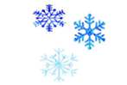
18 | 19  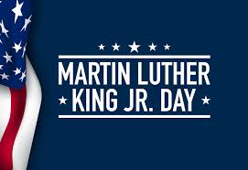  All ISD’s OUT | 20  Happy B-Day Mrs. Kelly!   | 21  National Hugging Day    Hug a Friend/Teacher | 22  Wear Your Polka Dots!   | 23  Happy B-Day Coach Ashton! | 24
25 | 26 | 27 | 28    National Hot Chocolate Day | 29 |   30 | 31

