

**The first month of the year,  
A perfect time to start all over again,  
Changing energies and deserting old moods,  
New beginnings, new attitudes.**

**Children:**

**Kiera 1/14/19**

**Reya 1/20/18**

**Liam 1/20/19**

**Cameron 1/21/19**

**Jiheon 1/24/17**

**Staff:**

**Ms. Melissa 1/19**

**Happy Birthday!!!**

**This Month we will be learning:**

Infants

(Lighthouse Bright Curriculum)

Topic: Competent Me

Color: Blue

Shape: Circle

Toddlers:

Topic: Space

Color Blue

Shape: Star

Preschool- 2’s-3’s:

(Lighthouse CARES Curriculum)

Topics: Seasons, Weather, Artic Animals & Magnets

Letters: J, L, P & Review

Pre-K / APK:

Topics: Seasons, Weather, Artic Animals & Magnets

Letters: J, L, P & Review

**January Newsletter**

Children’s Lighthouse of Apex • 2001 Apex Peakway • Apex, NC • 919-929-0401 • ChildrensLightouse.com/apex

**Hello Parents & Families,**

**Happy New Year! We hope everyone enjoyed the holiday and are ready for the New Year! The first day back to school and we get the pretty sight of snow. We are looking forward to our 2nd year of business and have been planning some fun things for this year, and we can’t wait to share them. We wish everyone a healthy and prosperous year in 2022!**

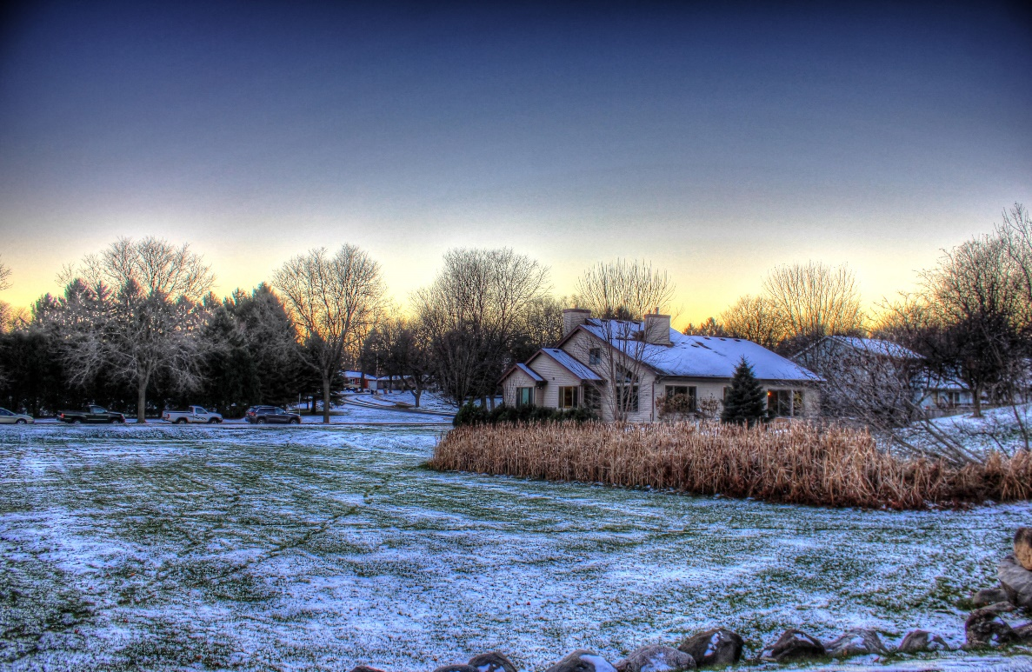



**January 17th- School is Closed for a Teacher Workday**

**February 14th- Valentines Classroom Parties**

**March 24th- Spring Pictures**

**Please have kids dropped off at school by 9am, per the school policy now in effect. If child is going to be late, please notify the admin team for approval.**

Friendly Reminders:

Children’s Lighthouse of Apex • 2001 Apex Peakway • Apex, NC • 919-929-0401 • ChildrensLightouse.com/apex