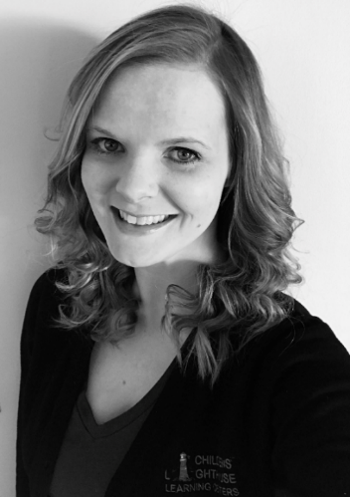

Amanda has 15 years of experience in early childhood education field with a Bachelors Degree in Early Childhood Development. Amanda has been with Children’s Lighthouse since August 2014. She helps oversee the Gardner location and the Olathe Location.

She is married to her husband, Earl and has two children of her own, Liliana and Liam. In her spare time, Amanda enjoys spending time with friends and family, going to the lake, and bargain shopping.

Amanda’s goal for Children’s Lighthouse is to provide a safe, family-oriented environment for our students to learn and grow. She truly values family and wants to ensure each Children's Lighthouse family feels confident in placing their trust in the school. She feels that communication with each family is very important and wants each family to feel welcome to come to her at any time!

Co- Area Director: Ms. Amanda

Assistant Director: Ms. Katelyn

Katelyn has 10 years of experience in the Early Childhood Education field. She is currently going to school to obtain her Associates Degree in Early Childhood Development. Katelyn has been with Childrens Lighthouse since April 2017.

Katelyn is married to her husband Derek and has two children of her own, Ariana and Carson. In her spare time, Katelyn enjoys spending time with her family, adventurous outdoor outings and watching Chiefs Football.

Katelyn’s goals for Childrens Lighthouse is to provide a safe and nurturing environment for the students to grow and learn. Katelyn believes family is important and wants all the families to feel welcomed and confident in placing their trust in Childrens Lighthouse.

Administrative Assistant: Ms. Kyleigh

Kyleigh has 4 years of experience working in the Early Childhood Education. AS a Administrative Assistant, Kyleigh will be assisting teachers in the classrooms with curriculum, classroom management, and behavior management. Kyleigh will also be assisting with office duties. Kyleigh has been with Children’s Lighthouse for almost 3 years.

Kyleigh is married to her high school sweetheart; his name is John. She has two boys, Cayden and Connor. In her spare time, Kyleigh enjoys quality time with her family, playing board games and making memories.

Kyleigh’s goals for Childrens Lighthouse is to create a safe and positive environment for the children, families and teaching staff.