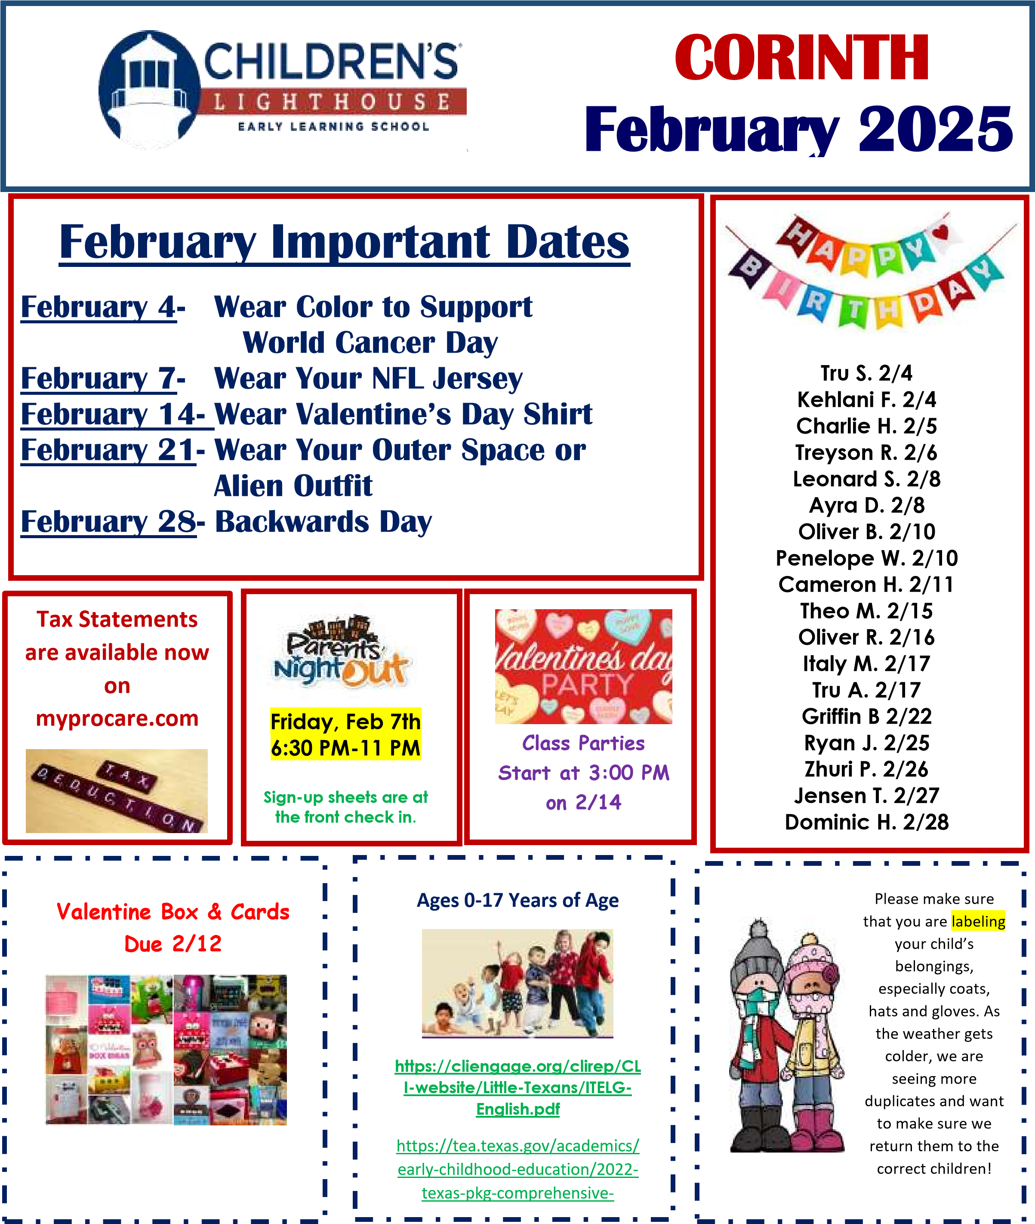

**Children Lighthouse at Corinth**

**1560 Post Oak Drive| Corinth, TX. 76210 | corinth@childrenslighthouse.com | 940-279-1168**

|  |
| --- |
| **Rooms 1-4** –  **Theme: Wheels On The Move**    **Spanish: Purple/ Violeta**  **Sign Language:**  **Wheel/ las ruedas**  **Prop Boxes: All Through The Town**  **Character Value: Truthfulness**  **Color: Purple**  **Shape: Heart**  **Music: “Down By The Station”**  **Finger Play/Rhyme: “Five Little Trucks”**  **The activities cover objectives in the following:**  **Physical Development, Cognitive Development, Social/Emotional**  **Development, Language Development, and Self-Help Development. The specific objectives are on the activity cards in the classroom**      **Room 5-9**  **Theme: America, Our Universe, Birds, and**  **Transportation**  **Letters: W, U, N, and Review**  **Spanish/ Sign Language: Flag/ La Bandera**  **Book/Author: Mo Willems**  **Character Value: Truthfulness**  **The activities cover objectives in the following:**  **Physical Development, Cognitive Development, Social/Emotional** **Development, Language Development, and Self-Help Development. The specific objectives are on the activity cards in the classroom**    **Room 10**–  **Amazing Because Four In A Row**  **Art Speak Heart Strings**  **Back to Back Heart Trouble**  **Balance Your Money Hoop Mania**  **Blanket Volleyball Marble Drop**  **Chinese New Year Ribbons Tangled Up** |

**Curriculum Highlights –**

**January 2025**



Pay your tuition safely and

securely with TUITION

EXPRESS

and never have to worry about

paying a late fee!

Additional information is

available

at the front

office.

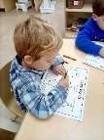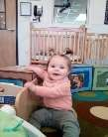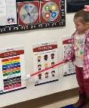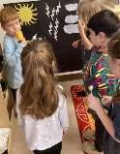

**Children Lighthouse at Corinth**

**1560 Post Oak Drive| Corinth, TX. 76210 | corinth@childrenslighthouse.com | 940-279-1168**