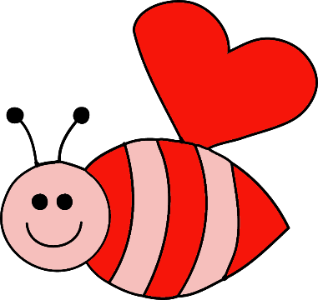
 | Monday | Tuesday | Wednesday | Thursday | Friday
Menu A: Week 1 | 3 B: Cereal, Mixed Fruit, Milk  L: Chicken Nuggets, Mixed Veggies, Oranges, Milk  S: Pretzels, 100% Juice | 4 B: Biscuits & Jelly, Oranges, Milk  L: Chicken alfredo, apple slices, Green beans, Milk  S: Graham Crackers, String Cheese, Water | 5 B: Muffins, Peaches, Milk  L: Cheese Quesadilla, Mixed Fruit, Broccoli, Milk  S: Chex Mix, 100% Juice | 6 B: Pancakes, applesauce, Milk  L: Chicken Parmesan, Tropical Fruit, Broccoli, Milk  S: Vanilla Wafers, Go-Gurt, Water | 7 B: Oatmeal, Mixed Fruit, Milk  L: Pizza Rolls, Corn, sliced apples, Milk  S: Animal Crackers, 100% Juice
Menu B: Week 2 | 10 B: Cereal, blueberries, Milk  L: Chicken Nuggets, Mixed Veggies, Peaches, Milk  S: Pretzels, 100% Juice | 11 B: Waffles, Tropical Fruit, Milk  L: Turkey & Cheese Sandwich, Green Beans, Bananas, Milk  S: Wheat Thins, String Cheese, Water | 12 B: Bagels w/ Cream Cheese, applesauce, Milk  L: Spaghetti, Corn, Applesauce, Milk  S: Veggie Straws, 100% Juice | 13 B: Cheese Toast, Mixed Fruit, Milk  L: Chicken Sandwich, Salad, Mandarin Oranges, Milk  S: Graham Crackers, Dried Cranberries, Water | 14 B: Cereal, Mixed Fruit, Milk  L: Mac N’ Cheese, Mixed Veggies, Pineapples, Milk  S: Classroom Parties @ 3PM
Menu C: Week 3 | 17 | 18 B: Cereal, Peaches, Milk  L: Chicken Nuggets, Mashed Potatoes, Mixed Fruit, Milk  S: Club Crackers, Go- Gurt Water | 19 B: English Muffins & Jelly, Tropical Fruit, Milk  L: Grilled Cheese, Green Beans, Oranges, Milk  S: Animal Crackers, 100% Juice | 20 B: Pancakes, Mixed Fruit, Milk  L: Meatball Stroganoff, Mixed Veggies, Peaches, Milk  S: Pretzels, String Cheese, Water | 21 B: Muffins, applesauce, Milk  L: Cheese Pizza, Salad, Pineapples, Milk  S: Cheez-Its, 100% Juice
Menu D: Week 4 | 24 B: Cereal, Mixed Fruit, Milk  L: Chicken Nuggets, Mixed Veggies, Peaches, Milk  S: Fig Bars, 100% Juice | 25 B: Cheese Toast, Pineapples, Milk  L: Chicken Spaghetti, Corn, Bananas, Milk  S: Vanilla Wafers, Bananas, Water | 26 B: Oatmeal, Tropical Fruit, Milk  L: Baked Mac N’ Cheese, Carrots, Pineapples, Milk  S: Graham Crackers, 100% Juice | 27 B: Biscuits & Jelly, applesauce, milk  L: Tuna Casserole, Green beans, Mixed Fruit, Milk  S: Animal Crackers, Dried Cranberries, Water | 28 B: French Toast, Oranges, Milk  L: Sun Butter & Jelly Sandwiches, corn, Sliced Apples, Milk  S: Nutri-grain bars, 100% Juice

