**CORINTH**

**December 2024**

Wear er

December: Important Dates

12/6- Dress Up Like Rudolph

12/7- Christmas Extravaganza 9 AM

12/10- Wear your Grinch Gear

National Card Day for Senior Center

12/12- Wear your favorite Christmas hat

National Gingerbread House Competition VOTE FOR YOUR FAVORITE

12/13- Wear your favorite Christmas Shirt

12/14- SATURDAY PARENT’S DAY OUT 4:30PM-11:30PM

12/16- Wear your favorite Christmas socks

12/17- Dress like an Elf Day

12/18- Mad about Plaid.. Wear Your Christmas Plaid

Parent Conference Rooms 5 & 6 at 5:30PM

12/19- POLAR EXPRESS ROOMS 8&9

Parent Conference Rooms 7,8,9 at 5:30PM

12/20- National Ugly Sweater

Wear your favorite Christmas Ugly Sweater

Parent’s Night Out 6:30PM -11PM

12/23- Wear Christmas Pajamas

12/24- CLOSE AT 3PM

12/25- CLOSED

12/31 CLOSE AT 3 PM

1/1- CLOSED





**Bring a book for the book exchange by Dec 13th**

**(CLASSROOMS 4-9)**

**Camden H. 12/2**

**Theodore D. 12/6**

**Kamdyn W. 12/7**

**Joshua S. 12/14**

**Noah L. 12/15**

**Jianna R. 12/21**

**Chloe P. 12/27**

**Henry F. 12/28**

**Addisyn D. 12/30**





**Dec 7th**

**9 AM- 12 PM**

**Join us for Christmas Fun!**



Parent Conference:

12/18 Room 5 & 6 @ 5:30

12/19 Rooms 7-9 @ 5:30

Sign Up at the front desk.

**Ages 0-17 Years of Age**

[**https://cliengage.org/clirep/CLI-website/Little-Texans/ITELG-English.pdf**](https://cliengage.org/clirep/CLI-website/Little-Texans/ITELG-English.pdf)

<https://tea.texas.gov/academics/early-childhood-education/2022-texas-pkg-comprehensive-guide.pdf>



**Children Lighthouse at Corinth**

**1560 Post Oak Drive| Corinth, TX. 76210 |** [**corinth@childrenslighthouse.com**](mailto:corinth@childrenslighthouse.com) **| 940-279-1168**

**Saturday, Dec 14th**

**4:30PM-11:30PM**

**$50 Per Child**

**Sign-up sheets are at the front check in**.

**If you would like to contribute, please donate new, unwrapped toys. We will be collecting until 12/11**



**Friday, Dec 20th**

**6:30 PM- 11 PM**

**$30 Per Child**

Sign-up Sheet will be at the front desk.



**Rooms 1-4**

**Theme: All About My Senses**

**Spanish: Green/ Verde**

**Sign Language: Eye/ los ojos**

**Prop Boxes: My world, my senses**

**Character Value: Patience**

**Color: Green**

**Shape: Triangle**

**Music: “The Muffin Man”**

**Finger Play/Rhyme: “Open, Shut Them”**

**The activities cover objectives in the following:**

**Physical Development, Cognitive Development, Social/Emotional Development, Language Development, and Self-Help Development. The specific objectives are on the activity cards in the classroom.**



**Room 5-9**

**Theme: Dinosaurs, Five Senses, Holiday Around the World**

**Letters: D,E,H**

**Spanish/ Sign Language: Touch/ Sign**

**Book/Author: “The Gingerbread Man”**

**Character Value: Patience**

**The activities cover objectives in the following:**

**Physical Development, Cognitive Development, Social/Emotional Development, Language Development, and Self-Help Development. The specific objectives are on the activity cards in the classroom.**



**Room 10**–

**Board Game Community Challenge**

**Create a Cookbook Defend the Hoop**

**Elephant Rumble Flying Snowmen**

**Index Card Morse Code**

**Over the River Protect Your Pizza**

**Roll a Snowman Spin on Art**

**Tic Tac Relay Towering Toothpicks**

**Toy Inventor Winter Boots**

Curriculum Highlights – November 2024

**Children Lighthouse at Corinth**

**1560 Post Oak Drive| Corinth, TX. 76210 |** [**corinth@childrenslighthouse.com**](mailto:corinth@childrenslighthouse.com) **| 940-279-1168**

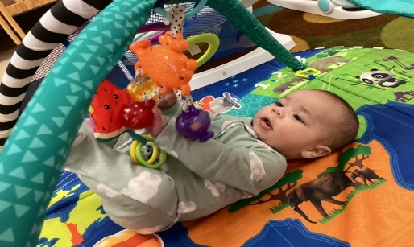



Pay your tuition safely and securely with TUITION EXPRESS and never have to worry about paying a late fee!

Additional information is available at the front office.

