December 6th-16th

Books are great Christmas gifts   
for everyone!

**Santa’s Workshop**

Saturday, December 10, 2022

9:00 A.M. -2:00 P.M.  
$35 per child

Breakfast with Santa

Reindeer Games

Ornament Making

“Santa Paws II” 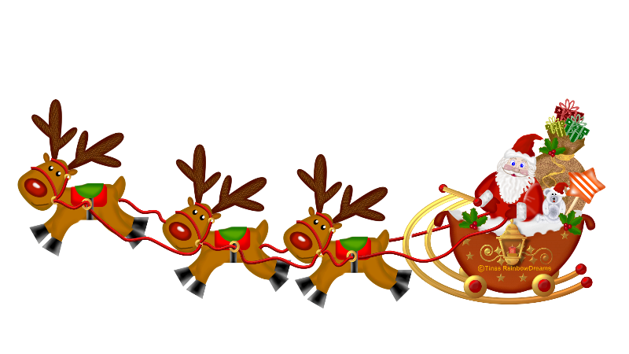

December 2022

**Lighthouse Beacon**

Childrens Lighthouse of Spring-Harmony • 2885 Waterbend Cove Drive • Spring ,Tx • 832-813-8307 • ChildrensLightouse.com

**Class Holiday Parties**

**Friday, December 16, 2022**

**11:30AM – Room 3 through 9**

**3:30PM - Afterschool Programs**

Sign up for party treats and bring a wrapped book for a book exchange.

(Please wrap books for girls in red   
and books for boys in green.)

Christmas and New Year School Closure Schedule

December 15th   
Closing at 5:30 P.M.

December 23rd   
Closing at 3:00 P.M.

December 26th   
Closed for Christmas

December 30th   
Closing at 3:00 P.M.

January 2nd  
Closed for New Years

**Childrens Lighthouse Annual Christmas Concert**

**Date: Thursday, December 15, 2022  
Time: 7:00 P.M.   
Location: Tom Cox Intermediate School  
All rooms 6-9 have been practicing songs to perform for the concert. Please let your child’s teacher know if they will NOT be attending the concert.**

**All children must arrive by 6:40 P.M.   
Come sing along with us and   
enjoy a joyful holiday-filled evening.**

Childrens Lighthouse of Spring-Harmony • 2885 Waterbend Cove Drive • Spring ,Tx • 832-813-8307 • ChildrensLightouse.com