December | Children’s Lighthouse of Sienna  281-778-2133
2018
Fridge Calendar

Reminders | Monday | Tuesday | Wednesday | Thursday | Friday | Infant/Toddlers  Innovations
Santa’s Workshop | 3 | 4 | 5 | 6 | 7 | Theme
Dec. 8th  9:00 am – 12:00 pm | Reindeer Games  (Rm 8 & 9) | 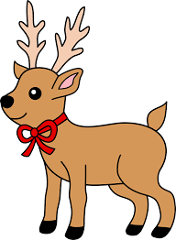 | Decorate Gingerbread Men  (Rm 7-9) |  | Candy  cane  Beads  (Rm6-9) | Sounds/  My Neighborhood
 | 10 | 11 | 12 | 13 | 14 | Shape
Polar Express Party  December 14th | Make Ornaments  (All Classes) |  | Reindeer Toothpaste Experiment  (Rm 8 & 9) | National Hot Cocoa Day | Polar  Express  Party  (All Classes) | Stars (Estrella)  Triangle (Triángulo)
 | 17 | 18 | 19 | 20 | 21 | Colors
 |  | Make Santa Hats  (Rm 3-5) | Wear Your Favorite Christmas Sweater  (All Classes) | Make Your Own Snow!  (Rm 5-9) | Ugly Christmas Sweater Contest  (Teachers) | Red (Rojo)  &  Green (Verde)
 | Christmas eve 24 | Christmas Day  25 | 26 | 27 | 28 | Infant Sign
School Closed December 25th in observance of Christmas | School Closes at 3pm | School Closed |  | Make New Year’s Noise Makers  (Rm 5-9) |  | Stars
 | 31 |  |  |  |  | Toddler Sign
Happy Holidays! | New Years eve  Closes at 3pm | 2 | 0 | 1 | 9 | Play

Character Value  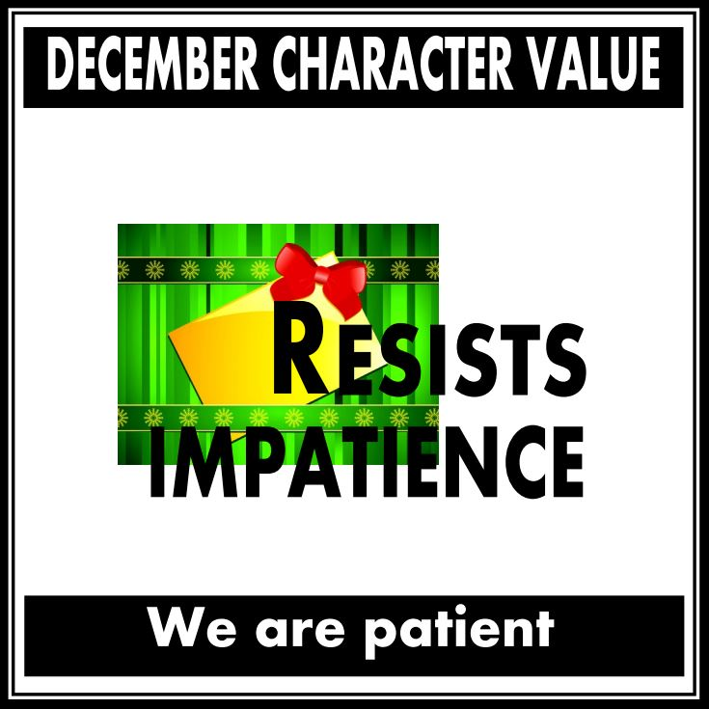  Patience | C.A.R.E.S. Letters of the Month  Dd, Hh, Ee | 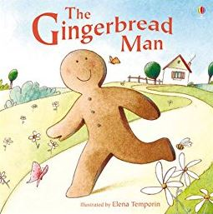  C.A.R.E.S. Book of the Month | C.A.R.E.S. Spanish Vocabulary  Smell – Olor  Touch – Tocar  Listen – Escuchar  Run – Correr  Merry Christmas – Feliz Navidad | 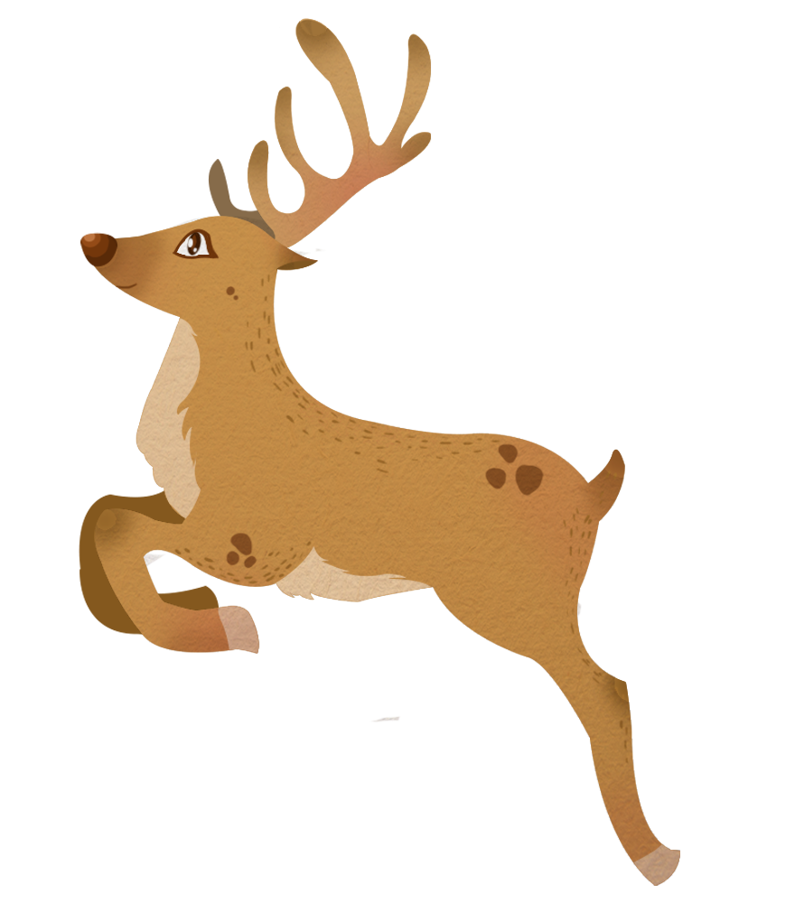  Reindeer | Our Five Senses  Smell  Touch  Taste  Hear  See

