Sunday | Monday | Tuesday | Wednesday | Thursday | Friday | Saturday
 |  |  |  |  |  | 1
2 | 3 | 4 | 5 | 6 | 7 | 8
 | Book fair Starts  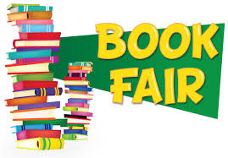 | National Sock Day  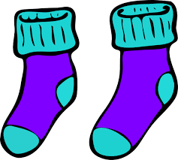  favorite socks | Festive Christmas Sweaters  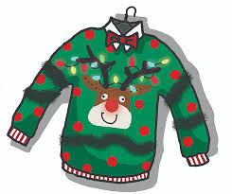 | Holiday Program 6:00pm  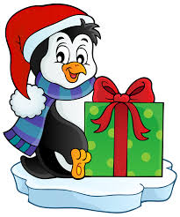 | Holiday Colors  Book fair Ends
9 | 10 | 11 | 12 | 13 | 14 | 15
 | Last Day of Hanukkah  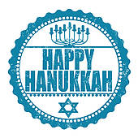  Wear Blue | Winter Mittens  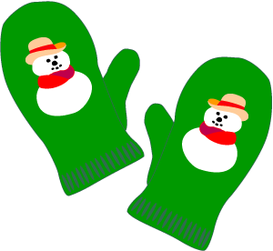 | Gingerbread House Day  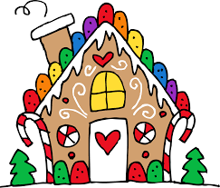 | Hot Chocolate & Polar Express  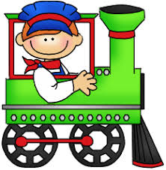 | Holiday hats  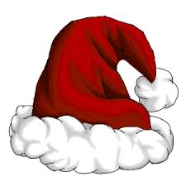  Class Holiday Parties  Book Exchange | Santa’s Workshop  10:00a-12:00p  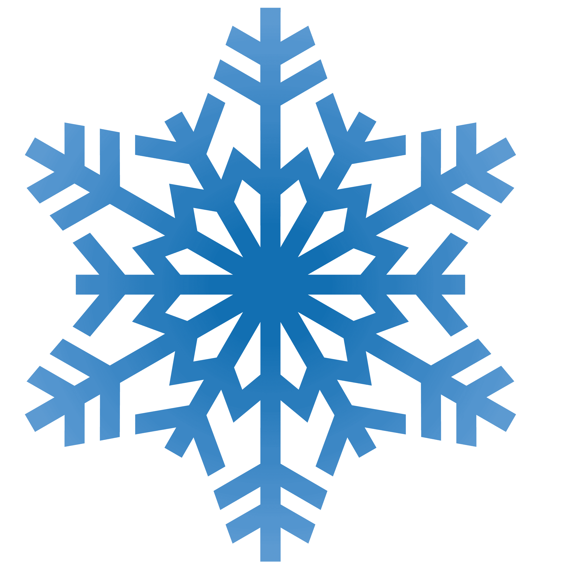
16 | 17 | 18 | 19 | 20 | 21 | 22
 | Bring in Your Favorite Ornament  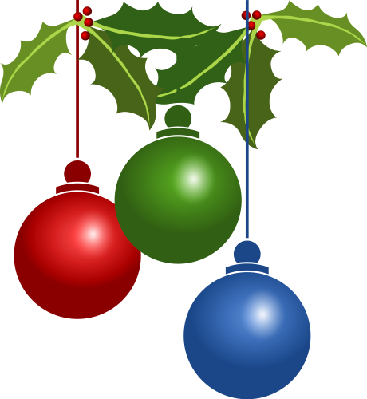 | Elf Day  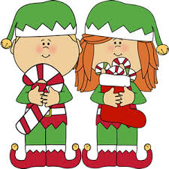  Dress as an elf | Winter Shirts  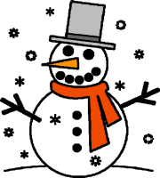 | Snowball Fight  Rooms 5-9  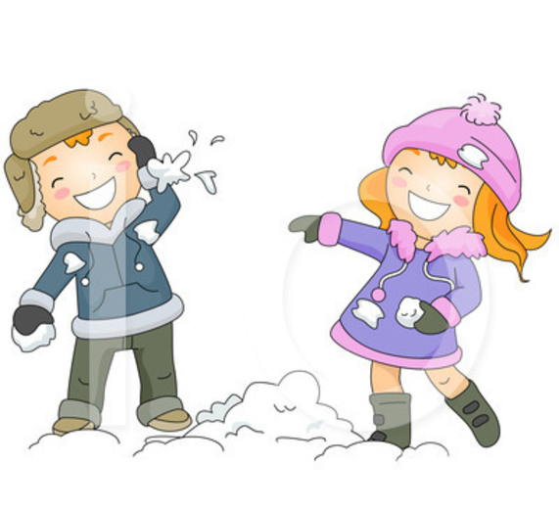 | Holiday Pajamas  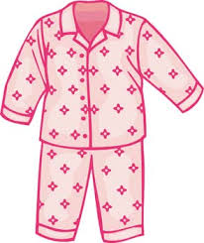
23 | 24 | 25 | 26 | 27 | 28 | 29
 | Christmas Movies  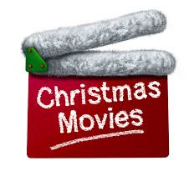  Hours: 6:30am-3:30pm | Christmas Day  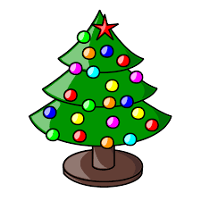  CLOSED | Candy Cane Day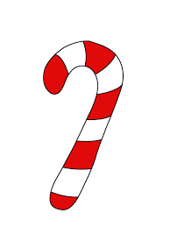  Wear red and white | Sing a Carol Day  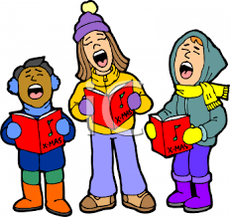 | Kwanzaa Day  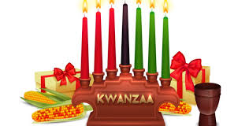  Wear Red, Black and Green
30 | 31
New Year’s Eve
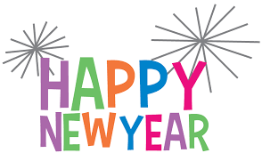
Hours: 6:30am-3:30pm

