
Toys for Tots- Ends Friday Dec. 12th

12/01 – Rosa Parks day
12/03 – National Candle Day (Bring a candle for your teacher)
12/06 – Happy 3-Year Anniversary Ms. Jaclyn!
12/09 – Happy B-Day Ms. Willabeth!
12/11 – Soccer Shots Showcase 9am
12/12 – Pancakes & PJ’s with SANTA! (5pm-6:30pm
PNO $25 Cash Per Child 6:30pm-9:30pm)
12/14 – Happy Hanukkah!
12/15 – National Cupcake Day (Grab a cupcake to go!)
12/17 – “A Christmas Carol” Day Movie/Story
12/18 – National Christmas Ugly Sweater Day (Wear your
ugly sweater)
12/19 – Virtual Winter Concert Times:
Rm9- 9:30am
Rm8- 11am
Rm7- 10:30am
Rm6- 10am
Winter Parties @ 3:30PM
CISD & MOGO Early Release
12/22 – Polar Express Train Rides & Polar Express Movie
MAG, MOGO, & CISD OUT 22nd- 5th
12/24 –CLWF CLOSING EARLY @3pm
12/25 – 12/26 – CLOSED
12/26 – Happy Kwanzaa
12/26 – Happy B-Day Ms. Prenisha!
12/28 – Happy B-Day Mrs. Maria!
12/29 – Visit from The Fussy Penguin
12/31 – CLWF CLOSING EARLY @3pm
01/01 – CLWF CLOSED
01/02 – CLWF CLOSED

12/05- Briggs C. 12/25- Callan W.
12/12- Sophia E. 12/27- Thomas A
12/13- Hayes L. 12/29- Evan S.
12/15- Lily S.
12/17- Landrie T.
12/17- Amelia A.
12/20- Serenity S.
12/20- London H.
12/22- Phorever A.
12/22- Lincoln G.
12/23- Anna B.
12/23- Levi B.
December Birthdays
Community Challenge: A Better Holiday
Character Value: Gratitude


Theme: Holidays Around The World
Letters: D, E, H
Spanish & Sign: Smell / Olor
Book: Author: The Gingerbread Man
Character Value: Patience

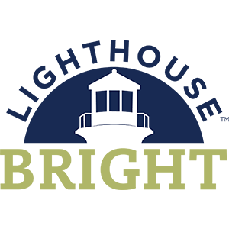
Theme: All About My Senses
Shape: Triangle
Color: Green
Character Value: Patience

Curriculum Monthly Themes

Upcoming Events
December

2024
Children’s Lighthouse of Woodforest • 2183 Woodforest Pkwy NW • Montgomery, TX • 936-588-8999• ChildrensLightouse.com
Lighthouse Beacon
Children’s Lighthouse of Woodforest

December’s Family of the
Month – The Wallers

Craft Corner

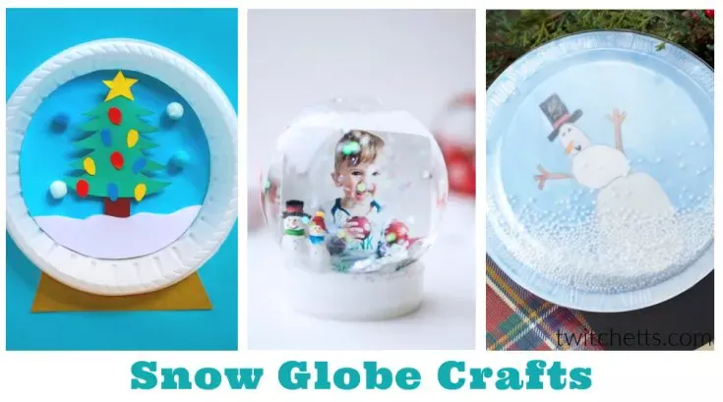

Supplies Needed:
Construction Paper – One of our favorite craft supplies.
Cardboard – Perfect for using up all those boxes you get in the mail!
Craft Sticks or popsicle sticks – A classic staple, use them in your craft or to mix paint.
Kid-Friendly paint – Kids love to get messy! Check out our favorite tips for painting with young children.
Googly Eyes – You can literally add them to any project and it instantly becomes cuter.
Tissue Paper – We always have this on hand. Buy it new or use or save it from birthday parties and holidays.
Toilet Paper/Paper Towel Rolls – A great way to recycle your paper tubes is to use them in crafts!
Paper Plates – Grab this party supply to create fun crafts.
Contact Paper – We use this a lot to create suncatcher crafts
Pipe Cleaners – Their bendy and hold their shape, which makes for some fun creating!
Coffee Filters – This inexpensive item is fun to create with.
Pom Poms – Fluffy and always fun.
Egg Cartons – Recycle these into fantastic crafts!
Puffy Paint – Makes great snow!!
Paper Bags – Using this recycled supply is a fun way to make puppets.

Directions:
https://www.thebestideasforkids.com/how-to-make-a-snow-globe/

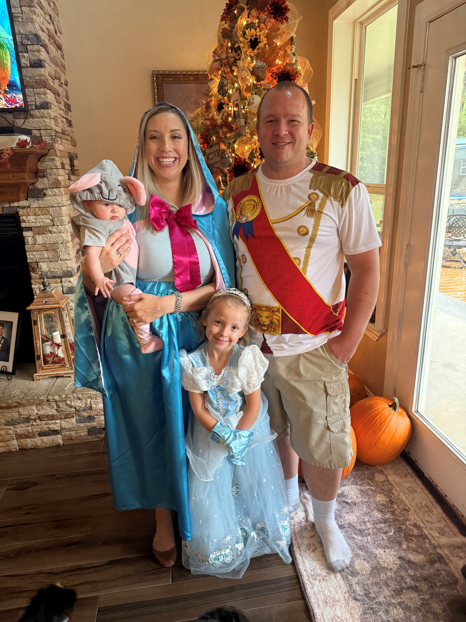
Jilliann (6 months) has absolutely loved coming to this facility and has learned so much. She loves her teachers and all of the fun things that they do in class. Adalynn (Jilly’s big sister) is in Kindergarten at Lone Star Elementary. Mom (Tiffany) is a 2nd grade reading teacher at Lone Star Elementary School, with MISD. And dad (Phillip) is an Engine Operator with Conroe Fire Department. They also have 3 miniature dachshunds-Bruce, Dixie, and Livi. Jilly and her family love to go on walks with the puppies, go fishing, swimming, going on golf cart rides, and snuggling up and watching movies.

Work Anniversaries!


We would like to congratulate our valued employees for all their hard work and dedication. We appreciate all they do.

Jaclyn G. 3 Years!

Teacher of the Month Dec.

Congrats to Ms. Willabeth RM 6


Friend us on Facebook
https://www.facebook.com/Childrens-Lighthouse-1753359808238757

