December
Sunday | Monday | Tuesday | Wednesday | Thursday | Friday | Saturday
 | 1  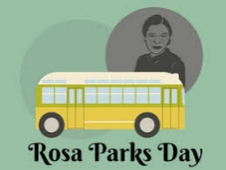 | 2 | 3  National Candle Day    Bring a candle for your teacher! | 4 | 5  Happy 3-Year Anniversary Ms. Jaclyn!!!  Make your wish list for Santa! | 6
7 | 8  Time Traveler Day!  Wear Retro Decade Shirt | 9  Happy B-Day Ms. Willabeth! | 10  Human Rights Day  Learning Coloring Sheets | 11  Soccer Shots Showcase @9am   | 12  Pancakes & PJ’s w/ Santa 5pm-6:30pm!  &  PNO 6:30pm-9:30pm   | 13
  14 | 15  National Cupcake Day!    Grab a cupcake on your way out! | 16   | 17  National  “A Christmas Carol” Movie/Story Day |   18 | 19  Winter Concerts 9:30am-11am (virtual)  Parties @ 3:30pm | 20  
21  MAG ISD  MOGO ISD  CISD  OUT 22nd-5th | 22  Polar Express Day   | 23 | 24  Closing Early @3pm   | 25  CLOSED | 26  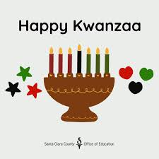  CLOSED  Happy B-Day Ms. Prenisha! | 27
28  Happy B-Day Mrs. Maria! | 29    The Fussy Penguin | 30 | 31  Closing Early @3pm   | 1  CLOSED  Happy New Year!  2026 | 2  CLOSED

