As one of the largest community blood centers in the United States, serving 26 counties across the Texas Gulf Coast, Brazos Valley, and East Texas, and they serve more than 170 hospitals and health care institutions. Their facilities include Gulf Coast Regional Blood Center East Texas as well as Gulf Coast Regional Blood Center of Brazos Valley.

T

As a nonprofit, the patients and donors they serve are at the heart of everything they do. They continuously ensure their donors have an incredible experience while saving lives in our community. From personal TVs to blankets and snacks, the aim is to keep their donors comfortable and happy. Every donor is a hero to us and the families you impact each time you give blood.

To meet the community's needs, they need about 1,000 donations a day, and all blood donors in the U.S. must be unpaid volunteers. Those units of blood are a vital lifeline for Houston’s health care industry and are used in surgeries, cancer treatments and various medical procedures.

he Family Anchor

“What We Learn Today Makes Us Better Tomorrow”

Children’s Lighthouse Creekside • 5585 Creekside Forest Dr. • The Woodlands, TX• 832.698.2735 • ChildrensLightouse.com/woodlands

The Woodlands • 5585 Creekside Forest Dr • Spring, Texas • 832.698.2735 • ChildrensLightouse.com/woodlands

**February Philanthropy:**

**Gulf Coast Regional Blood Drive**

**Events:**

Feb. 3rd – WEAR RED

Feb. 7th – Send a Friend a Card Day

Feb. 10th – Umbrella Day

Bring your favorite umbrella for show and tell.

Feb. 14th – Valentine’s Classroom Parties

Feb. 17th – Brazilian Carnival

Wear your colorful costumes!

Feb. 17th – PARENT’S NIGHT OUT

6:30 – 11:00 p.m.

Feb. 20th – President’s Day Parade

10:00 a.m. in the parking lot

Feb. 21st – Mardi Gras

(wear your green, purple and gold)

Feb. 22nd – Wear Pink

Feb. 22nd – Visit from the Dentist

Feb. 24th – Go Texan Day (Dress like a cowboy)

Feb. 28th – Gulf Coast Regional Blood Drive

12:00-6:00 p.m.

Feb. 28th –Scooter Party (Bring your scooter/bike)

*Love Liberates. It Doesn’t Bind. - Maya Angelou*

February 2023

**Where There Is Love There Is Life**

**!**

**Dates to Remember**

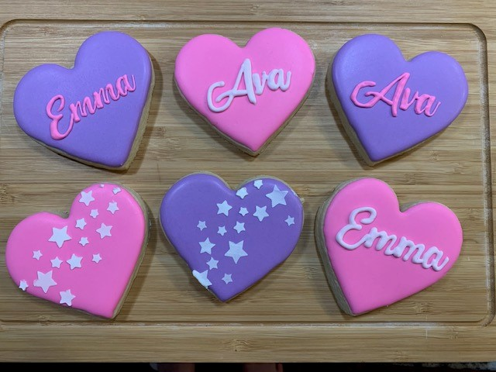

* Please see classroom doors to see what supplies are needed for the month of February.
* February is Children’s Dental Health month so with that in mind we are having a special guest, Dr. Arianda Valverde will visit with classes, February 22nd at 10:00 a.m. to discuss dental hygiene.
* If your family plans to travel for Spring Break do not forget to stop by the front desk to get your Absentee Credit Form.
* February 20th We are open.
* REMINDER: This month’s Parent’s Night Out will be Friday February 17th, from 6:30 p.m. to 11:00 p.m.
* If your child is 4 years old or turning four soon, please bring in a hearing and vision screening for the file.
* Valentine’s Day parties will be held at 3:00 p.m. Parent’s are always welcome to join. Sign up sheet will be posted on classroom doors.

https://www.mymagnoliafamilydental.com/

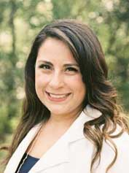

* Our class parties will be held Oct. 28th, 2022, please check with your child’s teacher for specific time.
* Thursday, Nov. 24th & Friday, Nov. 25th,2022 we will be closed in observation of Thanksgiving.
* Please notify the teacher if you will be absent any days of Thanksgiving week, there is a paper on the classroom door with more information.

**A Few**

**Reminders**

This month’s we are spotlighting Small Businesses featuring Shamrocking Cookies and Element Dental of Huntsville, both proudly owned by parents of our school.

Shamrocking Cookies

text/call 713-560-9928

Or

Be sure to get your orders in for Valentine’s Day, $45 a dozen or

**Spotlight:**

The Woodlands • 5585 Creekside Forest Dr • Spring, Texas • 832.698.2735 • ChildrensLightouse.com/woodlands