April | Children’s Lighthouse of Sienna  281-778-2133
2024 | Fridge Calendar
Reminders | Monday | Tuesday | Wednesday | Thursday | Friday | Innovations
 | 1 | 2 | 3 | 4 | 5 | Theme
 | April  Fools  Day | World  Autism  Day | Make a  Rainbow  (All Classes) |  |  | Inf: Bubbles, Mud and Puddles
 | 8  Music Monday  Wear RED  (All classes) | 9  CLASS  PICTURES  Rm 1 - 5 | 10  CLASS PICTURES AND  GRADUATION  PHOTOS | 11  Artsy Thursday  Create a Masterpiece  Wear Purple  (All Classes) | 12  Family Friday  Bring a sack lunch & join us!  Wear your fav. T-shirt | Toddler: Construction
Color
Purple
Shape
 | 15 | 16 | 17 | 18 | 19 | Oval
 | Make Birdfeeders  (Rooms 5-9) | Tasty Tuesday  Cook yummy treats!  Wear Orange  (All Classes) |  | Jump Like a Frog |  | Song  Inf: 5 Little Ducks
 | 22 | 23 | 24 | 25 | 26 | Toddler:
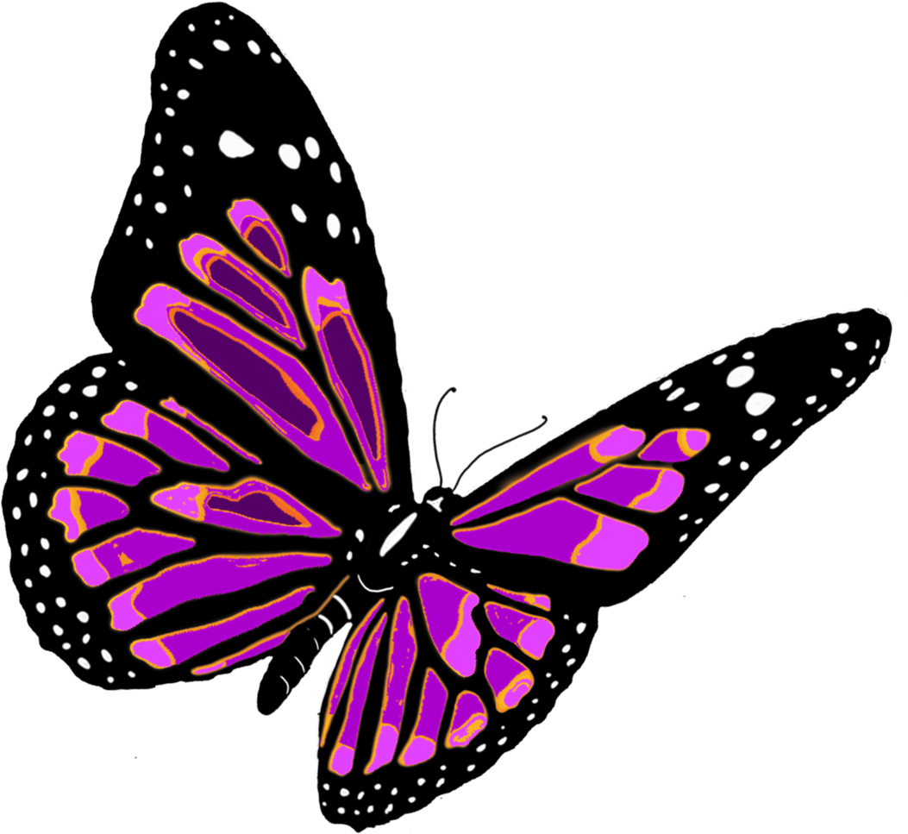  Life Cycle Of A  Butterfly | Earth Day Crafts  (All Classes) | Butterfly  Painting  (5-9) | Teamwork Wednesday  Let’s Work Together  Wear Blue  (All Classes) |  | Something starting with X, Y, or Z. | The Dump Truck Song  Sign
 | 29 | 30 |  |  |  | Water
 | International  Dance  Day | National  Honesty  Day |  |  |  | Spanish  Purple – la púrpura

Character Value  Accepts Responsibility  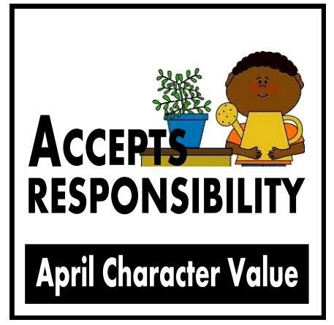 | C.A.R.E.S. Letters of the Month  Xx, Yy, Zz | C.A.R.E.S. Author of the Month  Eric Carle  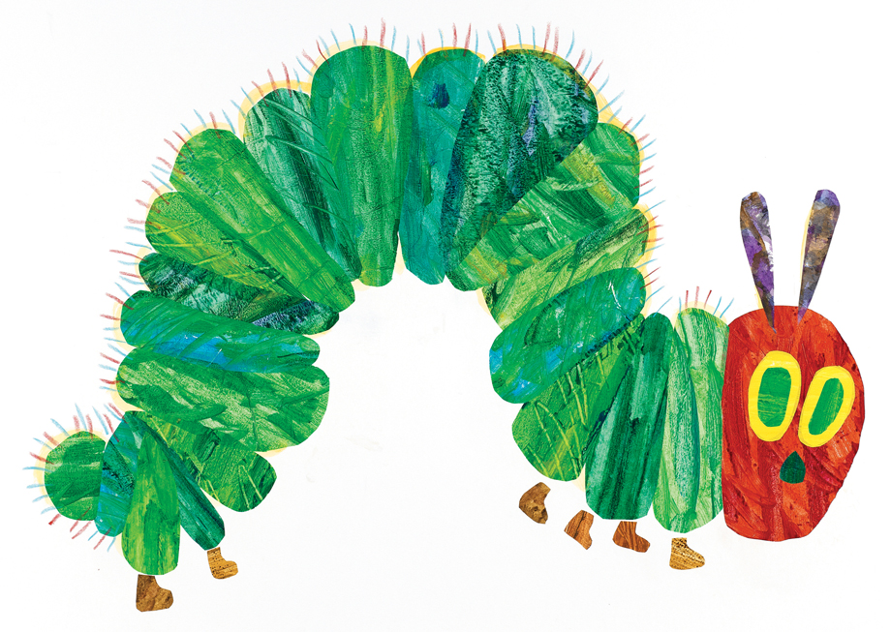 | C.A.R.E.S. Spanish Vocabulary  Butterfly – Mariposa  Frog – Rana  Bee – Abejo  Ladybug – Mariguita | Science  Life Cycles  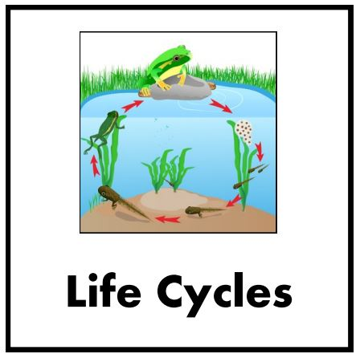 | Insects  Ladybugs  Ants  Butterflies  Aphids  Grasshoppers  Bees

