|  |  |
| --- | --- |
| April | 2885 Waterbend Cove Dr.  Spring, Texas, 77386  (832) 813-8307 |
| 2021 |  |

|  |  |  |  |  |  |  |
| --- | --- | --- | --- | --- | --- | --- |
| **Reminders** | Monday | Tuesday | Wednesday | Thursday | Friday | **Infant/Toddlers**  **Innovations** |
|  | 5 Insect Letter Match | 6 Butterfly Scissor Practice | **PK** 7 Butterfly Life Cycle | 8  Kindergarten Round-Up | 9  National Unicorn Day Wear your Unicorn Shirt | Spanish & Sign Language: |
|  |  |  |  |  |  | Agua/Water |
| Week of the Young Child | 12  Making music! | **PS3** 13 | 14 Work Together Wednesday National Garden Day | Process Art for Preschoolers: Painting with Yarn - Buggy and Buddy 15 | Family Friday 16 | Shape:  Oval  Color Purple |
|  | Toddlers | Tasty Tuesday Cookie Decorating |  | Artsy Thursday  String Art  **PS3** | Ride bikes to school! |  |
|  | 19 | 20 Pineapple Upside Down Cake Day with Mrs. Shay! | 21  Butterfly Hunt (and other fun bugs too!) | 22  Bubble wrap prints of a corn cob - YouTube | 23  **Parents Night Out** | Infants theme:  Bubbles, Mud and Puddles  Toddlers theme:  Construction |
|  | Fingerprint Lady Bugs |  |  |  |  | Infants Songs & Fingerplays:  Five Little Ducks |
|  | 26    Jumping Frog Activity  Toddlers & PS2-PS3 | PK 27  Butterfly Maze | 28    Super Hero Day! Wear your Super Hero Shirt Today | Ants on a Log 29    **APK (Sun-butter used)** | 30  New Parent Meet & Greet 10:00AM | Toddlers Songs & Fingerplays:  The Dump Truck Song |
|  |  |  |  |  |  | - “Grow a Little Seed.”  - “We Planted a Little Seed” |

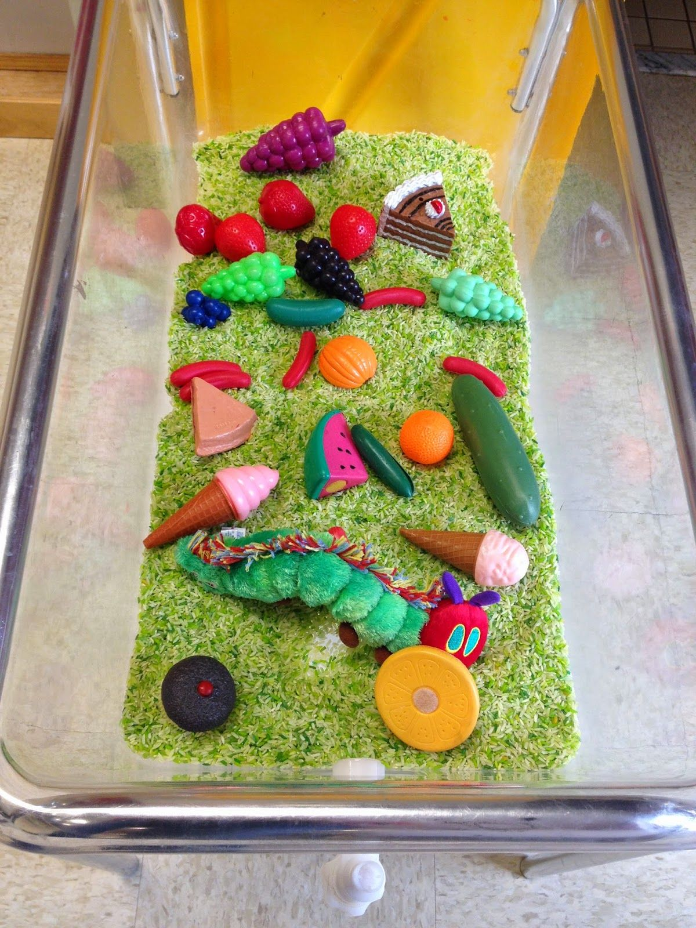

|  |  |  |  |  |  |
| --- | --- | --- | --- | --- | --- |
| Character Value  Accepting Responsibility | C.A.R.E.S. Letters of the Month  Xx, Yy, Zz | C.A.R.E.S. Book of the Month    Author of the Month:  Eric Carle | C.A.R.E.S. Spanish Vocabulary  Insect: Insecto Bee: La Abeja Butterfly: La Mariposa Frog: La Rana | C.A.R.E.S. Themes:  Insects | Sign Language  Water / Agua |