Theme:

**Spring**

**Life Cycles**

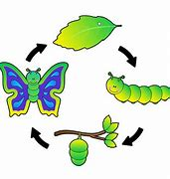

**Insects**

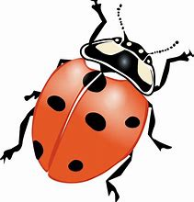

**Amphibians**

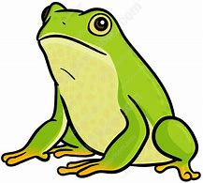

Character Value:

**Accepts Responsibility**

Reminders:

_______________



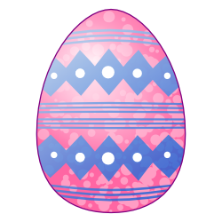

2021

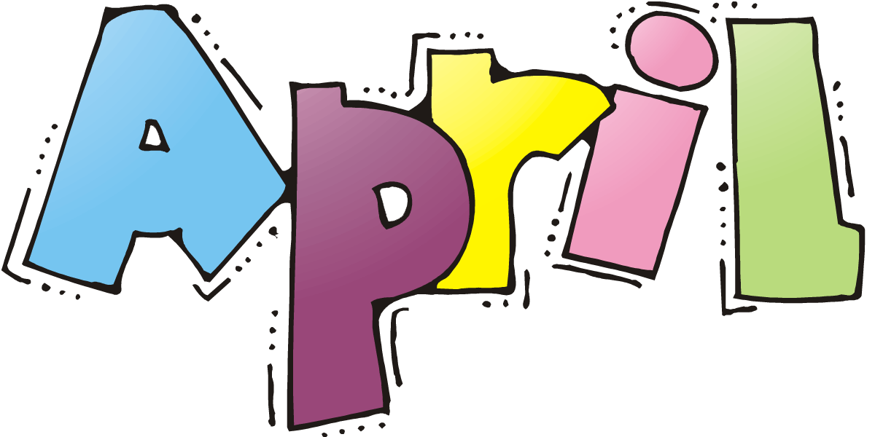

|  |  |  |  |  |  |  |
| --- | --- | --- | --- | --- | --- | --- |
| Sunday | Monday | Tuesday | Wednesday | Thursday | Friday | Saturday |
| **1** |  |  |  | **1** | **2**  **CLOSED FOR TEACHER WORKDAY** | **7**  **Hand Washing Clipart**  **Remember the best way to fight germs is to wash your hands!** |
| **8** | **5** | **6** | **7**  **Wear a flower in your hair day!** | **8** | **9** | **14** |
| **15** | **12**  **Music Monday**  **The Week of the Young Child** | **13**  **Tasty Tuesday** | **14**  **Work Together Wednesday** | **15**  **Artsy Thursday** | **16**  **Family Friday** | **21** |
| **22** | **19** | **20** | **21** | **22**  **Earth Day** | **23** | **28** |
| **29** | **26** | **27**  Dance Party! | **28** | **29** | **30** |  |