2025 Holiday Closing Calendar
January 1st (Wed.) New Year’s Day (Closed)
January 20th (Mon.) Prof. Dev. Day (Closed)
April 18th (Fri.) Good Friday (Closed)
May 2nd (Fri.) Closing at 5:00pm (SPRINGFEST)
May 26th (Mon.) Memorial Day (Closed)
June 19th (Thur.) Juneteenth (Closed)
June 20th (Fri.) Prof. Dev. Day (Closed)
July 4th (Fri.) Independence Day (Closed)
September 1st (Mon.) Labor Day (Closed)
October 13th (Mon.) Prof. Dev. Day (Closed)
October 24th (Fri.) Closing at 5:00pm (FALL FESTIVAL)
November 26th (Wed.) Closing at 3:00pm
November 27th ⁽Thur.) Thanksgiving Holiday (Closed)
November 28th (Fri.) Thanksgiving Holiday (Closed)
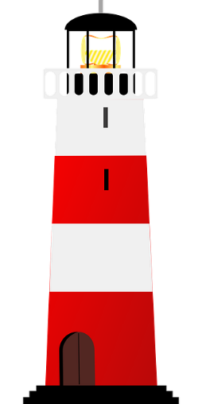
December 24th (Wed.) Winter Holiday (Closed)
December 25th (Thur.) Winter Holiday (Closed)
December 26th (Fri.) Winter Holiday (Closed)
December 31st (Wed.) Closing at 3:00pm
January 1, 2026 (Thur.) New Year’s Day (Closed)

